Friday 24th November 2023
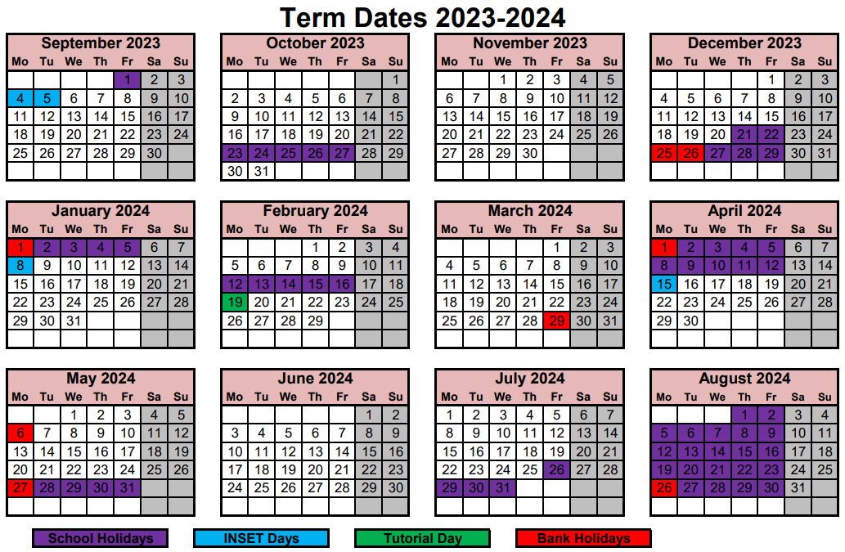

Important dates for your diary
Event |  | Class assemblies
04.12.23 | Flu vaccinations | 08.11.23 | 5BH
08.12.23 | Enterprise Fair | 15.11.23 | 2PH
12.12.23 | Christmas performance at 9:10am – years 4, 5 and 6 | 22.11.23 | Year1
13.12.23 | Christmas performance at 9:10am – years 1, 2 and 3 | 29.11.23 | 4AB
13.12.23 | Christmas lunch
14.12.23 | Christmas performance at 9:10am – Reception
15.12.23 | Christmas performance at 9:10am – Little Stars and Nursery
15.12.23 | Winter Fair
19.12.23 | Class parties
20.12.23 | Last day of term – 2:00pm finish
08.01.24 | INSET day
09.01.24 | Children return

Celebrations
Class | Star of the Week | Writer of the Week | Mathematician of the Week | Reader of the Week | Presenter of the Week
RCJ | Rafed | Freddie | Ananya | Charlie
1AJ | Anna | Raed | Joshua | Jolade | Alex
1HE | Saint | Muhanned | Lacey | Yusuf | Zaheem
2PH | Georgina | Ryan | Reuben | Alice | Nile
2ER | Sade | Yasima | Ian | Eilyeen | Romel

Class | Star of the Week | Writer of the Week | Mathematician of the Week | Presenter of the Week
3MR | Munira | Mariam | Isabelle | Abib
3GC | Zahara | Malik | Shuaib | Elise E
4AB | - | - | - | -
4EB | Jade | Zarah | Tilly | Ben
5BH | Kaycee | Meriem | Genesis | Uke
5AA | Abdulla | Aza | Asly | Nhiyra
6MV | 6MV | Michelle | Kiara | Matias
6CS | Kenza | Oliver C | Bazeet | Majid

This week’s gem winners are…. | Sapphires
This week’s treasure chest winners are… | 3MR 6CS

Attendance
This week’s attendance winners are 1AJ
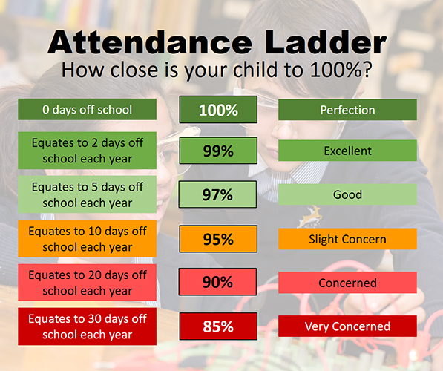
Class | Attendance
RCJ | 98.57
1AJ | 98.82
1HE | 96.47
2PH | 97.41
2ER | 96.92
3MR | 91.28
3GC | 98.33
4AB | 96.84
4EB | 98.33
5BH | 94.29
5AA | 91.82
6MV | 94.07
6CS | 98.03
Whole school | 95.07
School average (year) | 95.41%
National average (year) | 93.7%
School target | 96%

Classes with the best attendance this term so far…

1st
1HE 97.23% | 2nd
 | 2PH 96.88% | 3rd
 |  | 6MV 95.61%
Latest News

Safeguarding – concerning online incident
The School has been made aware of inappropriate WhatsApp content witnessed by Keyworth children. This included:

- Swearing;
- Sexualised content;
- Bullying behaviour;
- Children communicating with unknown users, some of whom were older than the children.

As always, the School advises parents/carers only allow their child/ren to use age-appropriate online networks. Additionally, parents/carers should regularly monitor what their child/ren is/are viewing and partaking in when online.

Should a parent/carer notice anything that is inappropriate, they should contact the school office promptly and request to speak to a safeguarding lead.

Safeguarding children is everyone’s responsibility.

Further information and support can be found by using the links below:

NSPCC UK Safer Internet Centre Childnet

Health-related survey (years 4 to 6)
During the next few weeks, children in years 4, 5 and 6 will be taking part in a Southwark Local Authority survey around health and health behaviour. The survey will be anonymous and confidential, with the results guiding Southwark Local Authority’s future actions in supporting young people in the borough around health and wellbeing.

The School is sharing the contents of the survey in order to be transparent with families and should your child/ren want to talk to you at home about it. The contents of the survey all relate to what the children are taught in the KS2 PSHE curriculum:

- Home and family;
- Emotional health and wellbeing;
- Bullying;
- Healthy eating and exercise;
- Tobacco, alcohol and drugs (years 5 and 6 only).

Should you have any questions or queries about the survey, please email the school office.
Maths Enterprise Fair

School Council competition – Design a ‘Buddy Bench’

Year 1 Autumn walk
Year 1 hunted for signs of Autumn during their Autumn walk – look at the excitement on their faces!

Year 6 visit The Royal Courts of Justice
Year 6 have enjoyed a fantastic day at the Royal Courts of Justice reenacting the historic Emmeline Pankhurst court case.

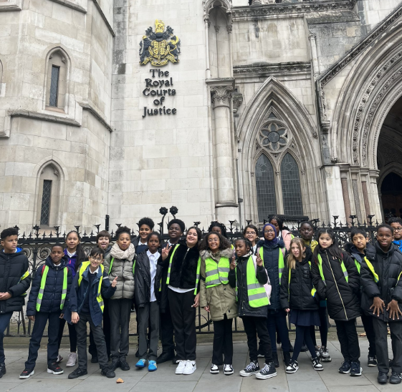
Year 4 British Museum visit
Yesterday, Year 4 went to the British Museum. They went to explore the Anglo-Saxon and Vikings exhibition and learn about their different ways of life.

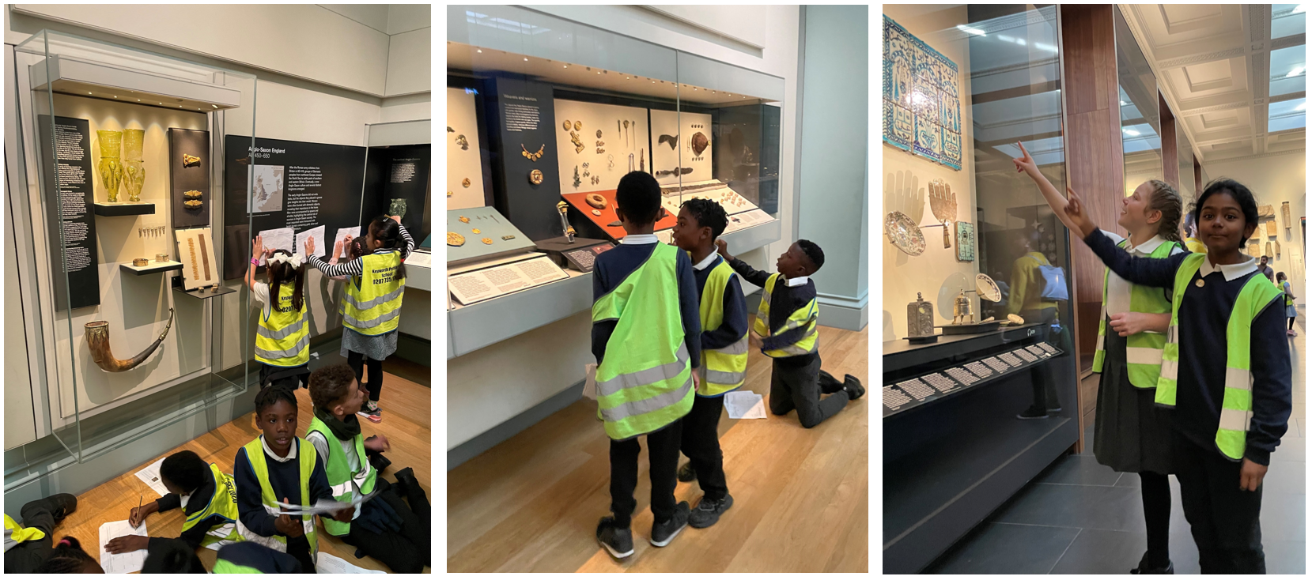

Poppy appeal
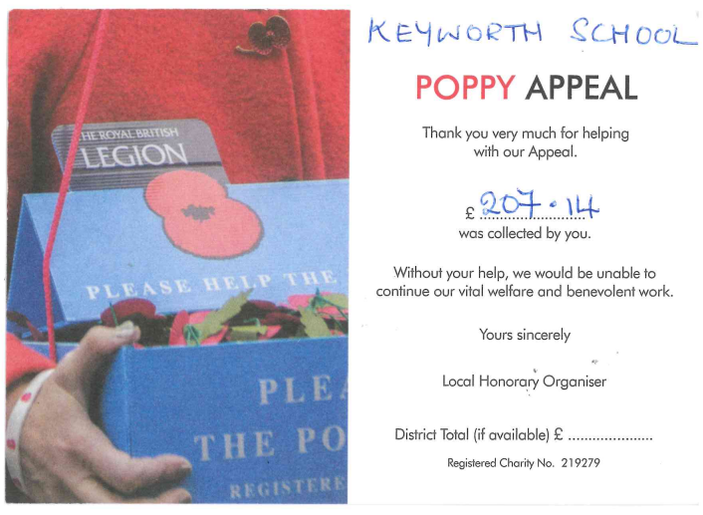
Thank you to everyone who donated to the poppy appeal!

Support for families 1 – FREE Christmas Fair at Surrey Docks Farm
Get in the festive spirit at Surrey Docks Farm in SE16 on Saturday 2nd December (11:00am to 4:00pm) where there will be carol singing, craft stalls, mulled wine, animal handling, plus wreath making kits and beautiful Christmas trees on sale. Further details of the farm can be found by clicking on the link below:

Surrey Docks Farm

Support for families 2 – FREE day pass to Southwark leisure centres
Southwark Council are offering you a free day pass to try out one of your local leisure centres. The pass will get you a free swim session, a free gym session and a tour of the centre. Further details can be found by clicking on the link below:

Southwark leisure centre pass

Support for families 3 – FREE three months’ bike hire
Southwark Council are funding the Try Before You Buy Bike scheme, which allows you to hire a bike for three months, free of charge. Codes can be gifted to family and friends (as long as they live in Southwark) so they can join in on the cycling adventure. Further details can be found by clicking on the link below:

Southwark cycling scheme

Support for families 4 – FREE virtual Weight Watchers support
If you're 18 or over you may be eligible for 12 weeks’ free weight loss support. This includes virtual expert coaching, and discounted gym membership. You'll need to have a certain body mass index (BMI), and be a resident and/or be registered with a Southwark GP to apply. Places are limited, so apply today! Further details can be found by clicking on the link below:

Weight loss support

Support for families 5 – family coffee morning (Brandon Library)
At the end of this newsletter, you will find a poster containing information about a family coffee morning at Brandon Library.

Support for families 6 – London Youth Choirs
Sign-up is now open for the next LYC auditions in January 2024! All auditions are FREE. There is a subscription cost for the choir, however if your audition is successful and you are offered a place but require financial assistance to accept, LYC can offer financial assistance to cover all costs of membership. Further information can be found by clicking on the link below:

London Youth Choirs

Support for families 7 – SENsational play sessions
At the end of this newsletter, you will find a poster containing information about an open day where you can find out more about play sessions for children with additional needs and disabilities.

Word of the Week
This week’s Word of the Week is awkward. Please discuss its meaning with your child/ren and encourage them to share what they have learned with their teachers in school to receive gems. Do they know the origin? Can they use the word correctly in a sentence? Can they identify and explain the meaning of alternative forms e.g. awkwardly/awkwardness? Can they identify any synonyms or antonyms?

Please find below previous words that we have used in school:

Previous words | defensible, corresponded, exaggerated, recommended, determined, hinder, accommodated, controversy, sacrifice, persuade

I would like to wish you and your family a lovely weekend!

Ray Capper
Head of School

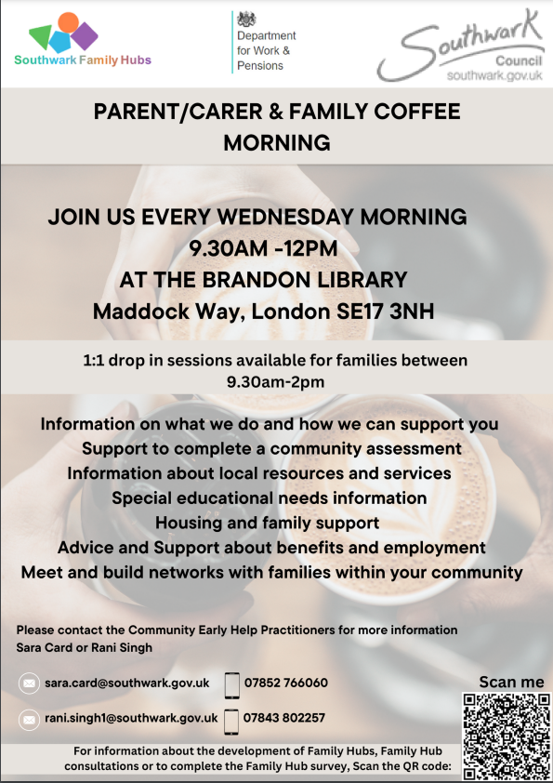
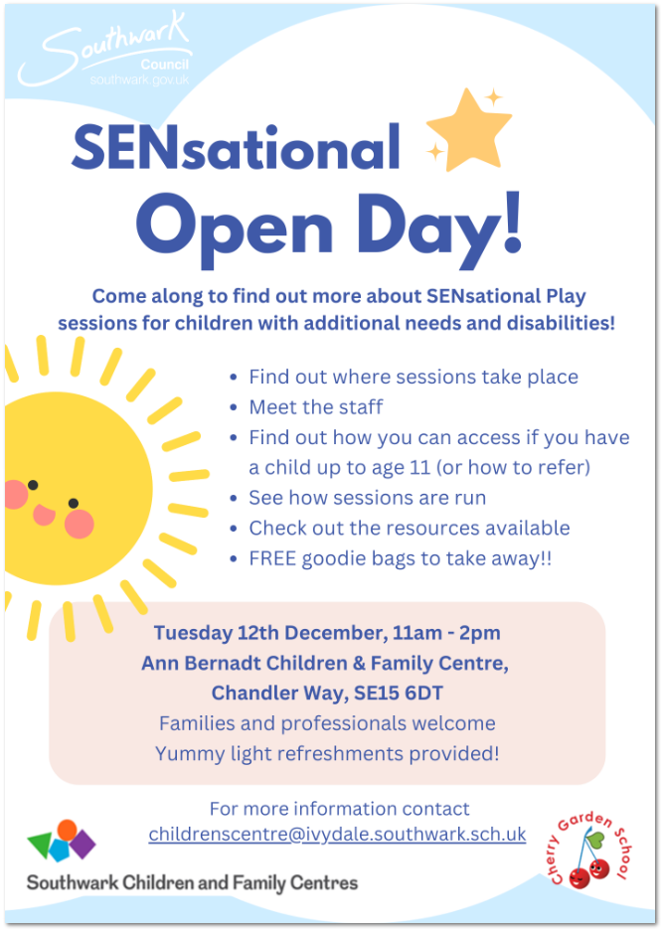

People currently receiving Healthy Start food
vouchers need to reapply online by 10 March
2022 to receive a prepaid card, otherwise
their payments will stop. Please help to
spread this message, and offer support, to
any families who need to make this transiti
People who receive Healthy Start foo

