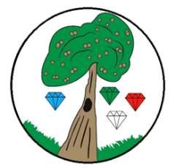
Year: 6 Term: Autumn 1

Science: Light
Pre-Learning Pack
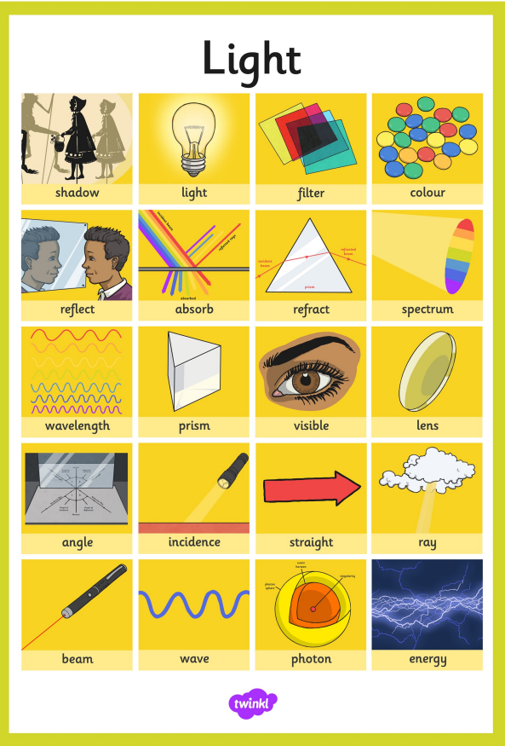
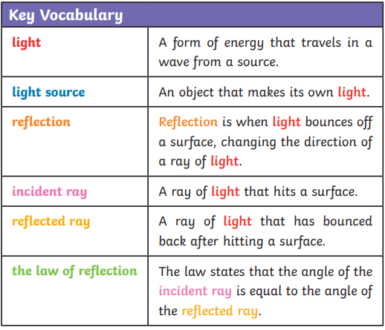
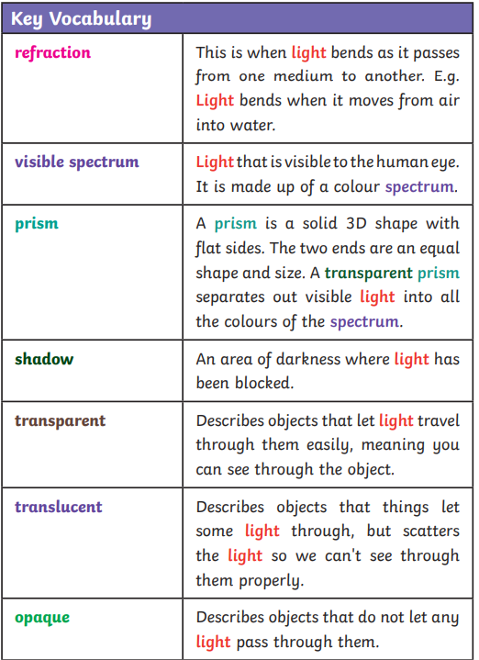
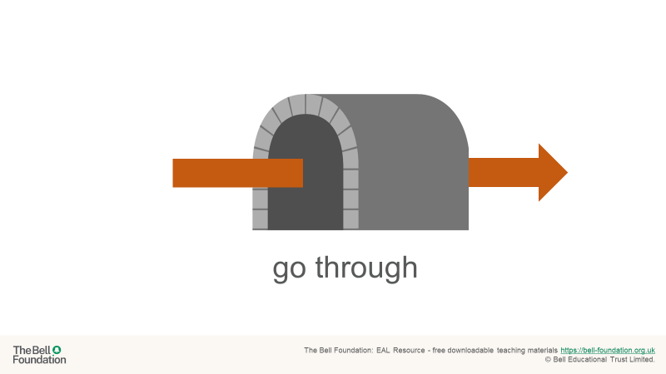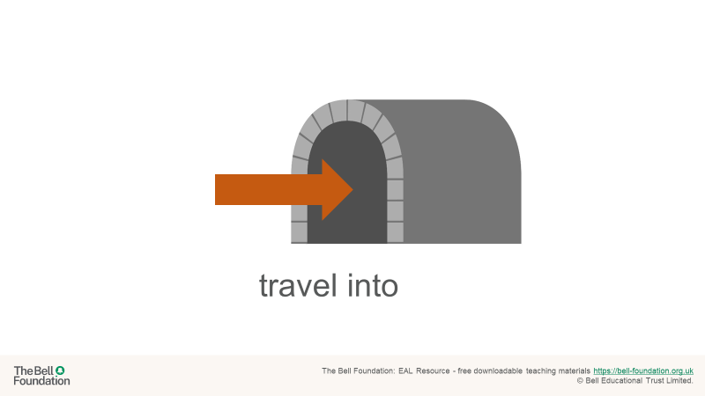

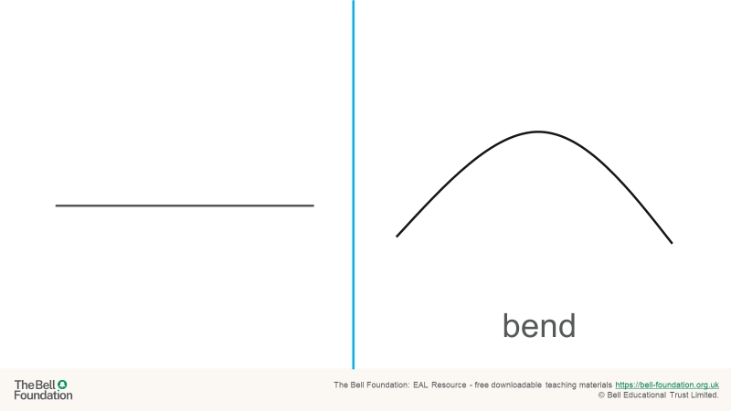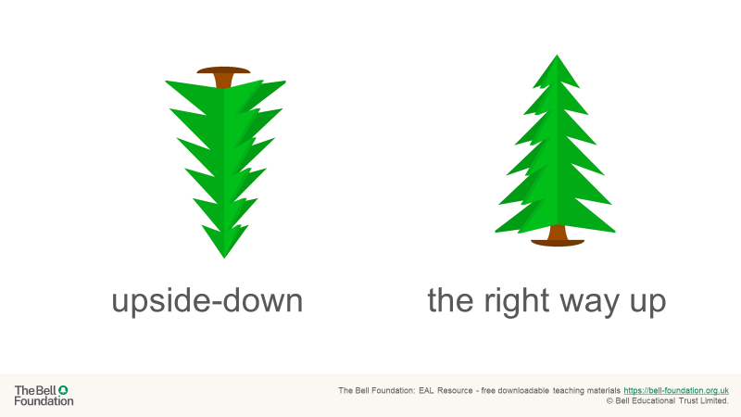

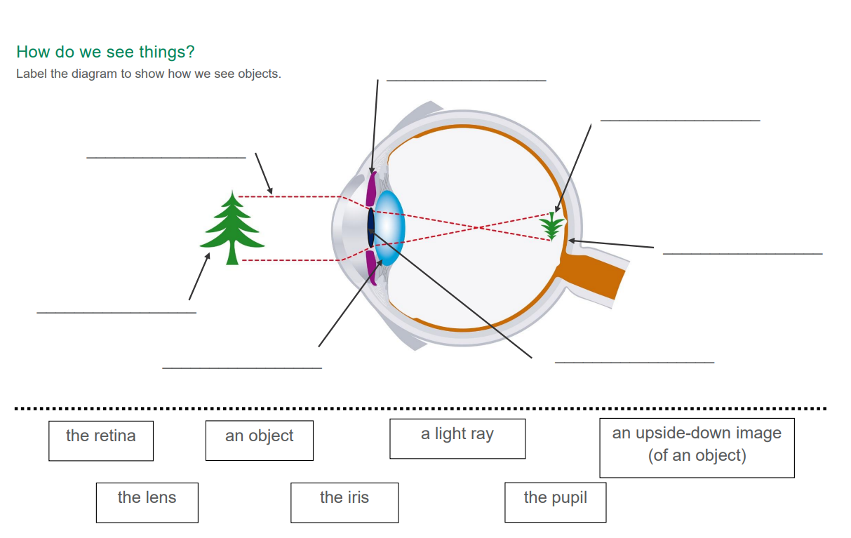
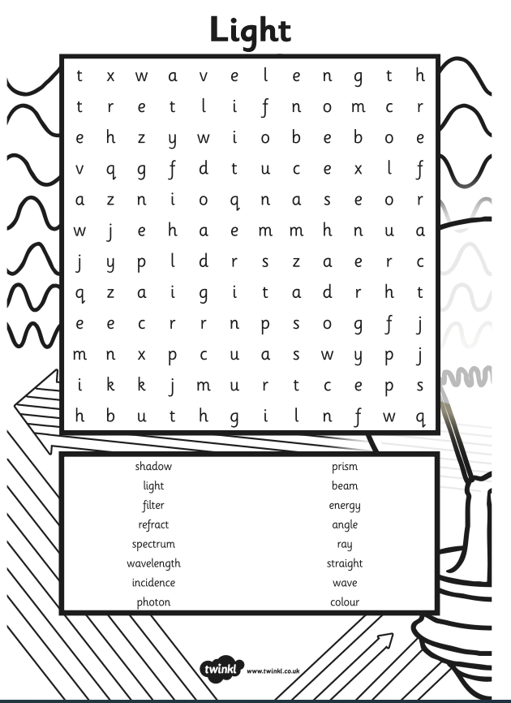

 | Videos | Activity suggestions
Light | How does the eye detect light?  https://www.bbc.co.uk/bitesize/topics/z3nnb9q/articles/zrs62v4  Modelling light  https://www.stem.org.uk/resources/elibrary/resource/30672/modelling-light  Simple light song  https://www.youtube.com/watch?v=kmxhbT9a2jY | - Word search  - Make a periscope - https://www.nasa.gov/stem-ed-resources/making-a-periscope.html  - Make a shadow puppet https://nhm.org/make-your-own-dinosaur-shadow-puppet-and-screen  - Make a rainbow https://www.rookieparenting.com/make-your-own-rainbow-science-experiment/  - Make a stained glass window https://www.youtube.com/watch?v=kHax38AtEuI

