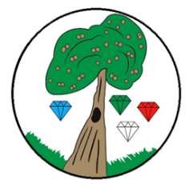
Year: 6 Term: Autumn 2

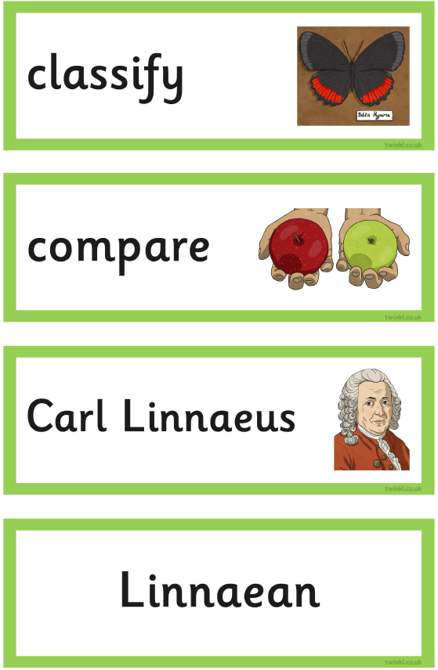
Science: Living things and their Habitats
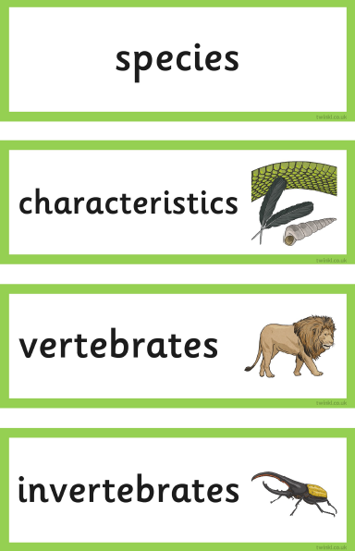
Pre-Learning Pack
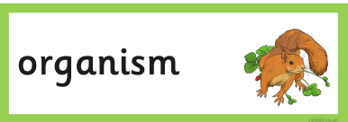
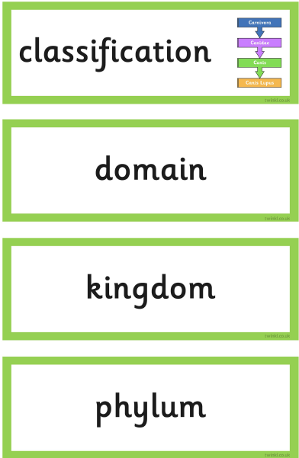
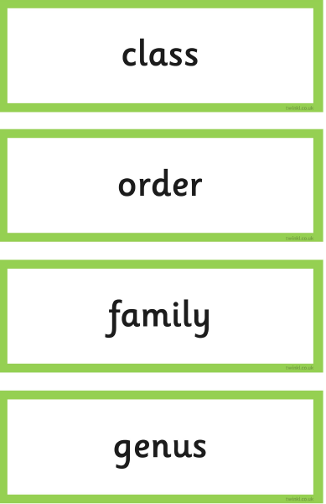

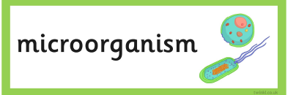
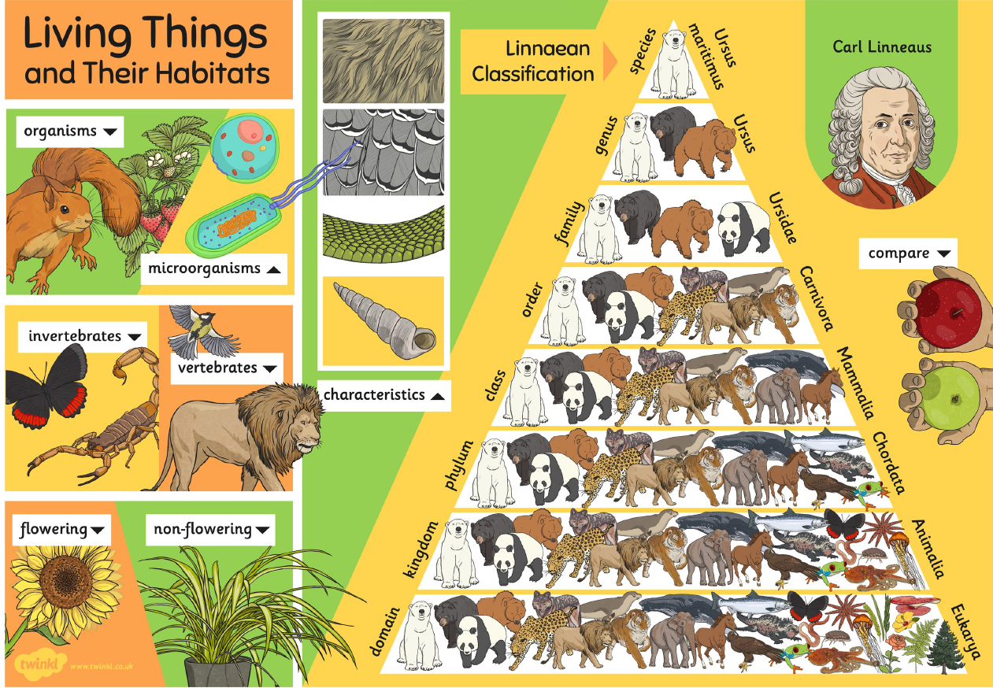

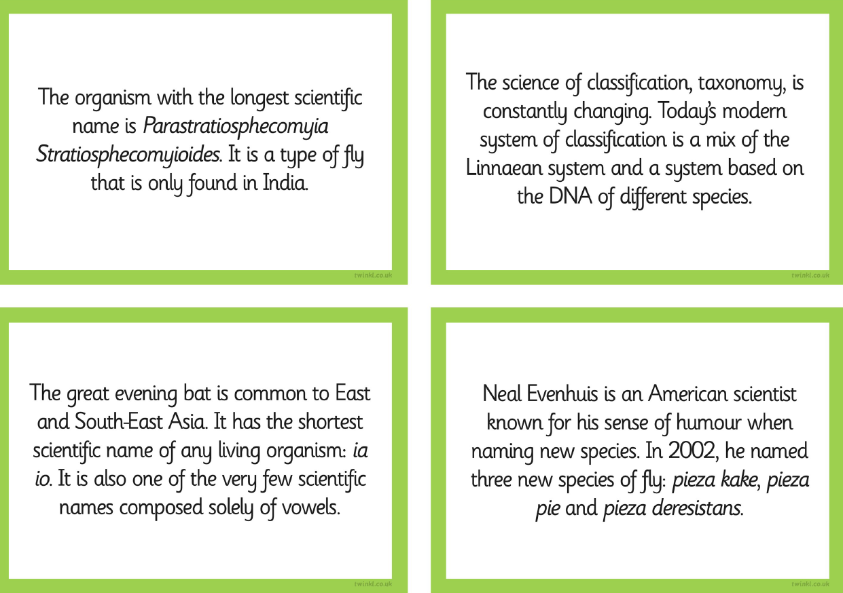

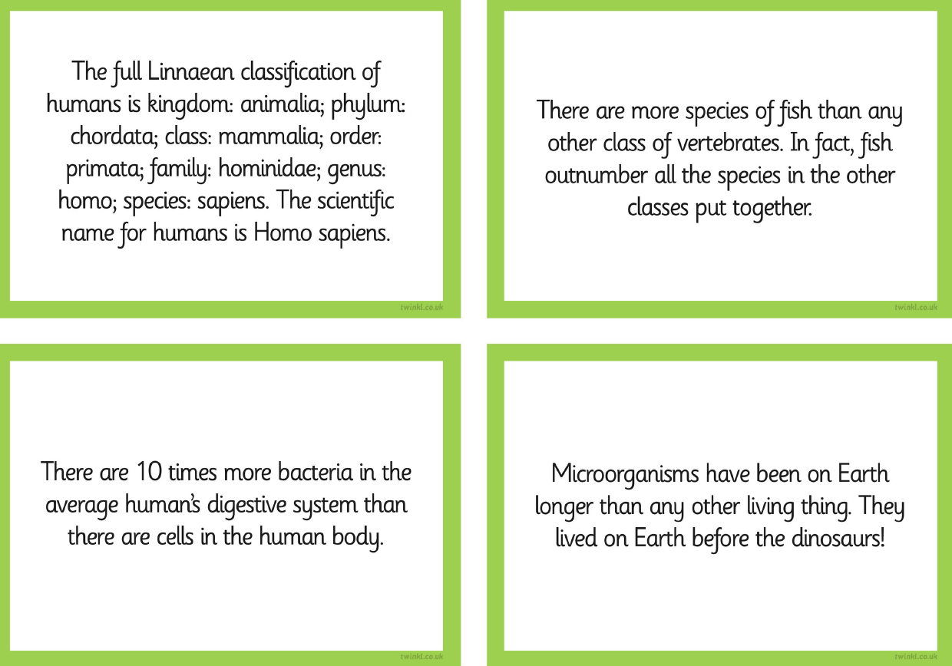

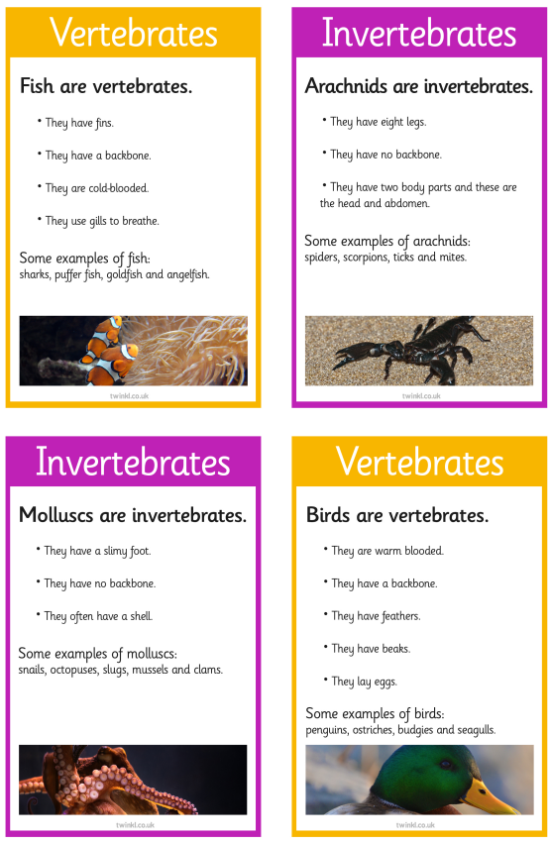
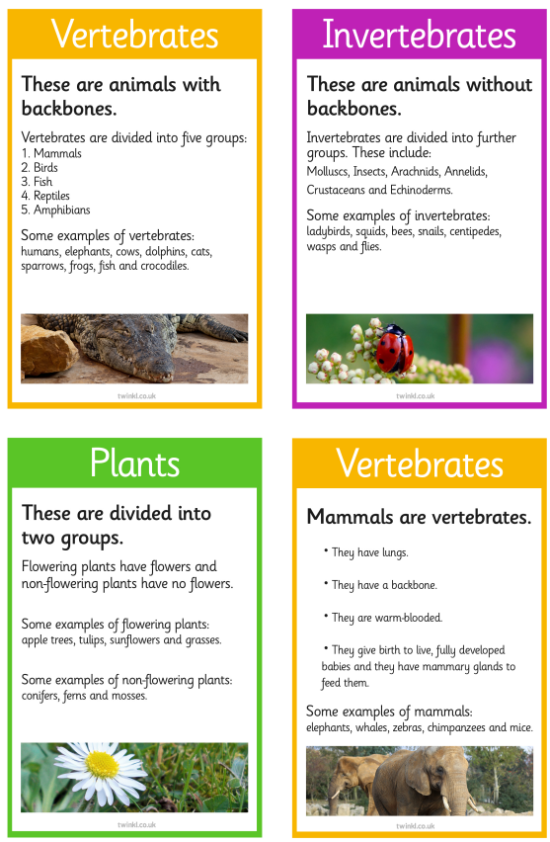

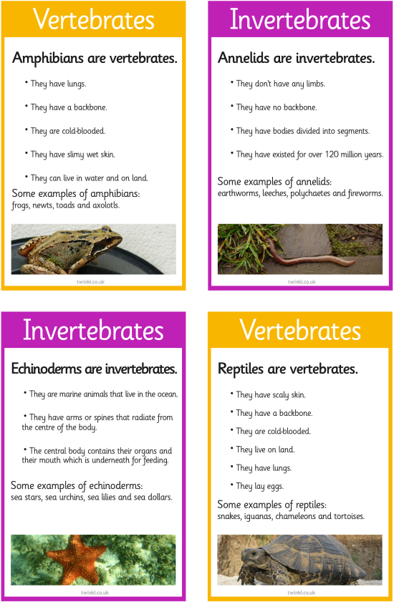

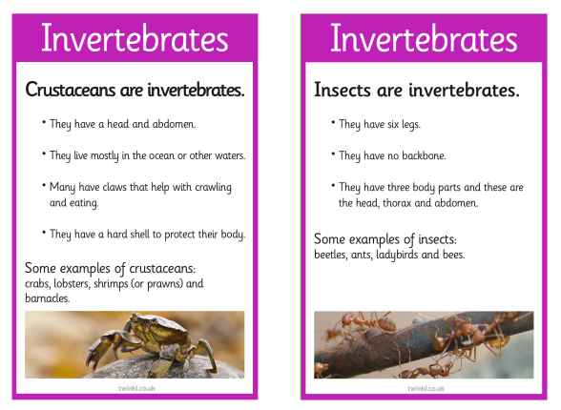

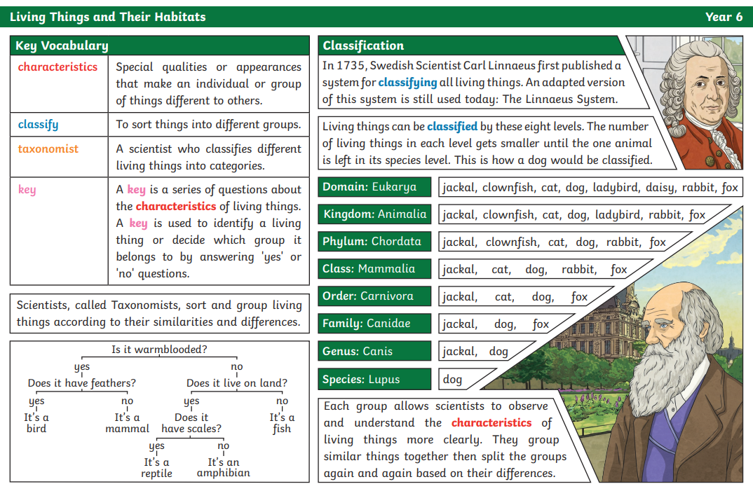

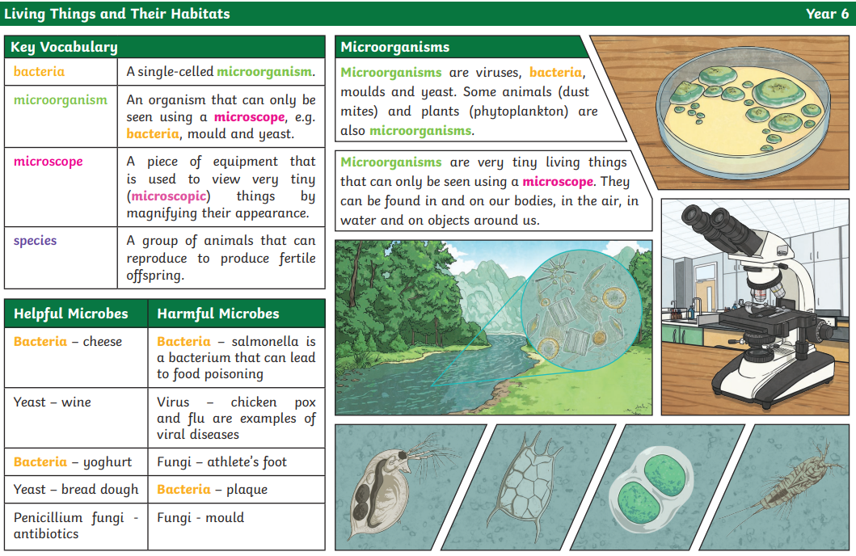
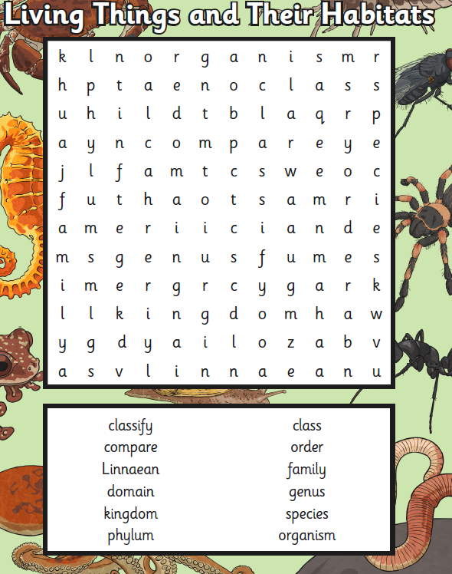

 | Videos | Activity suggestions
Living things and their Habitat | Exploring habitats and classifying living things  https://www.bbc.co.uk/iplayer/episode/m0011f4g/bitesize-daily-79-year-olds-science-89-yearolds-2-habitats  What is a microorganism?  https://www.bbc.co.uk/bitesize/topics/z6wwxnb/articles/zsgtrwx  The work of Carl Linnaeus  https://www.bbc.co.uk/teach/class-clips-video/science-ks2-the-work-of-carl-linnaeus/zhnjf4j | - Visit a gardening centre  - Visit a farm  - Create a poster on Carl Linnaeus  - Create your own classification key (a series of questions that determine an organism's physical characteristics)  e.g.  