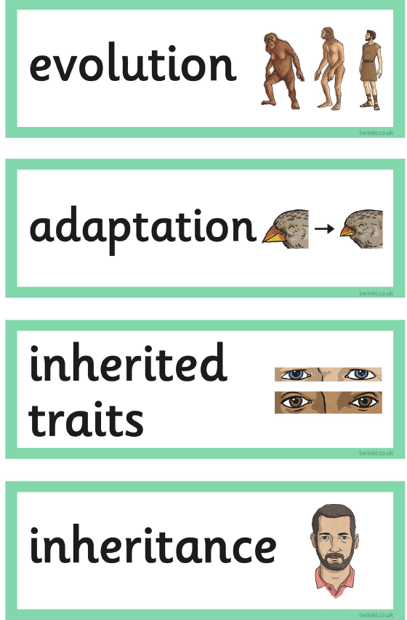
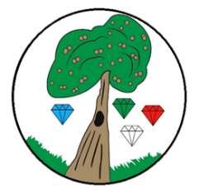
Year: 6 Term: Spring 2
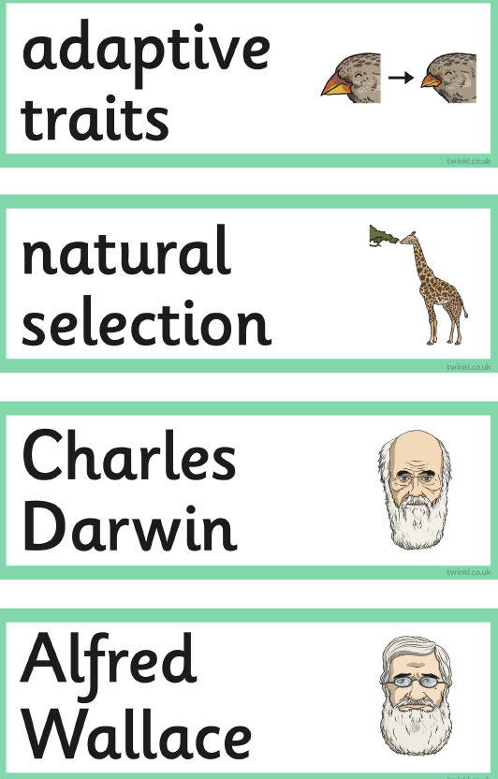

Science: Evolution and Inheritance
Pre-Learning Pack

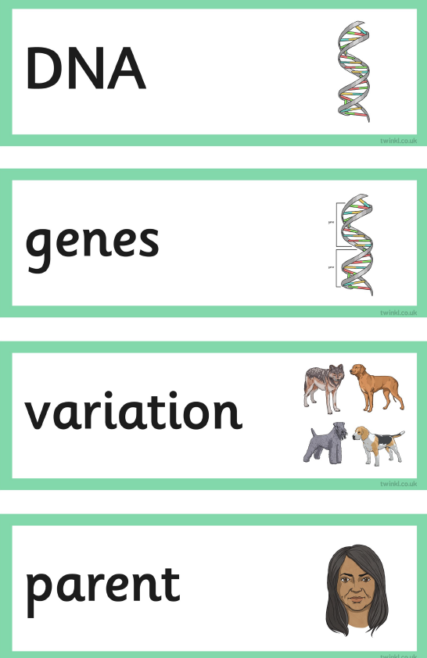
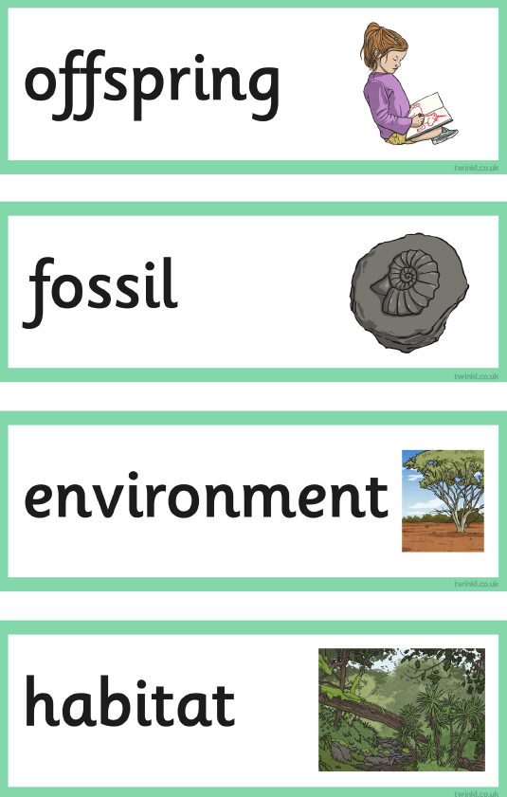

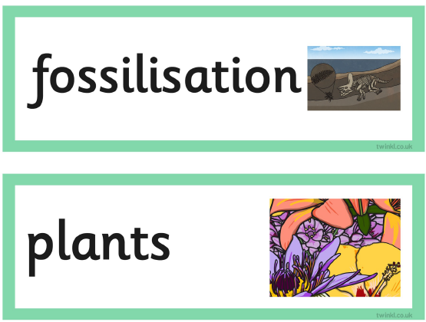
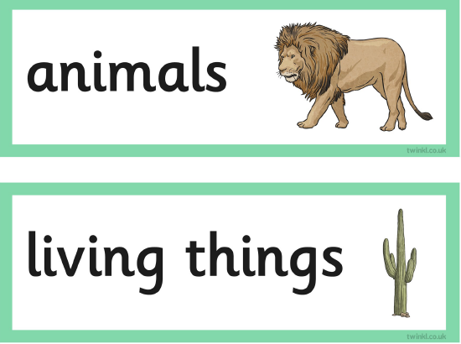

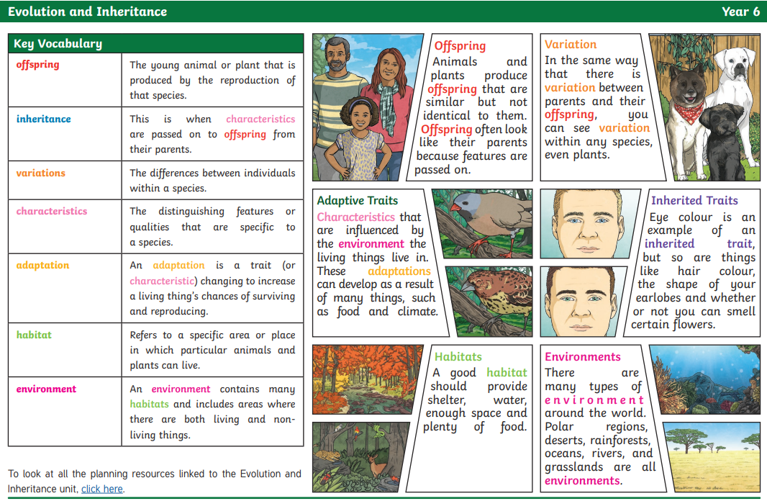

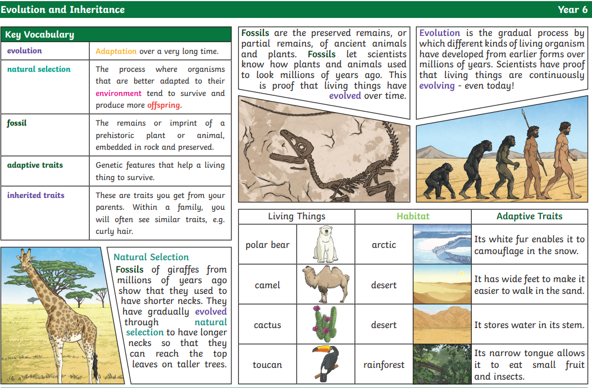

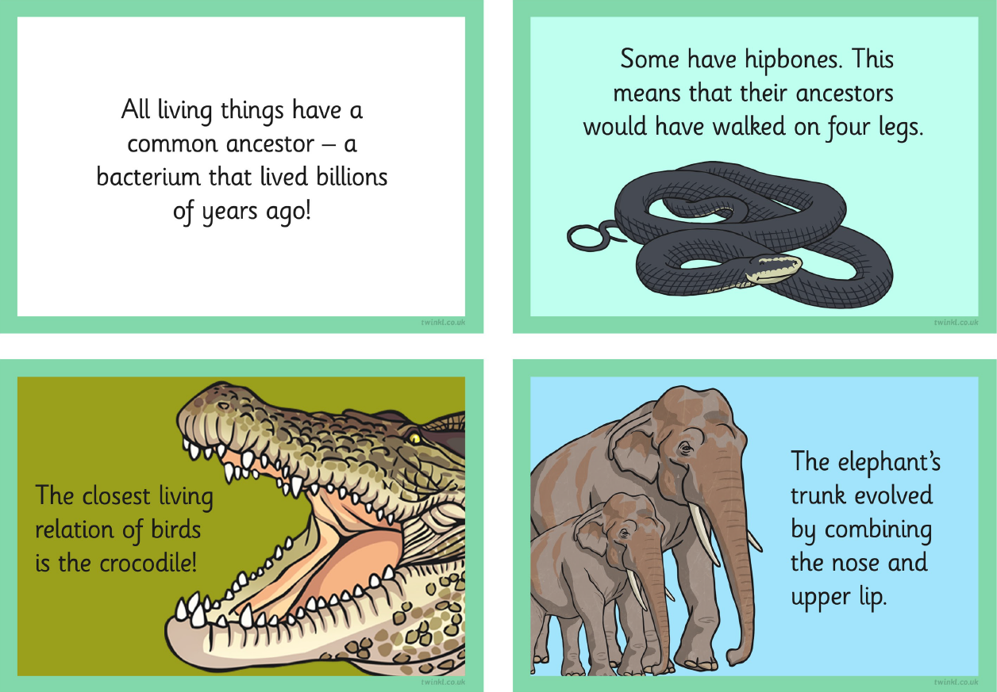

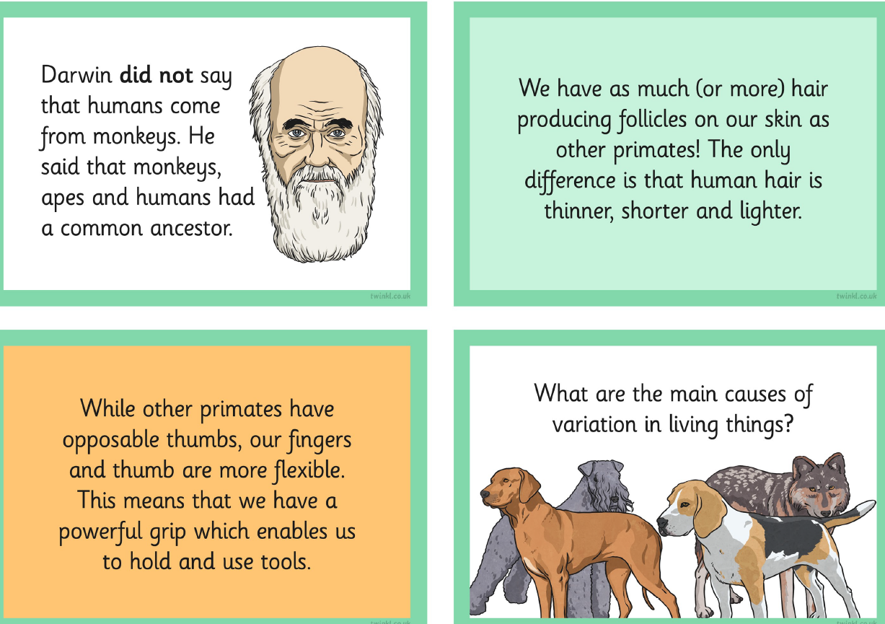

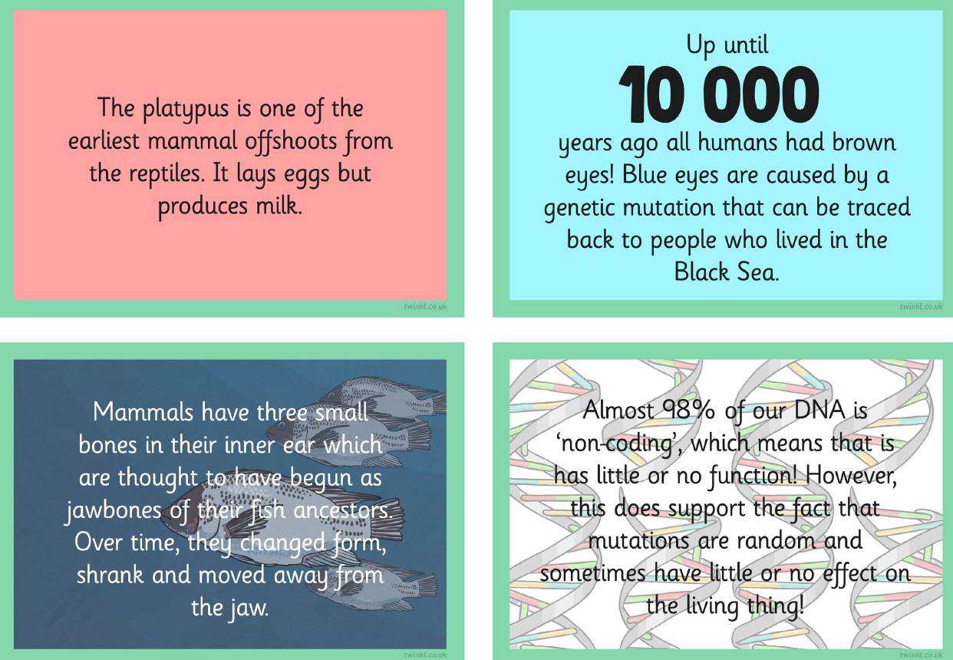

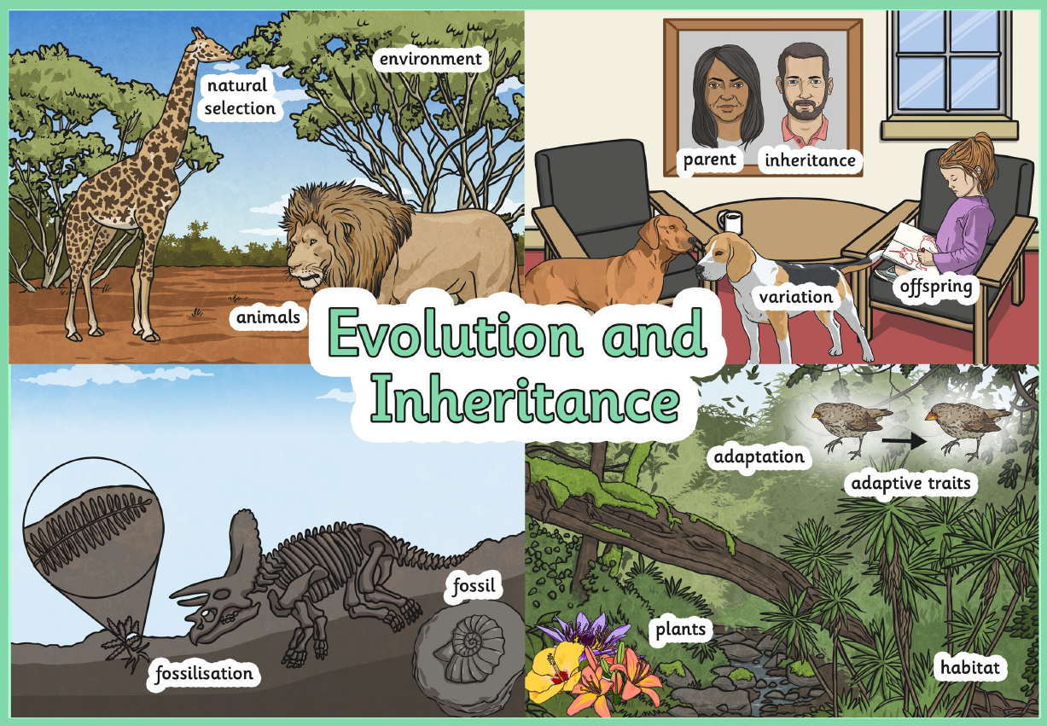

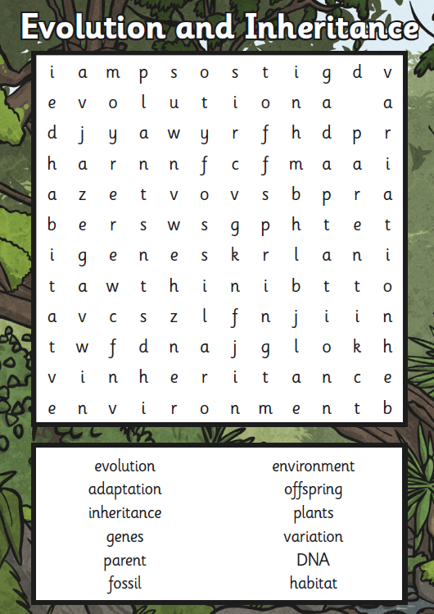

 | Videos | Activity suggestions
Evolution and Inheritance | https://www.bbc.co.uk/iplayer/episode/m0011f1f/bitesize-daily-911-year-olds-science-1011-yearolds-1-adaptation-evolution-and-inheritance  Adaptation, Evolution and Inheritance  https://www.youtube.com/watch?v=vbKpu8QTn5I  Terrific Scientific: What is evolution? | BBC Teach Live Lesson  https://www.youtube.com/watch?v=MCK46f1pStQ  Terrific Scientific: Adaption & Evolution of Living things | BBC Teach Live Lesson  https://www.youtube.com/watch?v=K3F5BV82Lg8  The Story of Inheritance - Dara O Briain's Science Club - BBC Two  https://www.youtube.com/watch?v=YdvDxo3yp70  Year 6 Science - Evolution and Inheritance | Out and about – the local area  - Pupils can design an animal that would thrive in their local environment.  Out and about  - Visit the Natural History Museum in London and take a self-guided tour and/or book onto their 45 minute ‘Evolution Workshop’

