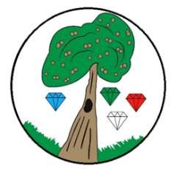
Year: 6 Term: Summer 1

Science: Animals including Humans
Pre-Learning Pack
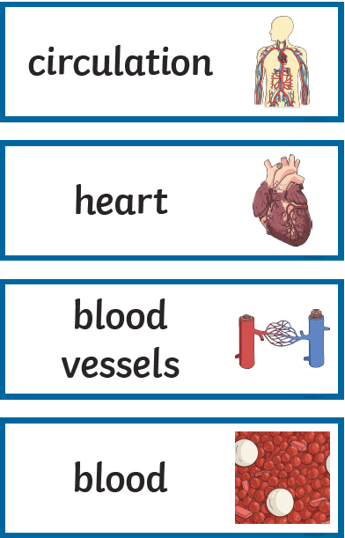

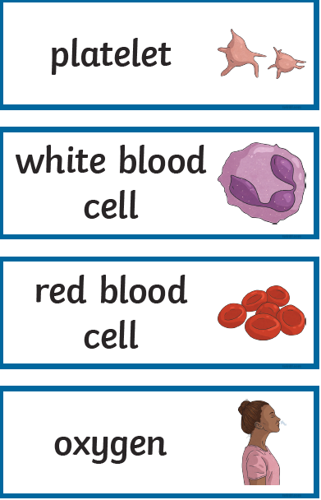
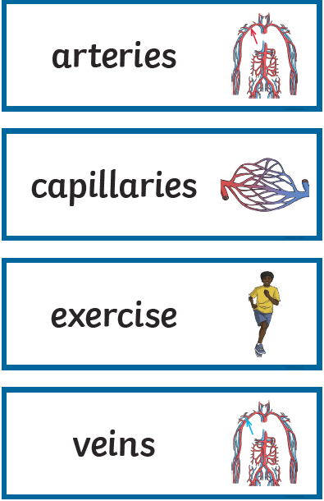
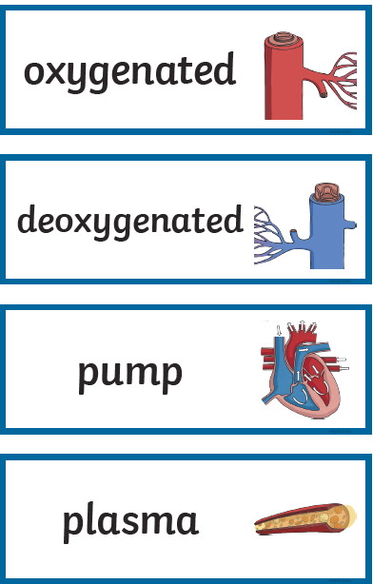

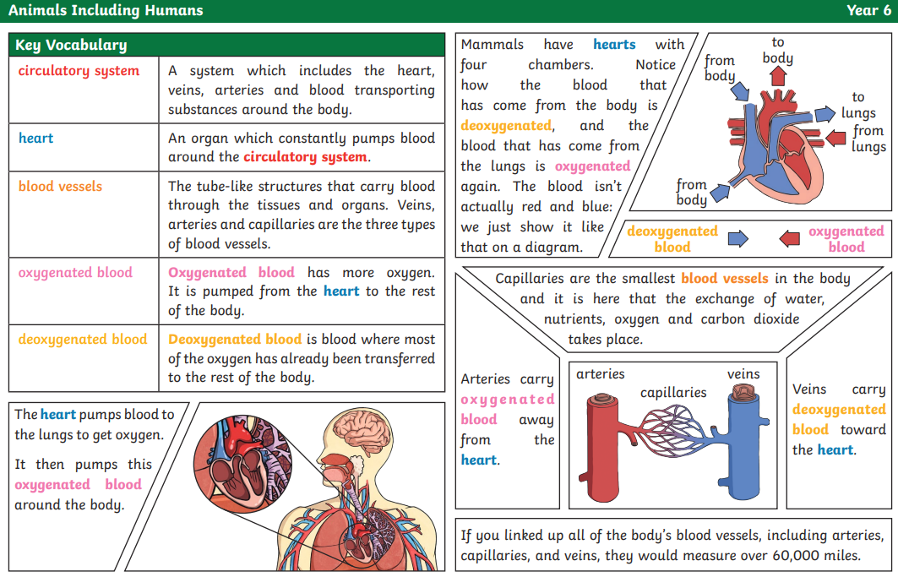

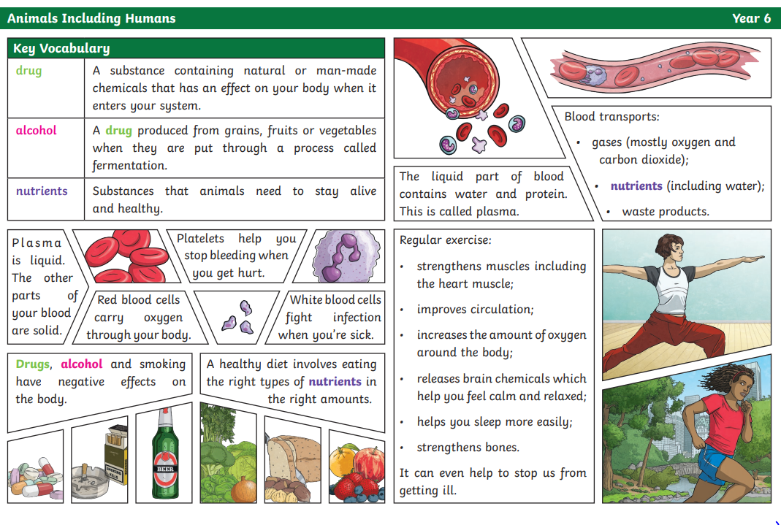

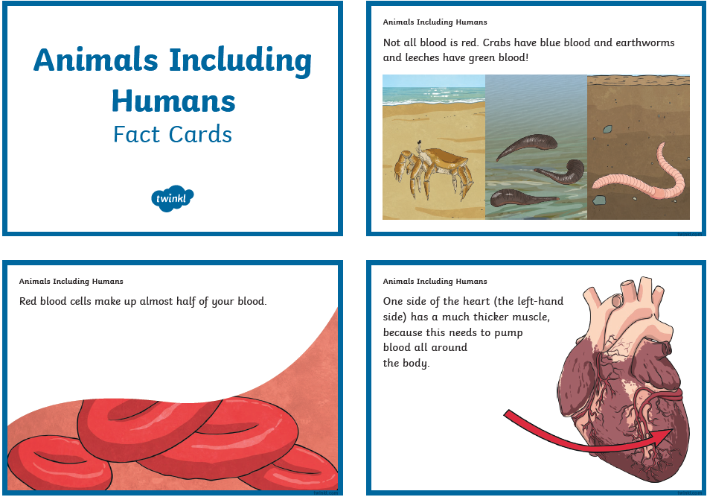

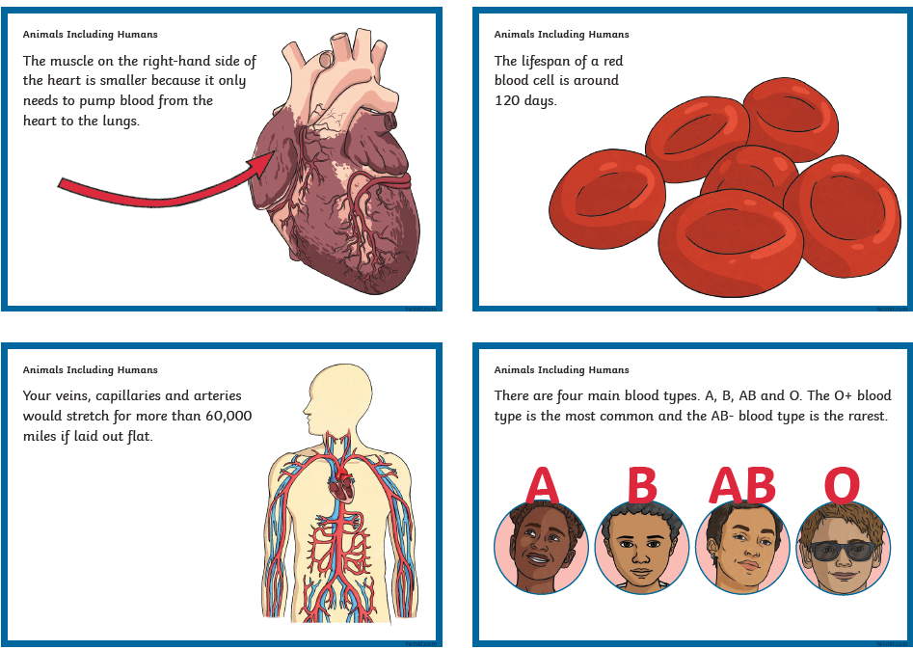

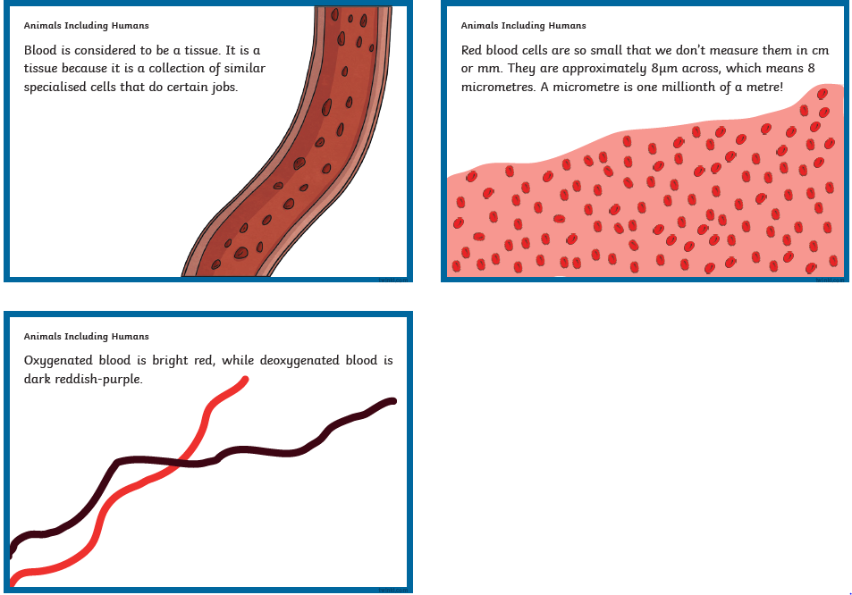

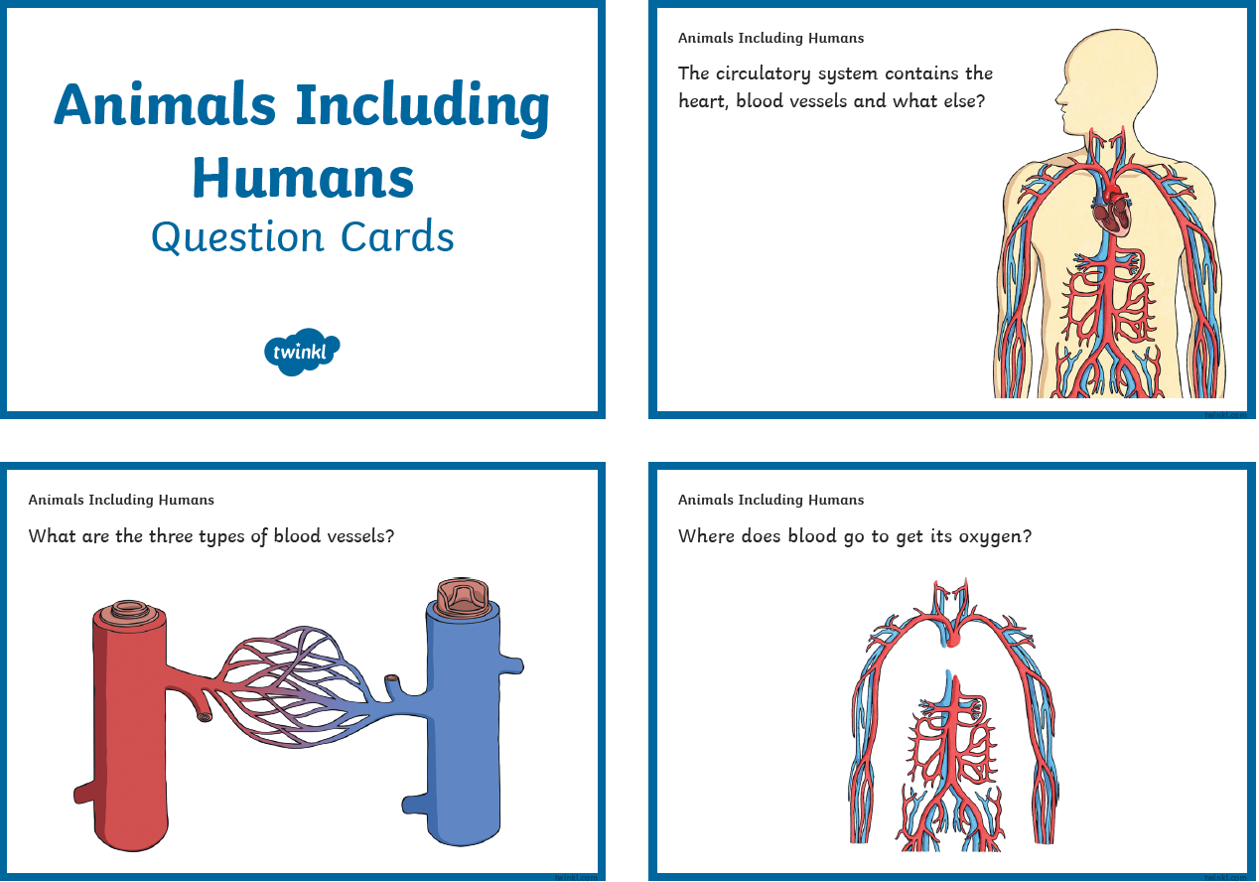

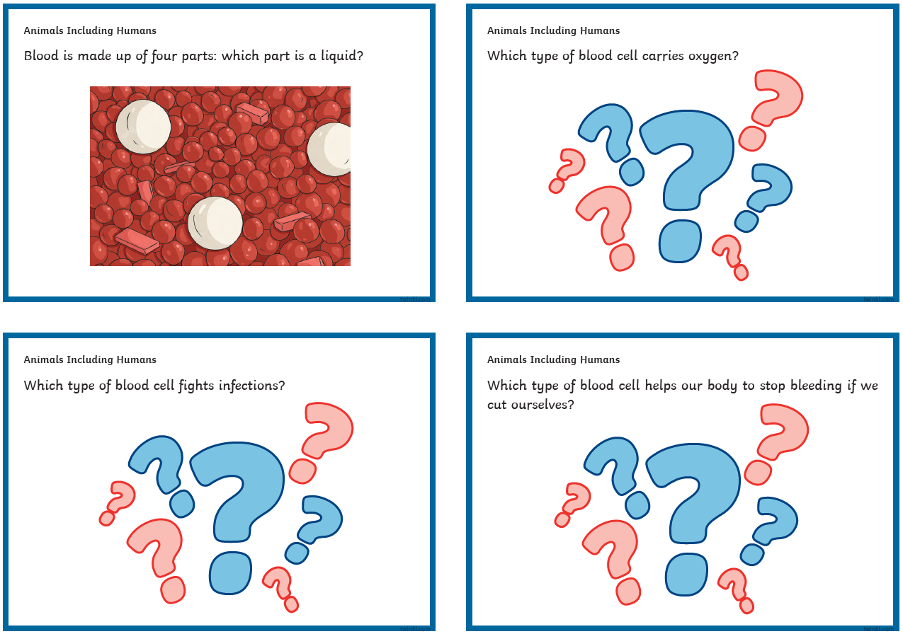

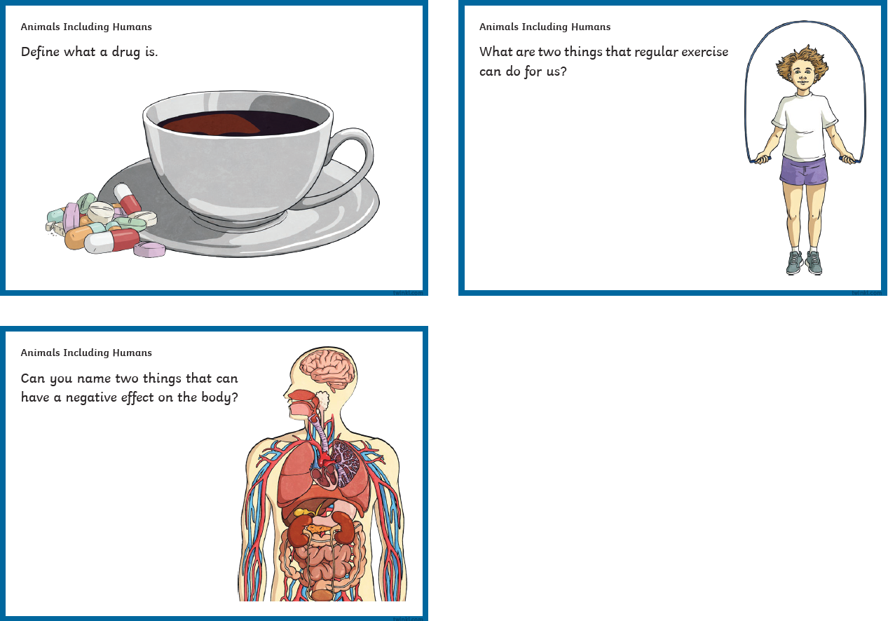

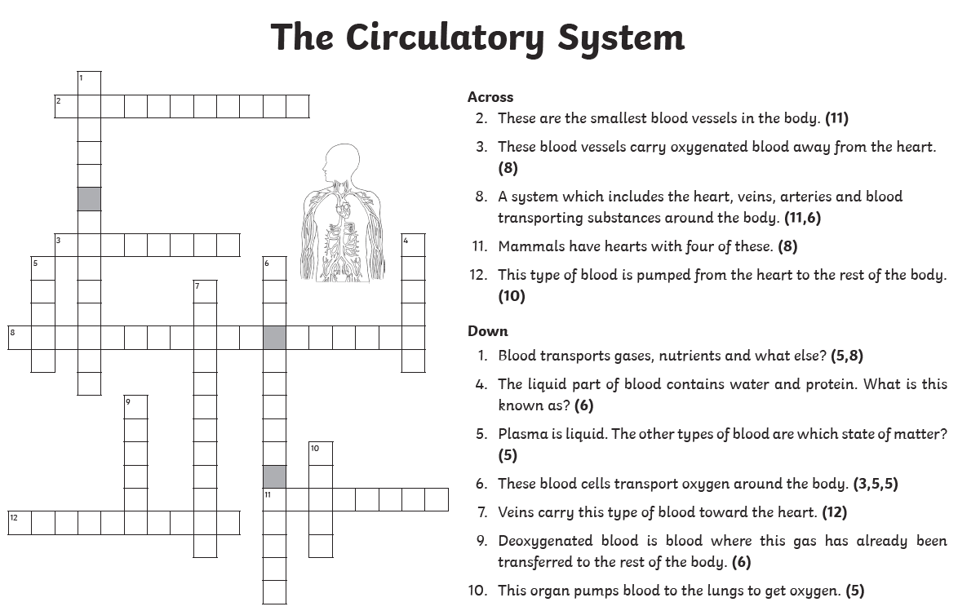
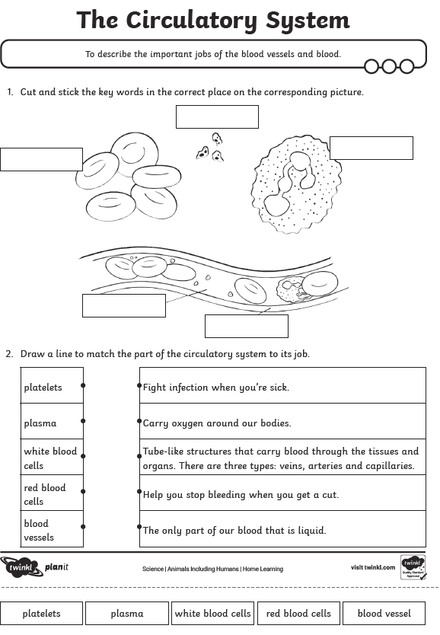

 | Videos | Activity suggestions
Animals including  Humans | The circulatory system  https://www.youtube.com/watch?v=mC7-XXmbF90  The circulatory system - BBC Bitesize  https://www.bbc.co.uk/bitesize/topics/zcyycdm/articles/z9w9r2p  Watch animation of William Harvey’s discovery  https://www.youtube.com/watch?v=bIGB8aooakE  Transport of nutrients and water – BBC Bitesize  https://www.bbc.co.uk/bitesize/articles/zsgk4xs | Visit a museum e.g. Horniman museum to observe different animals  Make a poster to explain the circulatory system  Out and about – further afield  - Visit the world’s largest display dedicated to the story of medicine  at the Science Museum, London.

