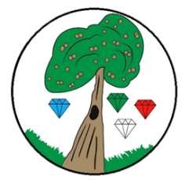
Year: 5 Term: Autumn 1

Science: Properties and Changes of Materials
Pre-Learning Pack
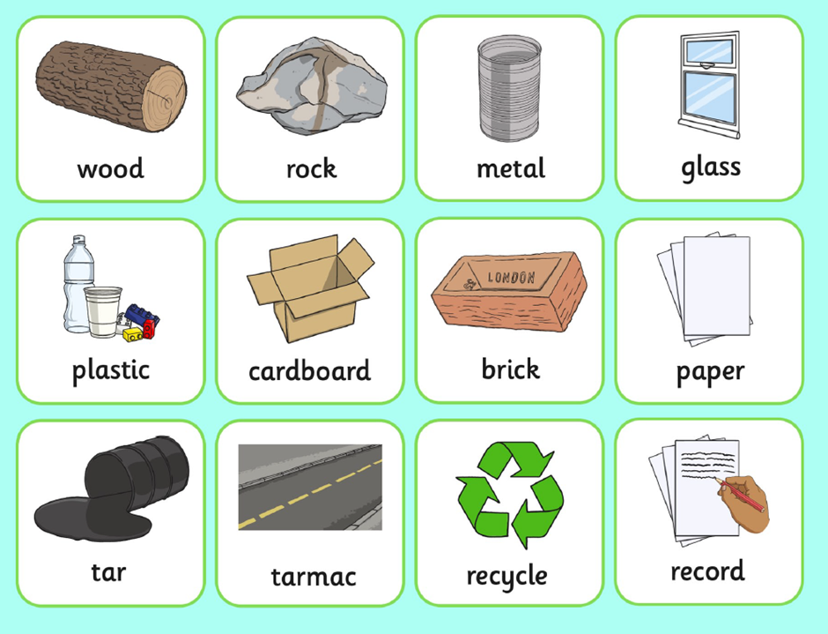

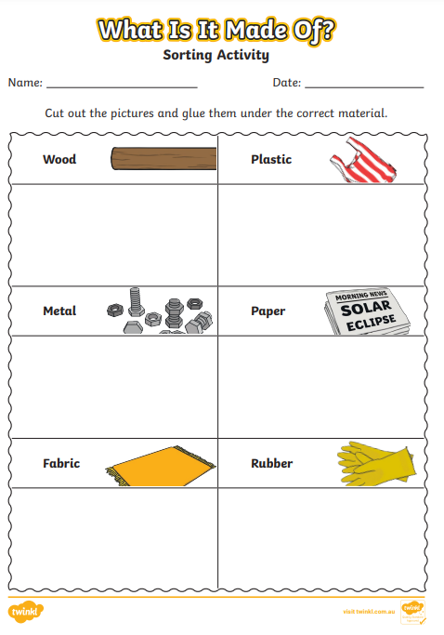
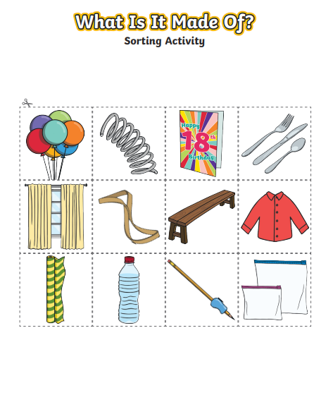

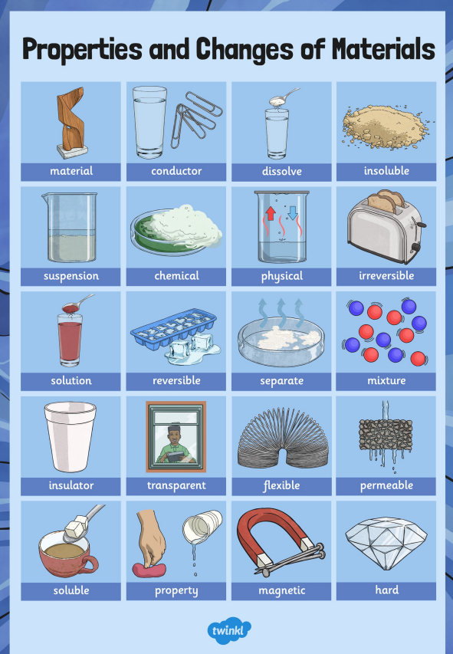

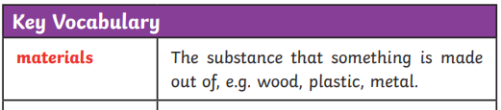
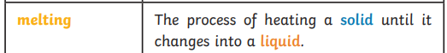

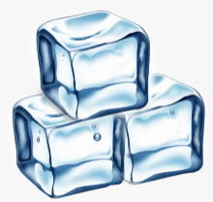

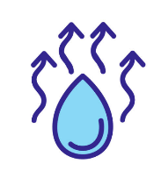
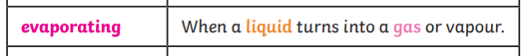

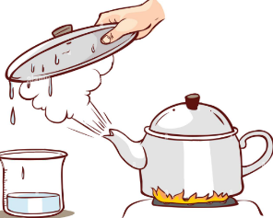
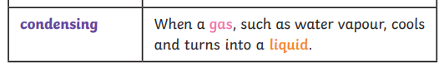

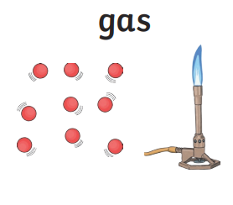
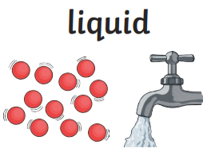
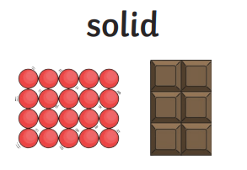
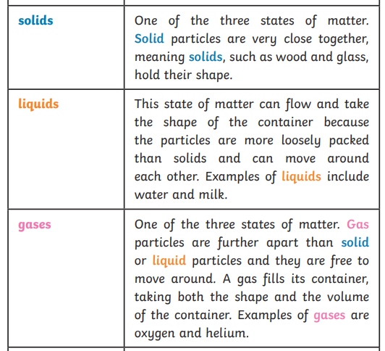
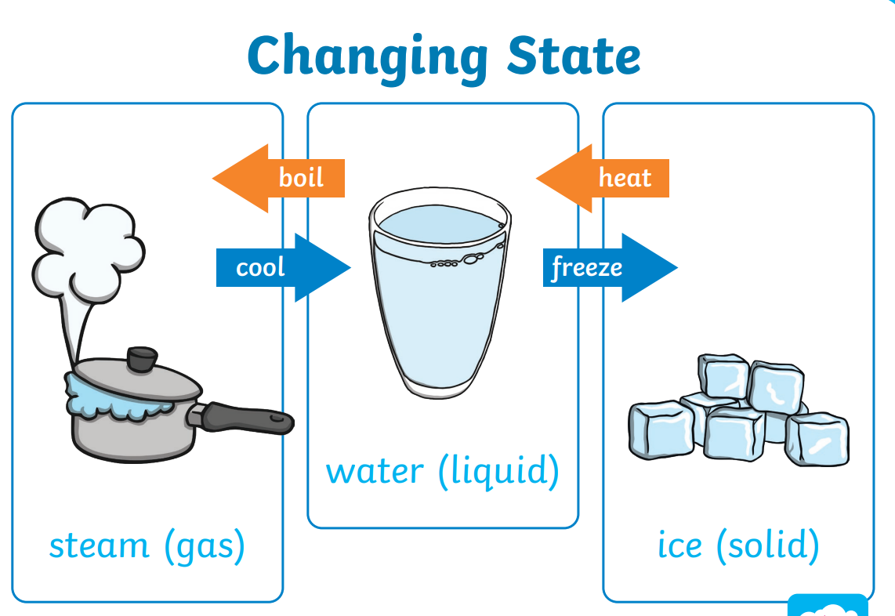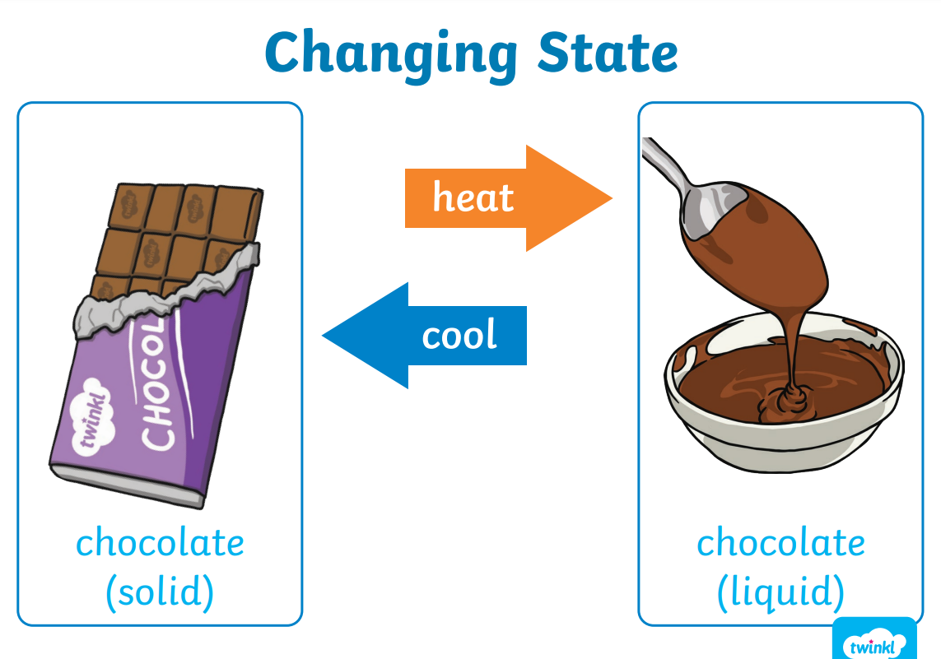
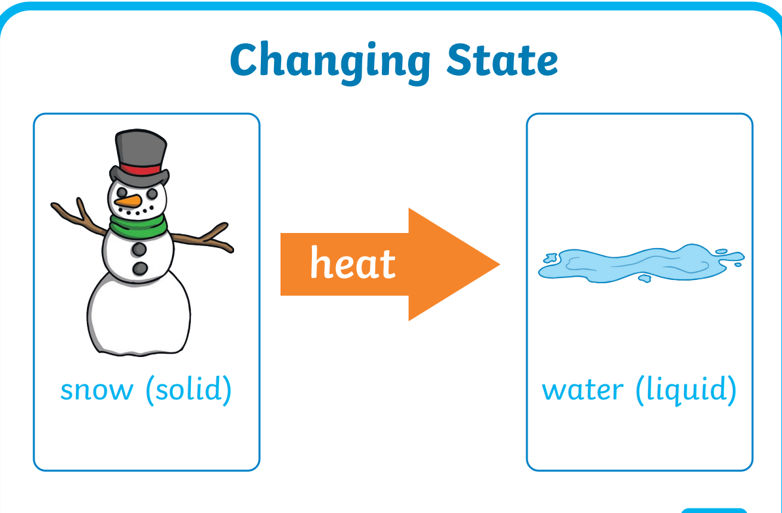
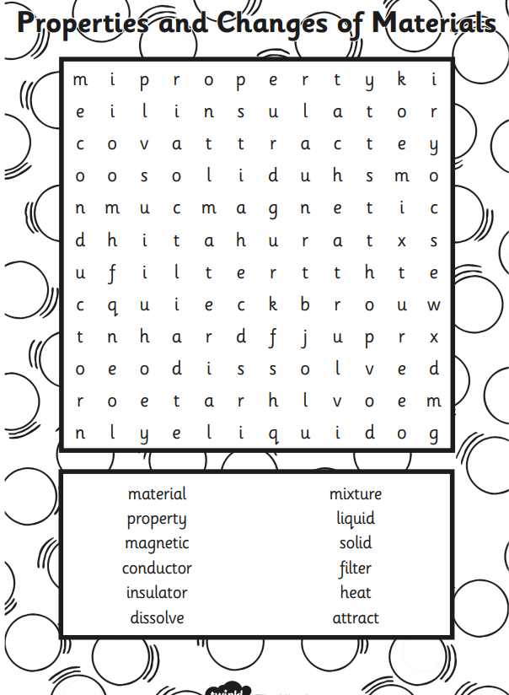

 | Videos | Activity suggestions
Properties and changes of materials | How to Identify Materials  https://www.bbc.co.uk/bitesize/topics/zryycdm/articles/zk2d96f  Separation  https://www.bbc.co.uk/bitesize/topics/zryycdm/articles/zsgfp4j  Chemical Reactions and Reversible Changes  https://www.bbc.co.uk/bitesize/topics/zryycdm/articles/z7dcbqt  Understanding reversible change with chocolate  https://www.stem.org.uk/resources/elibrary/resource/34080/understanding-reversible-change  Solids, liquid, gases dance  https://www.youtube.com/watch?v=3IW8E1YR0kE  Simple materials video  https://www.youtube.com/watch?v=340MmuY_osY&t=157s | - Word search  - Object hunt at home- what can you find and what properties does it have and why they were chosen for that object  - Cooking and baking with reversible and irreversible changes e.g. melting chocolate  - What dissolves in water experiment https://littlebinsforlittlehands.com/which-solids-dissolve-in-water-chemistry/

