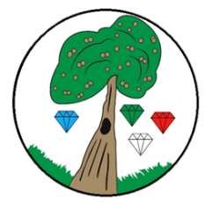
Year: 5 Term: Spring 2

Science: Living Things and their Habitats
Pre-Learning Pack
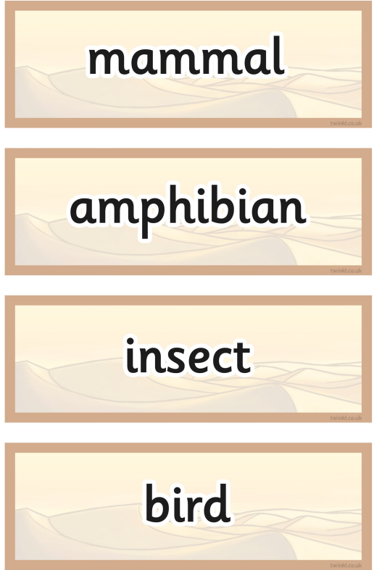
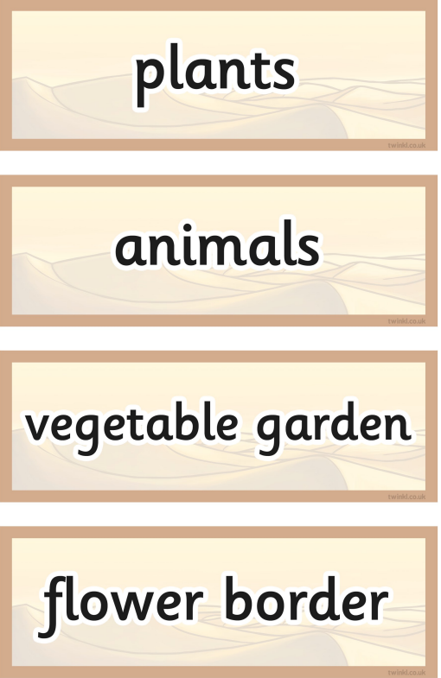
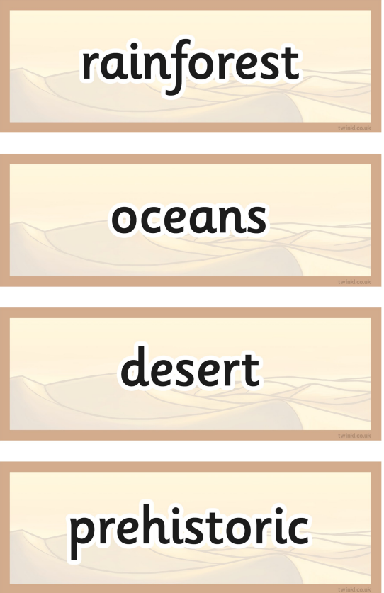
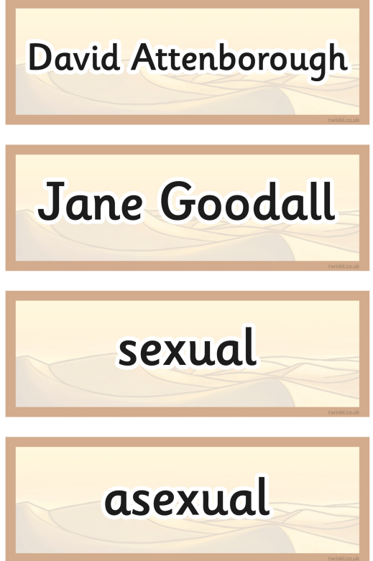

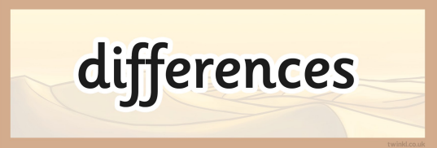
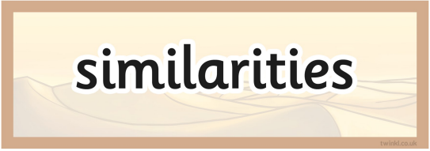

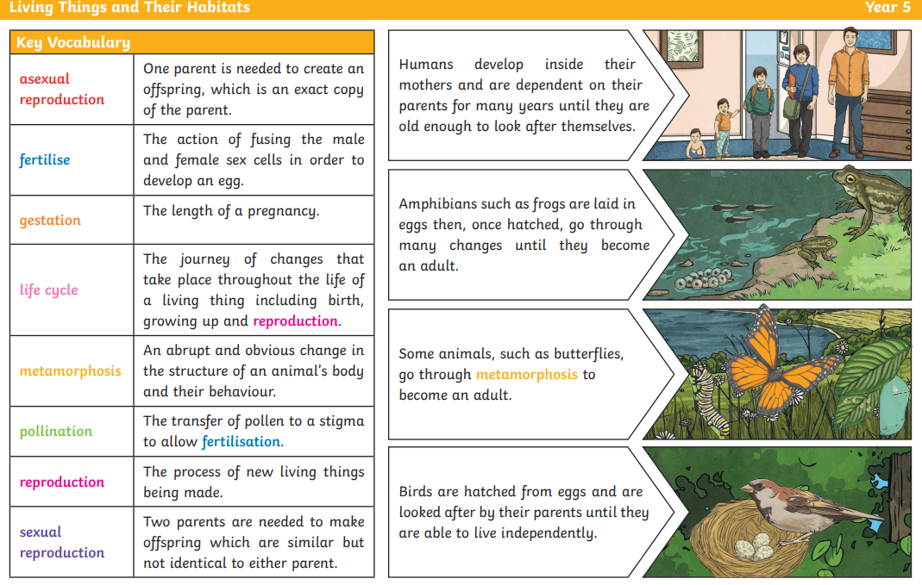

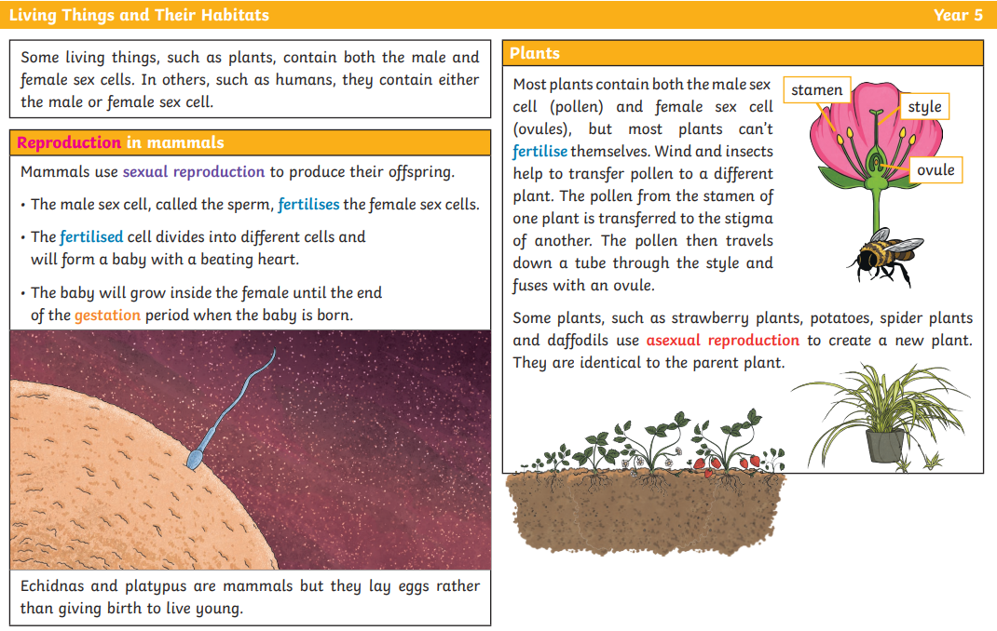

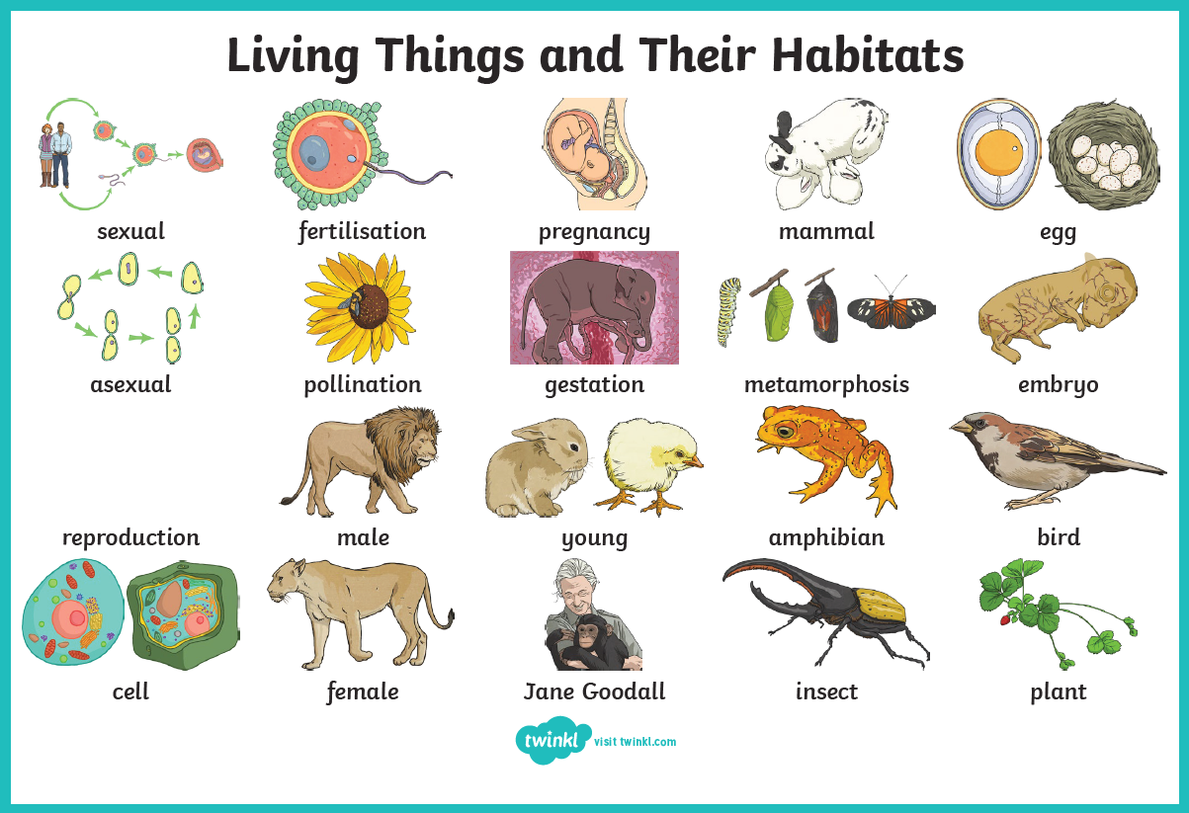

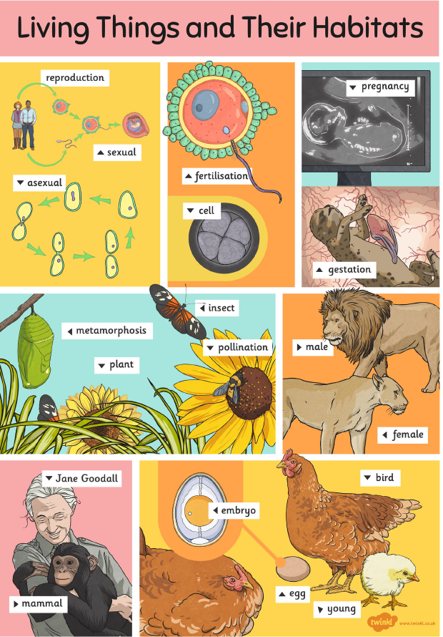

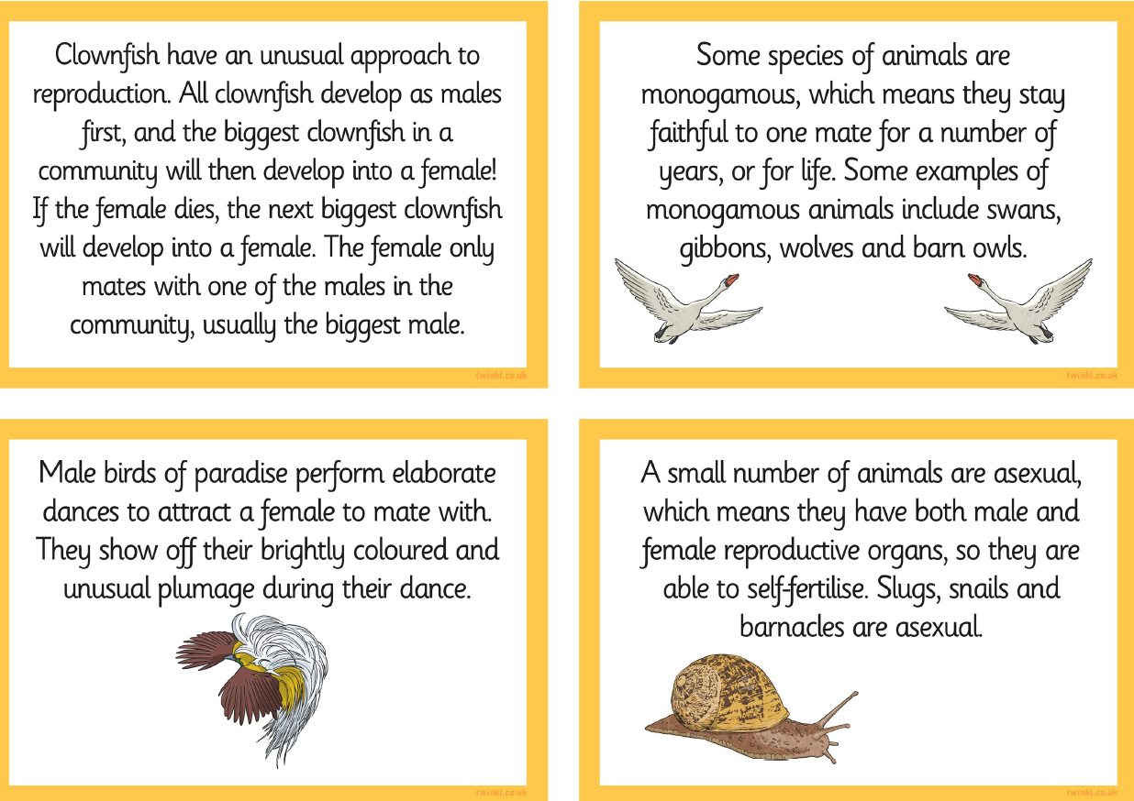

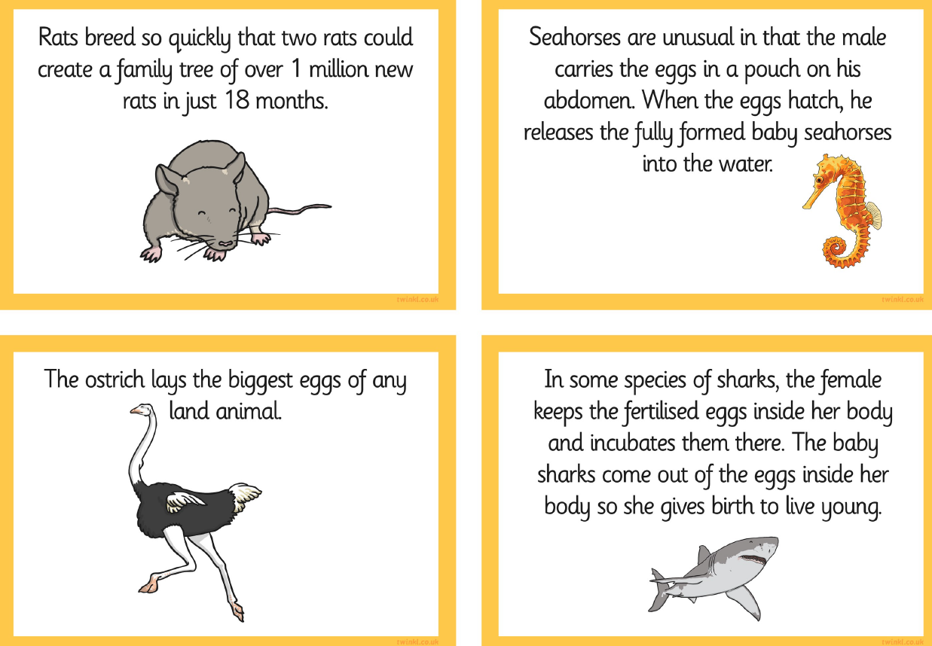

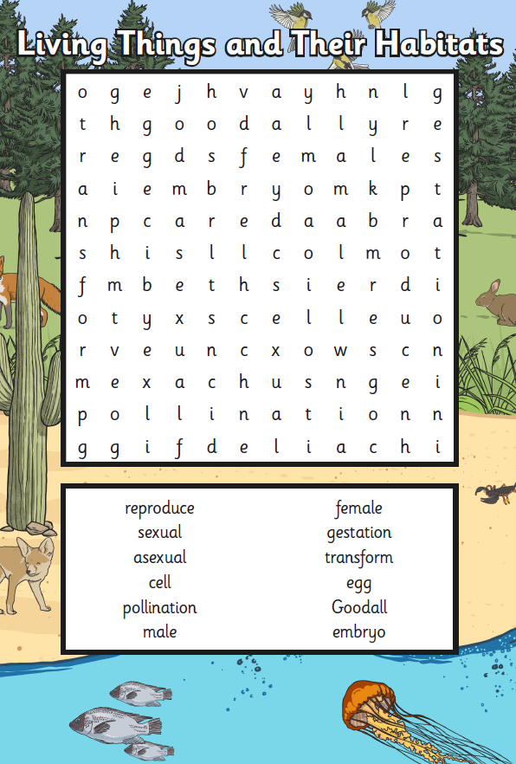

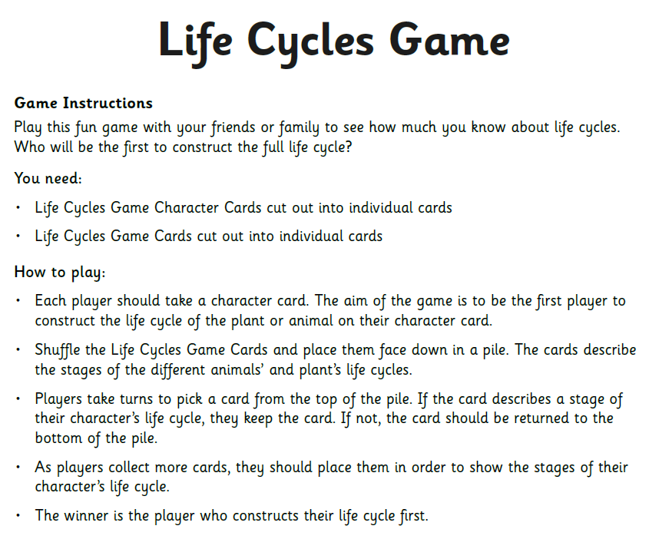
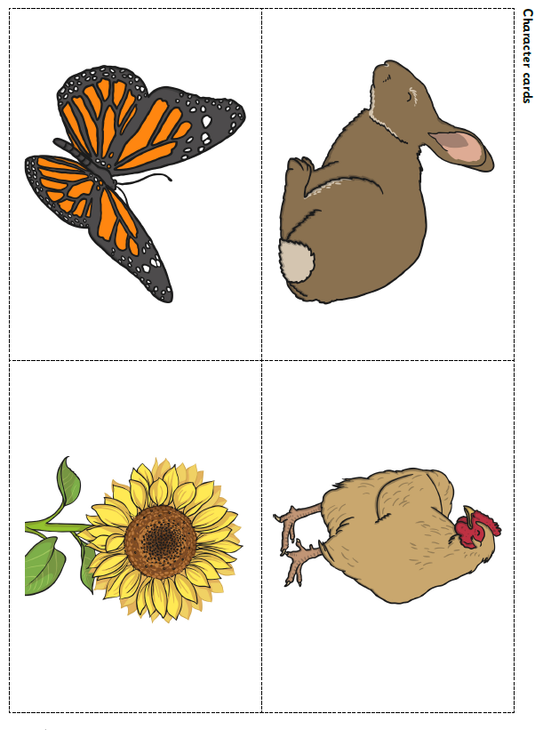

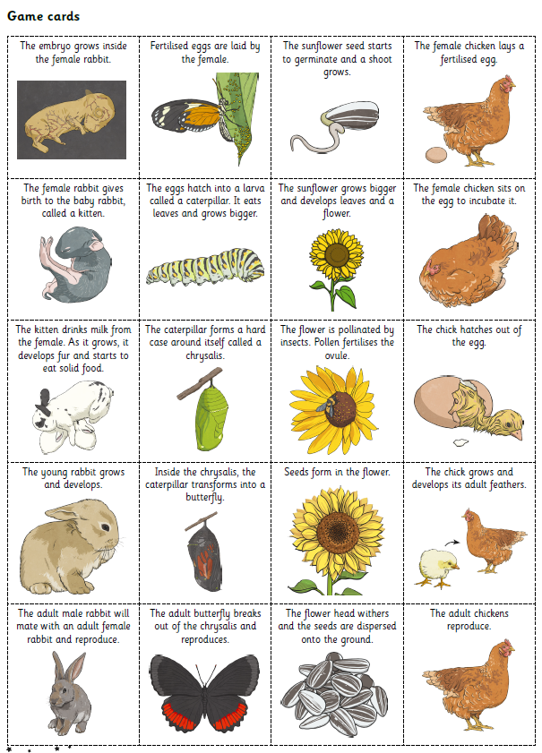

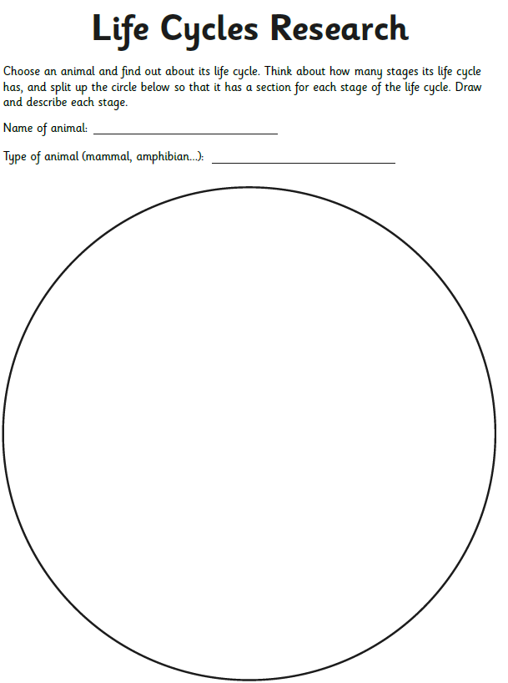

 | Videos | Activities
Living Things and their Habitats | Life cycles of various living organisms | Biology – Life Lessons  https://www.youtube.com/watch?v=CH_YkA6Deo4  What is a lifecycle?  https://www.bbc.co.uk/bitesize/topics/z6wwxnb/articles/zdvhxbk  David Attenborough - Wonderful World - BBC  https://www.youtube.com/watch?v=B8WHKRzkCOY  How Animals Reproduce  https://www.bbc.co.uk/bitesize/topics/z6wwxnb/articles/zsq9r2p | - Visit a gardening centre  - Visit a farm  - Write your own biography about Goodall’s life and work  - Create a classification grid  