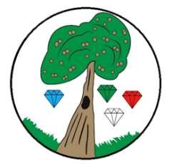Year**: 5** Term**: Spring**

**Science: Forces**

Pre-Learning Pack

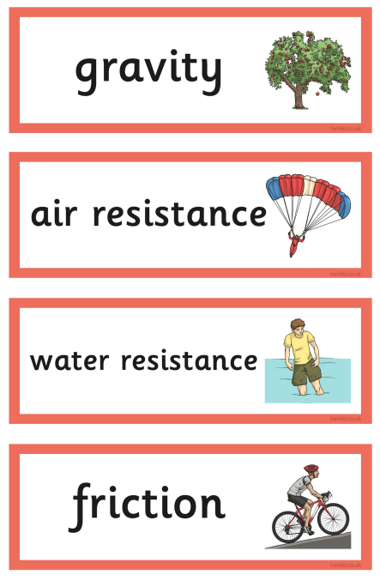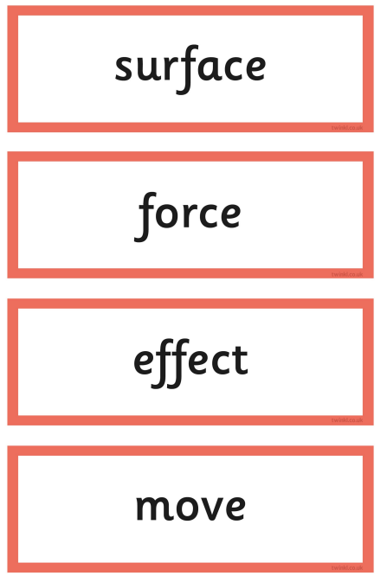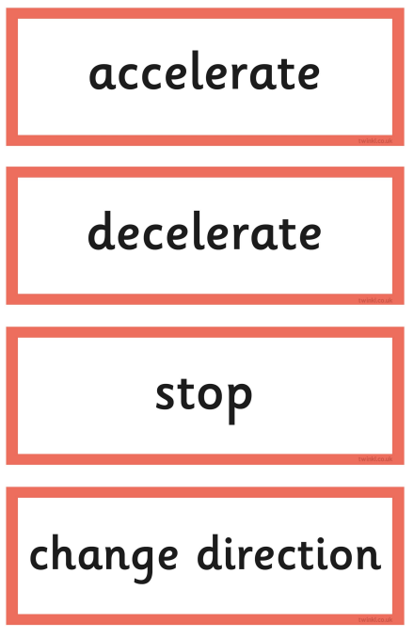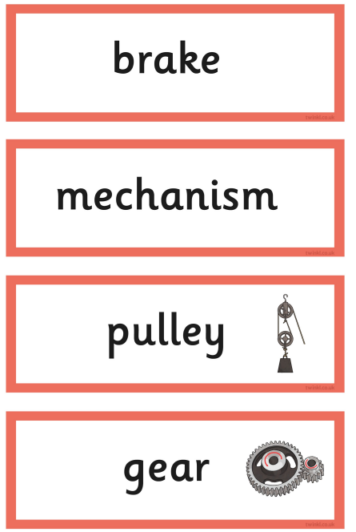

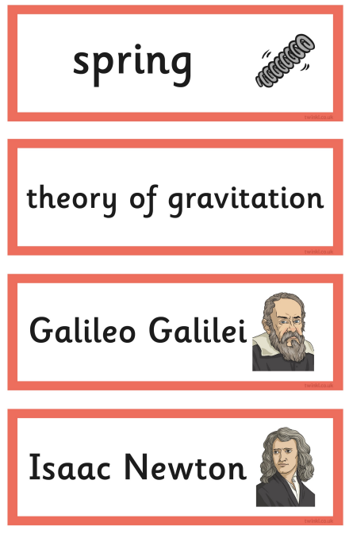 

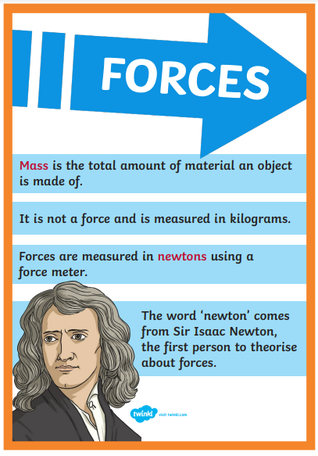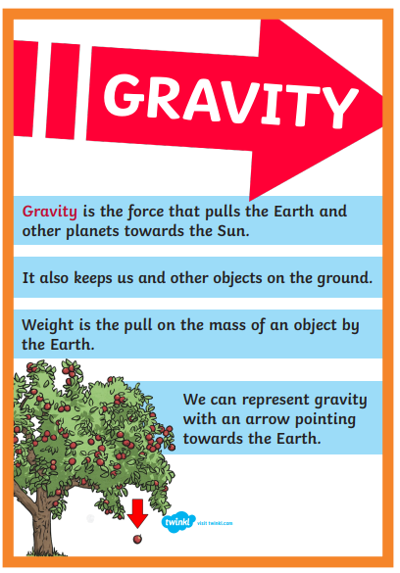

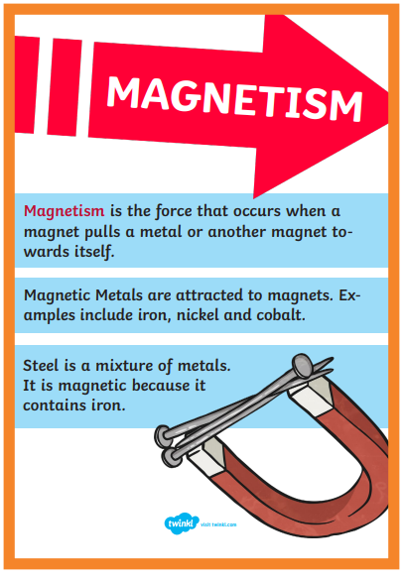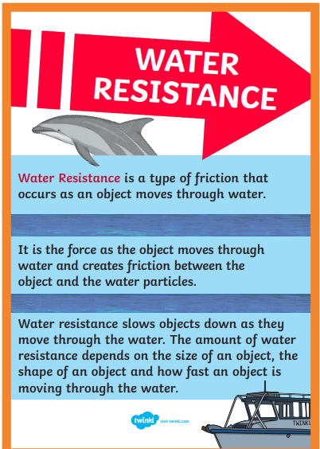

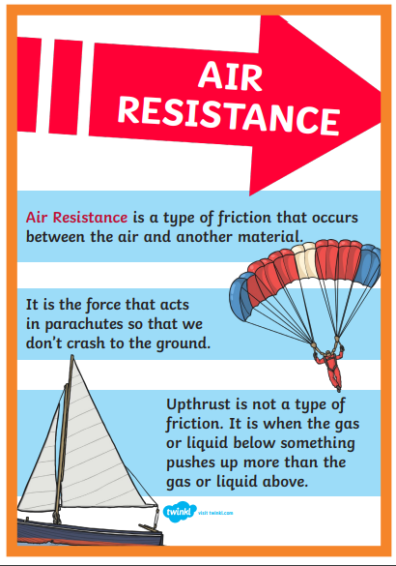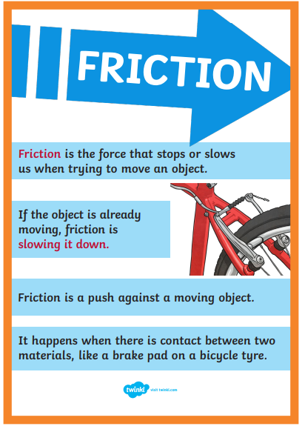

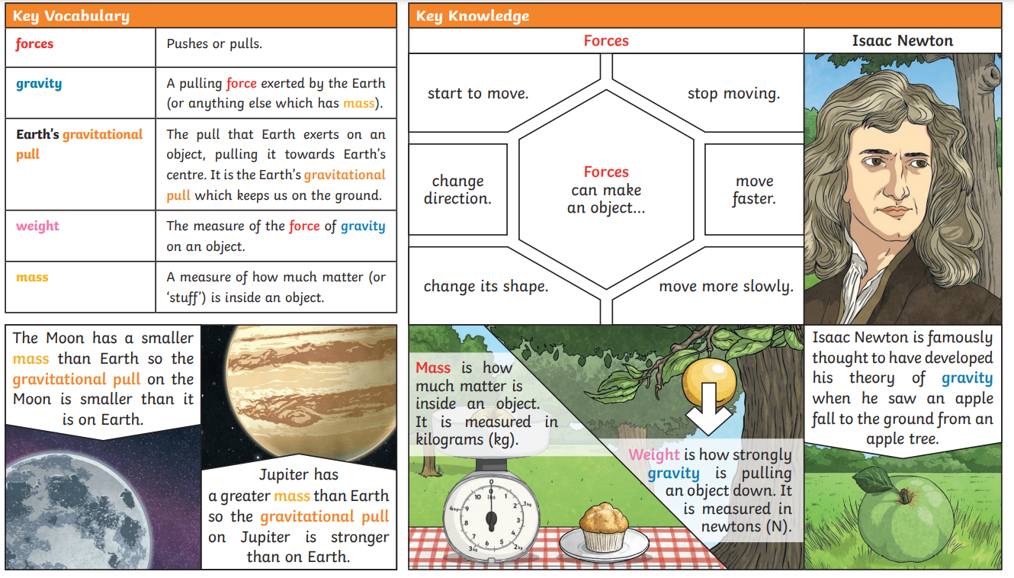

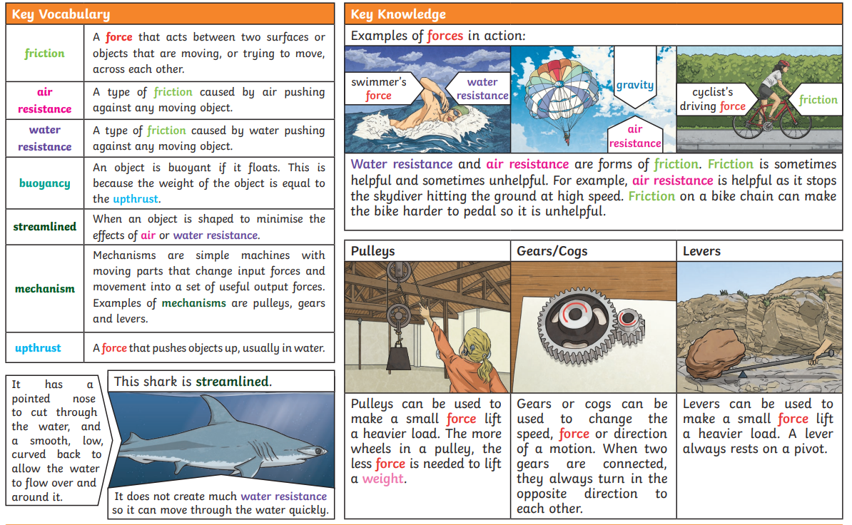

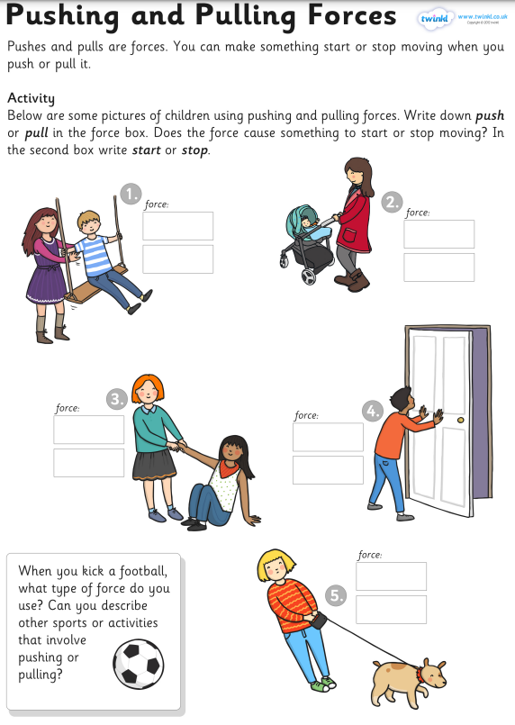

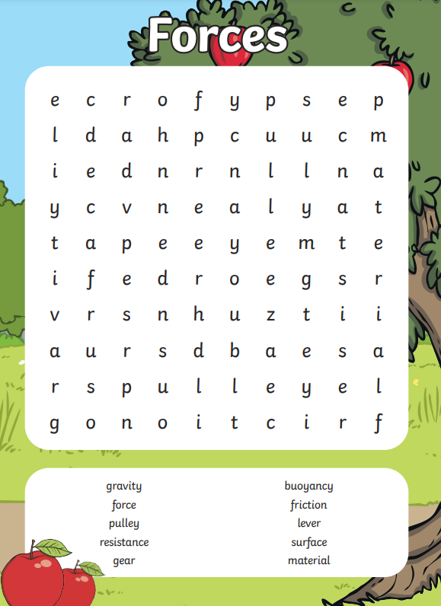

|  |  |  |
| --- | --- | --- |
|  | **Videos** | **Activities** |
| **Forces** | Friction*https://www.bbc.co.uk/bitesize/topics/znmmn39/articles/zcmwkty* Air and Water Resistance  [*https://www.bbc.co.uk/bitesize/topics/znmmn39/articles/zb784xs*](https://www.bbc.co.uk/bitesize/topics/znmmn39/articles/zb784xs)  *Forces sing*  [*https://www.youtube.com/watch?v=-lOyW3pEUl0*](https://www.youtube.com/watch?v=-lOyW3pEUl0) | * Visit the science museum   Timing   * Experimenting with wheeled toys on different surfaces e.g. carpet glass mirror. Can you use a timer to compare them? * Rolling a ball down different surfaces |