Year 5 Term: Summer 1

Science: Forces
Pre-Learning Pack
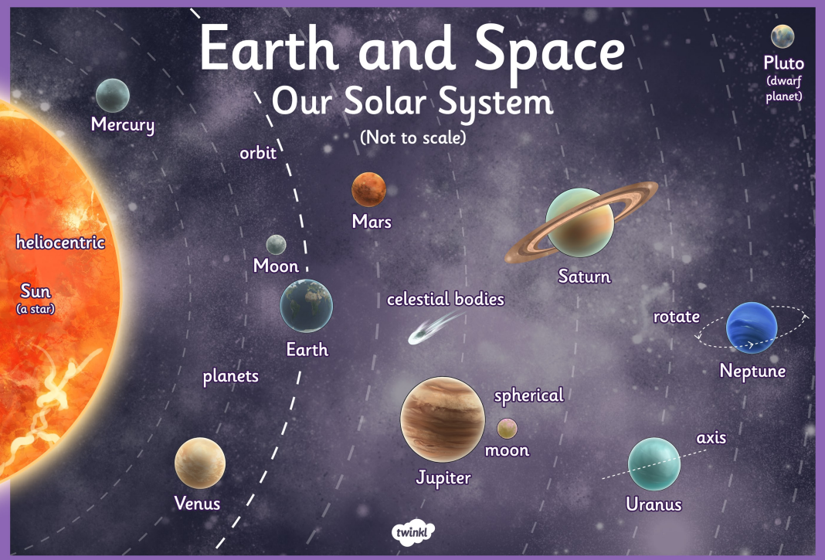
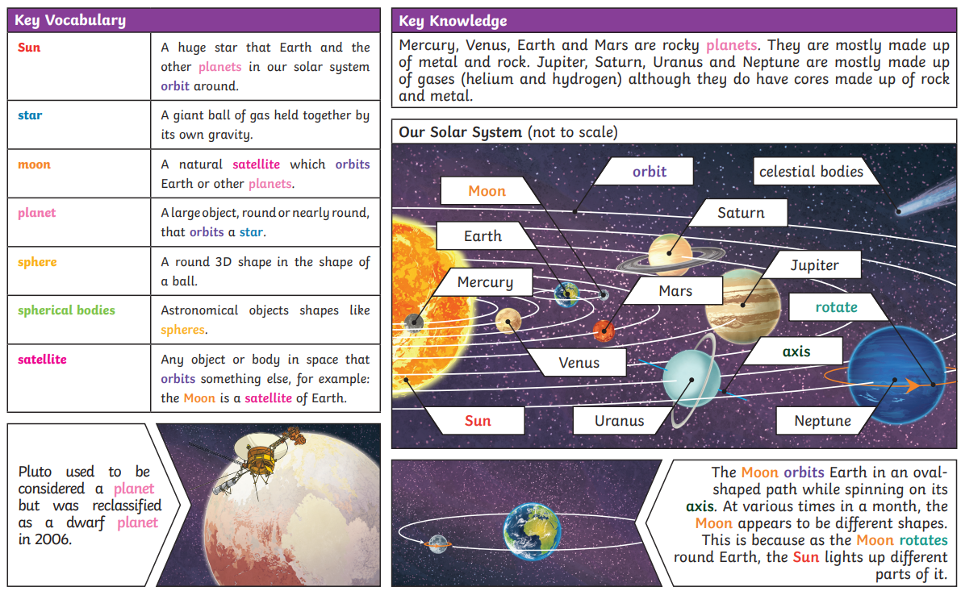

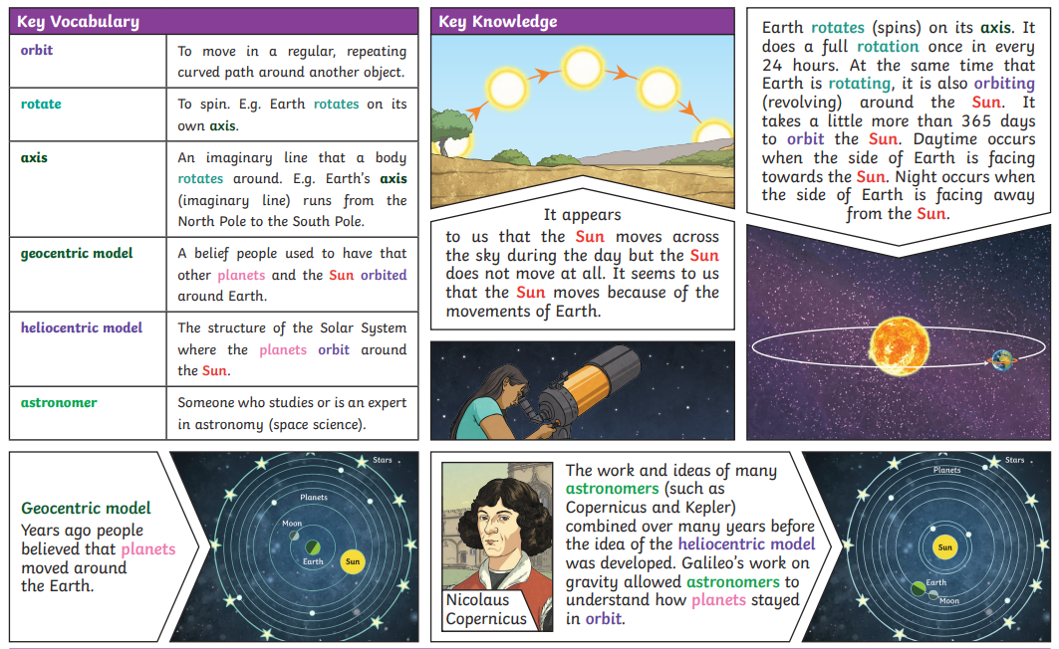

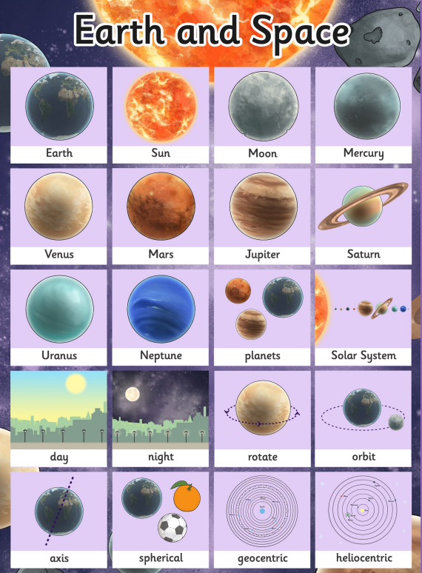
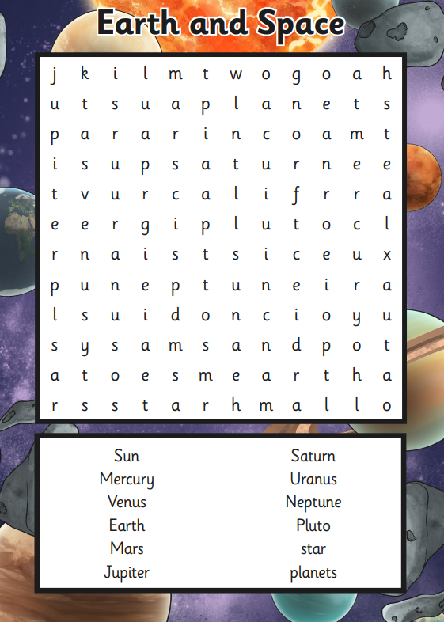
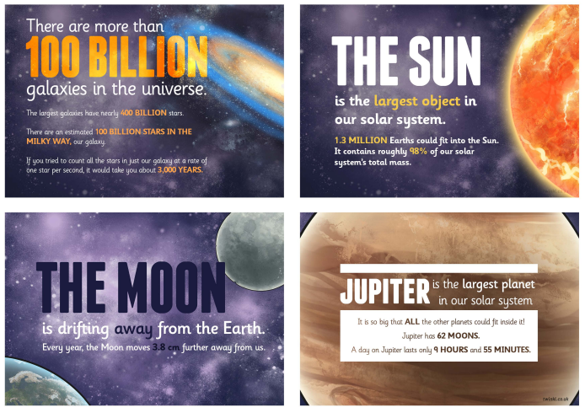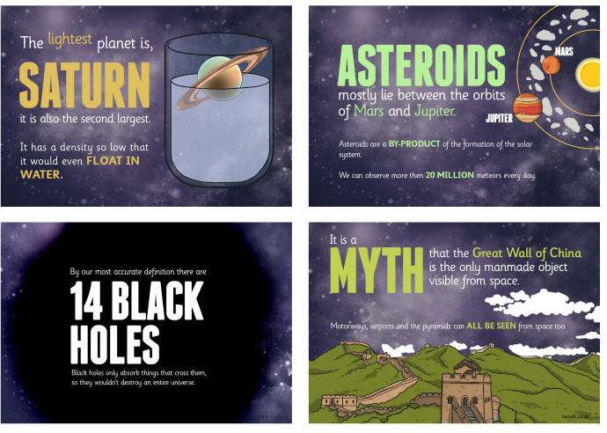

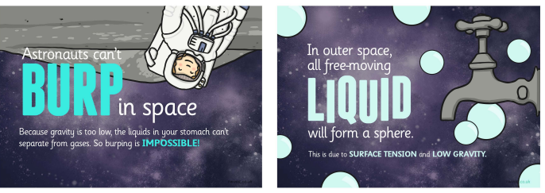

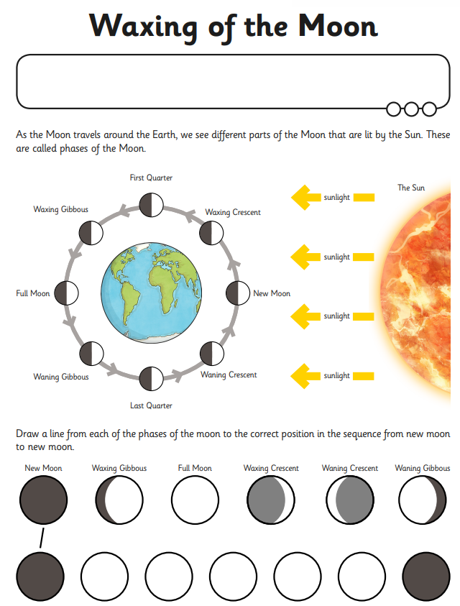
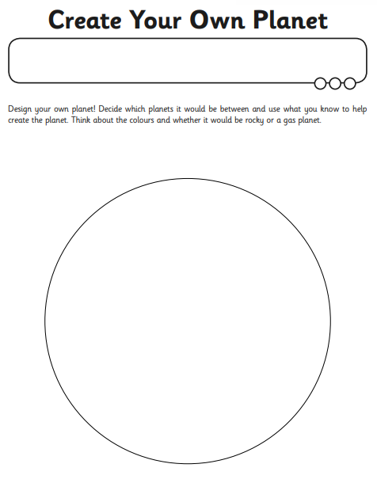
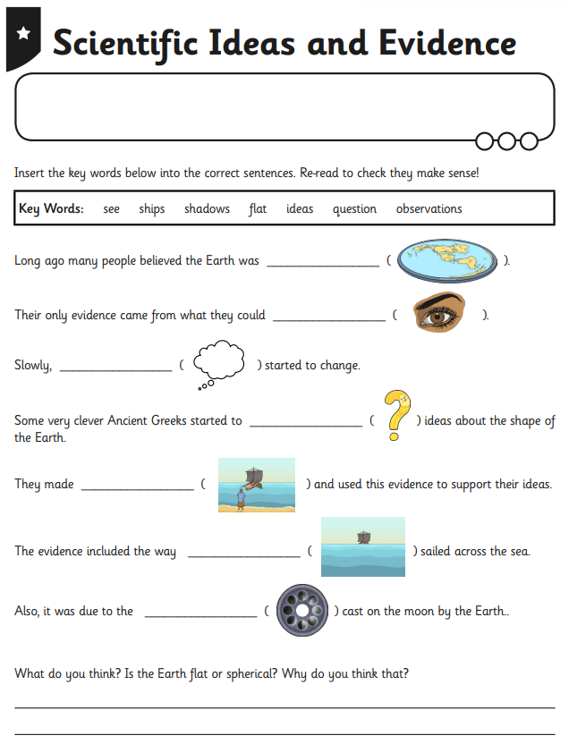

 | Videos | Activities
Forces | What is Earth?  https://www.bbc.co.uk/bitesize/topics/zkbbkqt/articles/zppmqfr  What is the solar system?  https://www.bbc.co.uk/bitesize/topics/zkbbkqt/articles/zsnx7yc  The Sun  https://www.bbc.co.uk/bitesize/topics/zkbbkqt/articles/zbh2jsg  The Moon  https://www.bbc.co.uk/bitesize/topics/zkbbkqt/articles/z3b3ydm  BBC Bitesize selection of videos:  https://www.bbc.co.uk/bitesize/topics/zkbbkqt | Make paper mache planets  https://www.youtube.com/watch?v=M7iokGsaYus  Make the solar system from fruit:  https://www.youtube.com/watch?v=yfSzf2QVJ0I  Sun, Earth and Moon orbit activity:  https://www.youtube.com/watch?v=yQFUtbSBYaE  Out and about:  Visit the Science Museum and see the Free Object Gallery that has some fascinating objects from space missions https://www.sciencemuseum.org.uk/see-and-do/exploring-space

