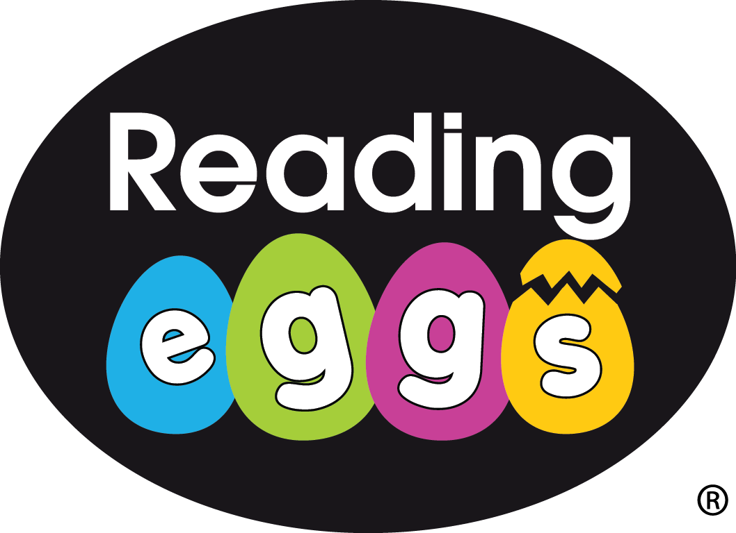

**Places you could visit**

The Temple of Mithras- 12 Walbrook, London EC4N 8AA

The Roman London wall in Tower Hill.

Guildhall Art Gallery (remains of a Roman Amphitheatre on site).

* British Museum

**Topic Words**

Do you know what these words mean and how to spell them?

Revolt

Gladiator

Mythology

Roman

Battle

Pompeii Eommpire

Celtic Boudicca

**MATHS**

Throughout the half term, the children will partake in rocket quizzes. If they complete the test successfully they will move up the rocket. They should practice the skill for the test they’re on as their homework.

Don’t forget to log onto Mathletics!

**Yr5 Roman Britain Homework**

**Challenge**

Can you find any examples of Roman architecture in London?

Can you photograph Roman remains and stick them into your scrap book?

Our topic this half term is Roman Britain. We will be learning about the Romans, their impact on Britain and their historical legacy.

The homework can be completed by the children, on their own or with adult support.

CLASS 5JA and 5BH

DATE SET: 16th September

DATE DUE: 20th October

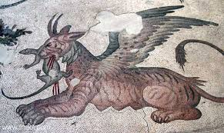

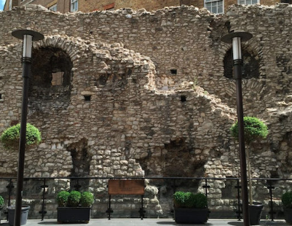

**READING**

Remember to read each day and get an adult to sign your reading record. Don’t forget you can use Reading Eggs at home.

**SPELLING**

Don’t forget to write sentences for and learn your spellings each week!

**WRITING AND TOPIC**

You have a scrap book to use to complete your homework project. Over the next six weeks complete some of these activities or make some up of your own.

**COMPLETE AT LEAST ONE OF THE WRITING TASKS**

1. Write a newspaper article based on a Roman myth.
2. Write a fact file about a famous Roman.
3. Write your own Roman myth.
4. Write an information booklet about childhood in Roman times.

**NOW CHOOSE SOME OR ALL OF THESE**

1. Draw a mythical beast.
2. Make a model of the colosseum.
3. Create a poster advertising Roman chariot racing.
4. Design your dream Roman house.
5. Draw a detailed map of the Roman Empire.