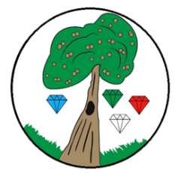
Year: 4 Term: Autumn 1

Science: States of matter
Pre-Learning Pack

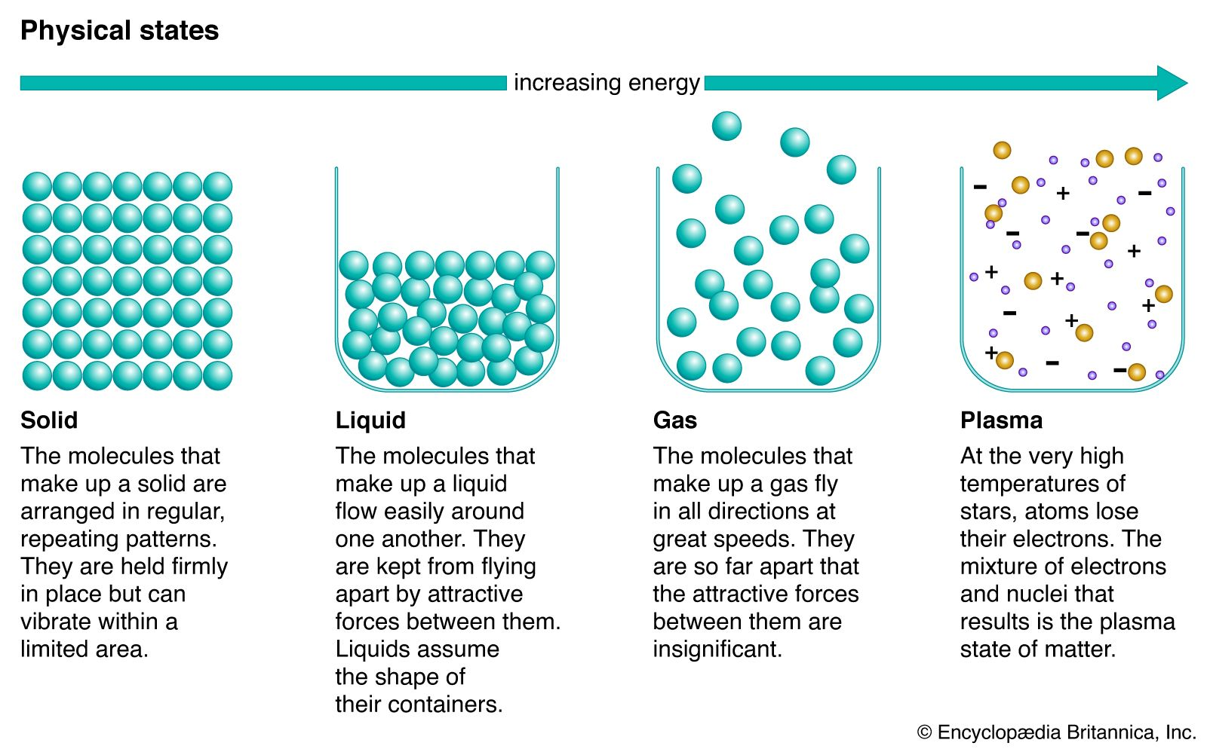
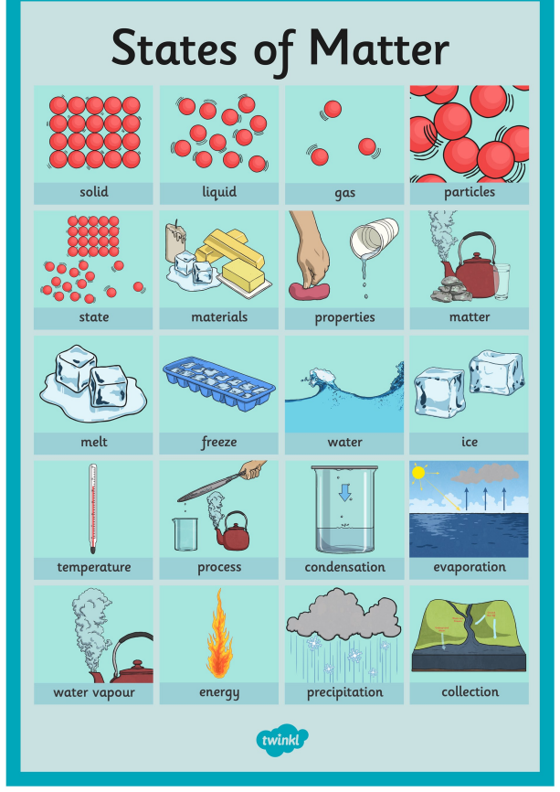
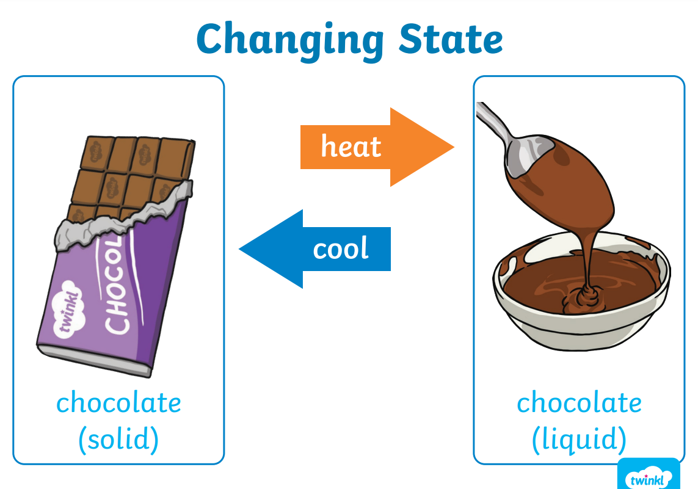

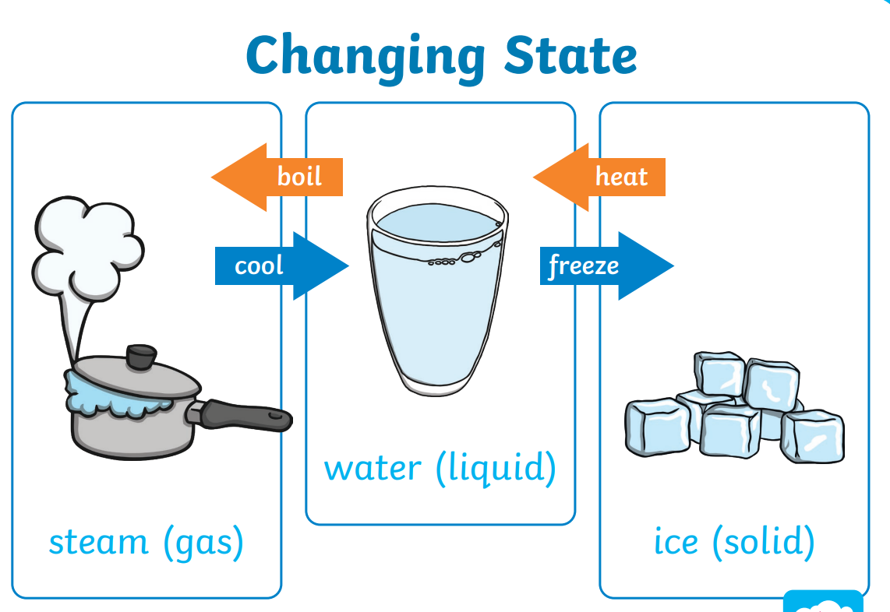
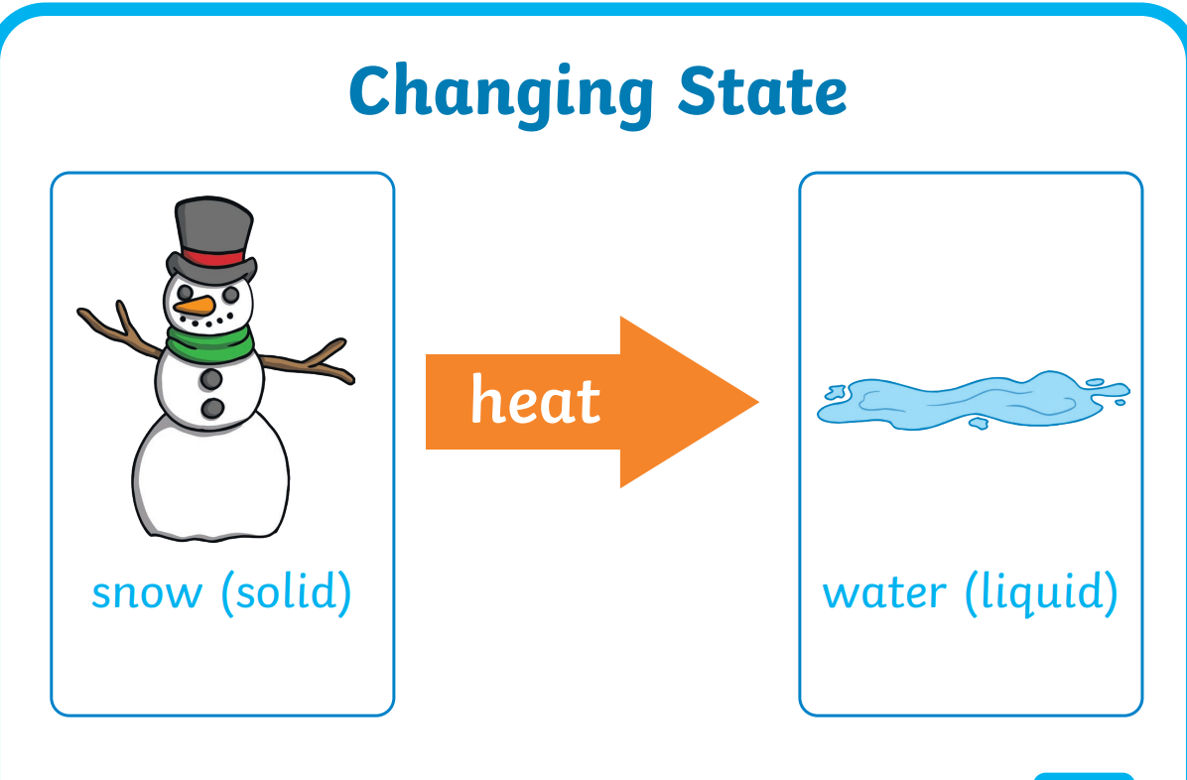
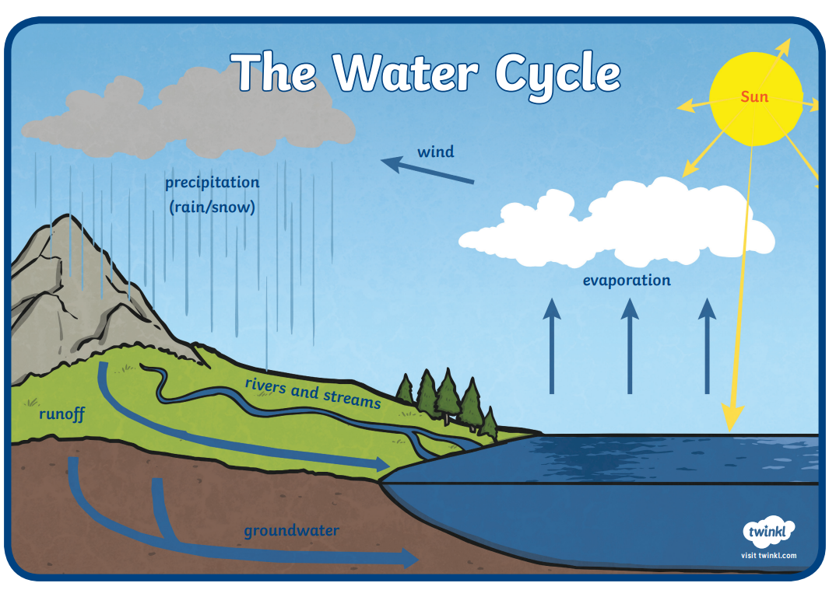
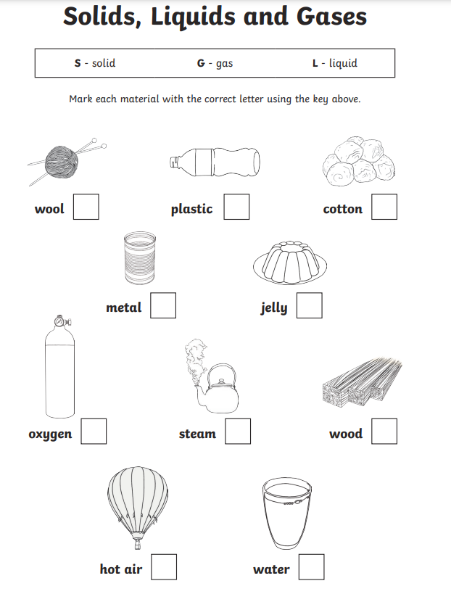
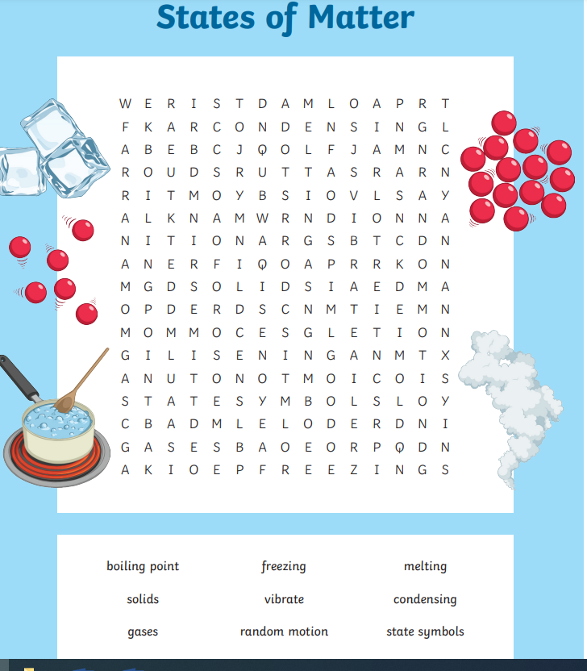

 | Videos | Activities to complete | Home activities
States of matter | Solids, Liquids and Gases  https://www.bbc.co.uk/bitesize/topics/zgwc96f/articles/zngfp4j  Changing State  https://www.bbc.co.uk/bitesize/topics/zgwc96f/articles/zwj9r2p  The water cycle  https://www.bbc.co.uk/bitesize/topics/zgwc96f/articles/z4gfp4j  Solids, liquid, gases dance  https://www.youtube.com/watch?v=3IW8E1YR0kE  Go Noodle water cycle song  https://www.youtube.com/watch?v=KM-59ljA4Bs |  | - Freezing and defrosting toys  https://nurturestore.co.uk/frozen-ice-sensory-play-ideas-ice-excavation  - Making crispy cakes and noticing the change - https://www.bbcgoodfood.com/recipes/chocolate-rice-krispie-cakes  - Baking a cake.  - Visiting a river or lake

