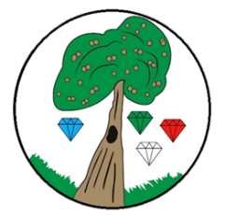
Year: 4 Term: Spring 2

Science:
Pre-Learning Pack – Sound

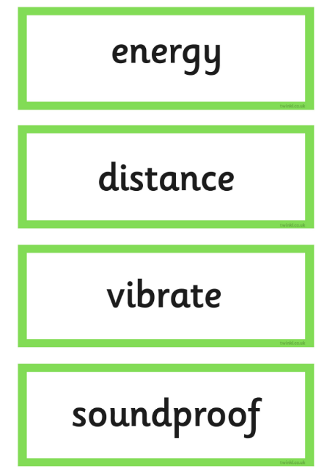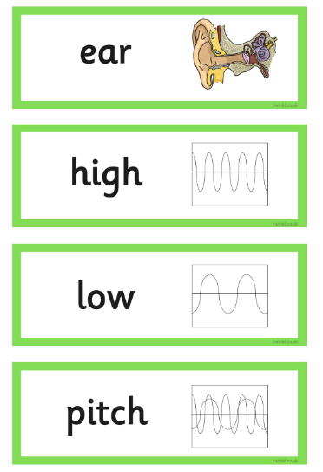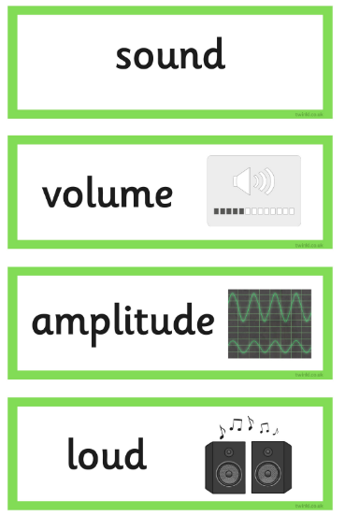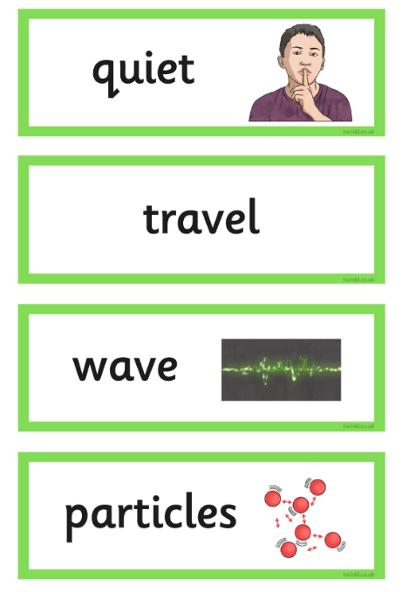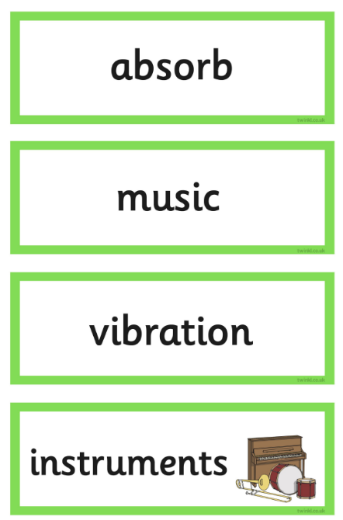

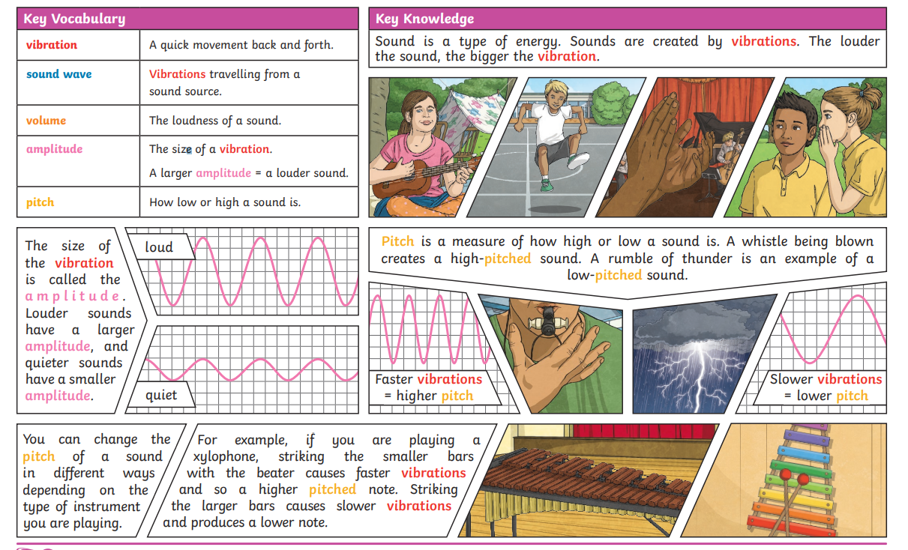

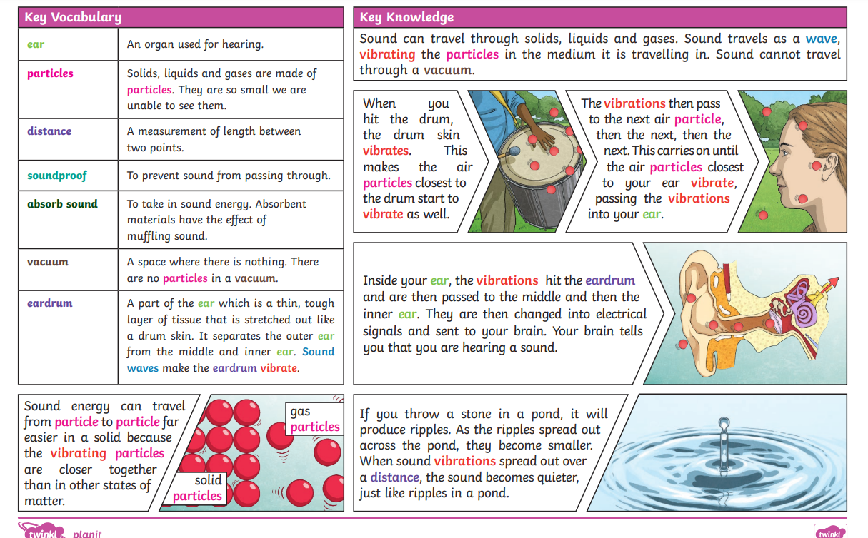
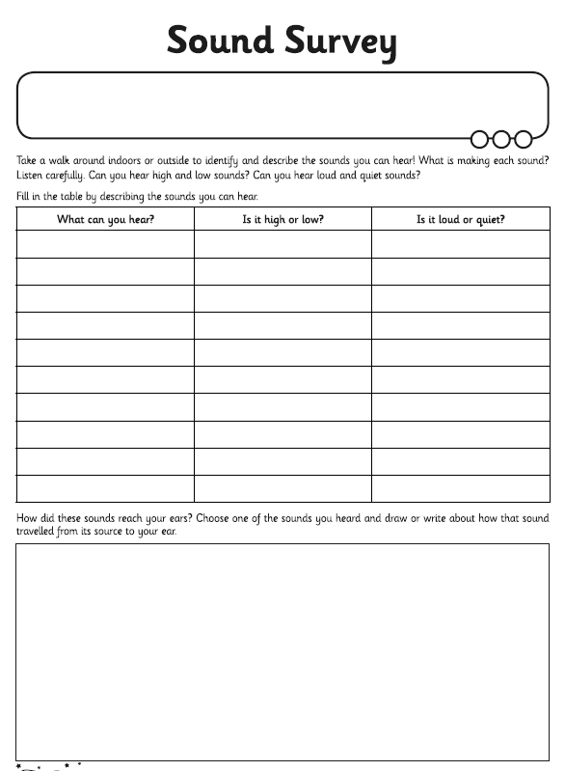
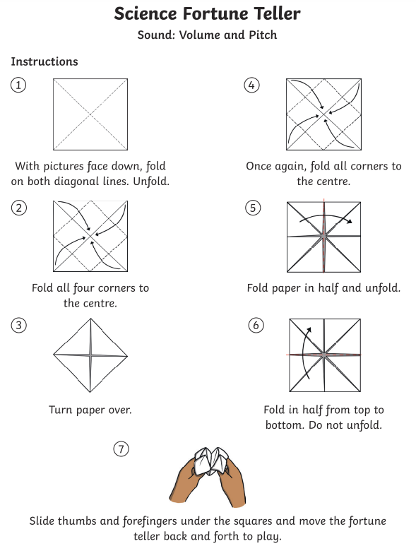
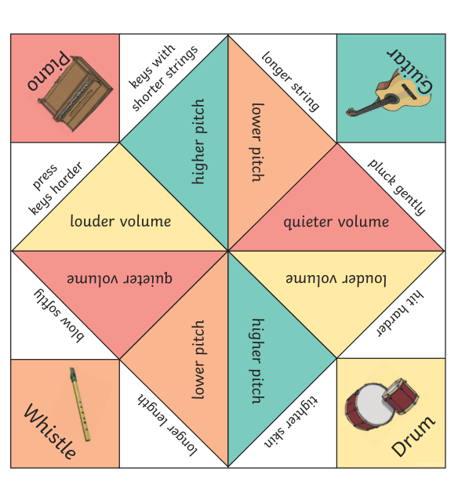
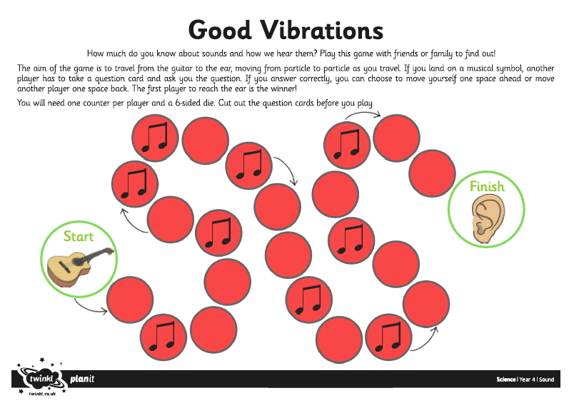
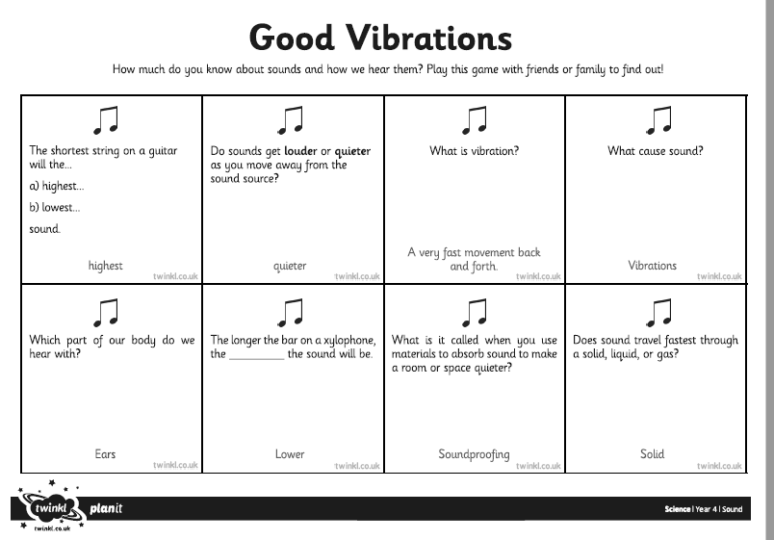
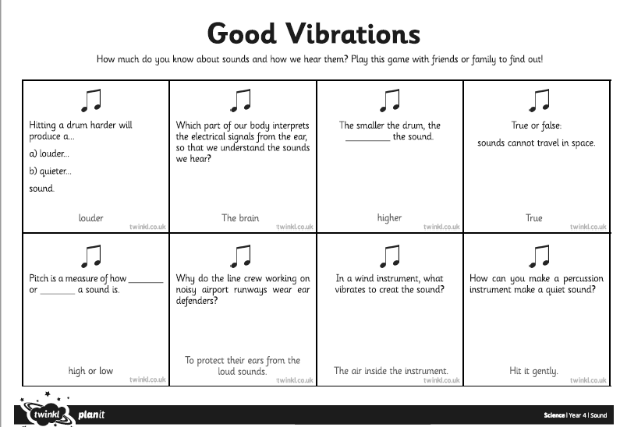

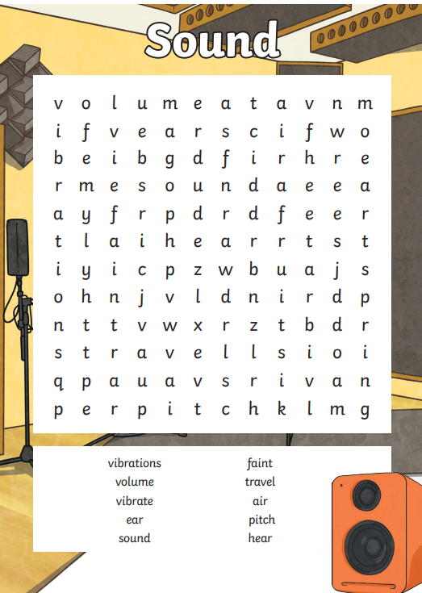

 | Videos | Activities to complete | Home activities
Sound | Pitch  https://www.bbc.co.uk/bitesize/topics/zgffr82/articles/z8s62v4  Volume  https://www.bbc.co.uk/bitesize/topics/zgffr82/articles/zd67wnb  How are sounds detected?  https://www.bbc.co.uk/bitesize/topics/zgffr82/articles/z3d4g7h#z9kgg7h  How are sounds made?  https://www.bbc.co.uk/bitesize/topics/zgffr82/articles/zh9bydm |  | - Use recyclable materials to make your own musical instruments. E.g. a shaker with dried beans inside a cup. A guitar with a tissue box and string or elastic. https://www.bbcgoodfood.com/howto/guide/5-instruments-kids-can-make  - Make a string telephone  https://www.youtube.com/watch?v=JWB_-wevjSY  - Make a DIY phone speaker  https://www.science-sparks.com/diy-phone-speaker/  - Dancing Sprinkles (to show that sound creates vibrations)  https://www.youtube.com/watch?v=j9IvcwZFx9s&t=44s  - Musical straws  https://www.sciencebuddies.org/stem-activities/make-musical-instrument?from=Blog  - Musical bottles  https://www.sciencebuddies.org/stem-activities/musical-bottles?from=Blog

