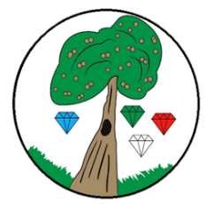
Year: 3/4 Term: Summer 1 1
Science: Electricity
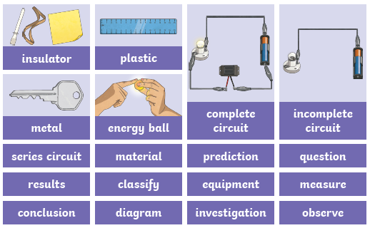
Pre-Learning Pack
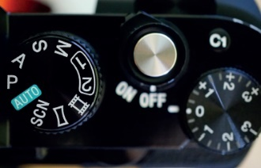
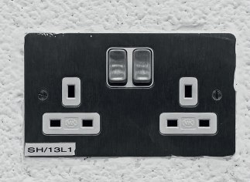
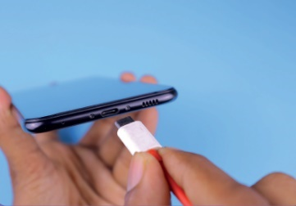
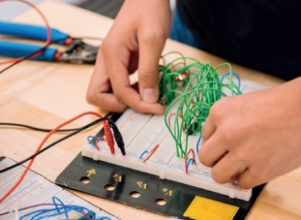
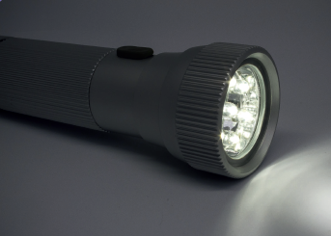
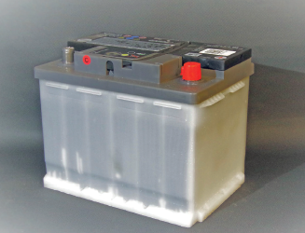
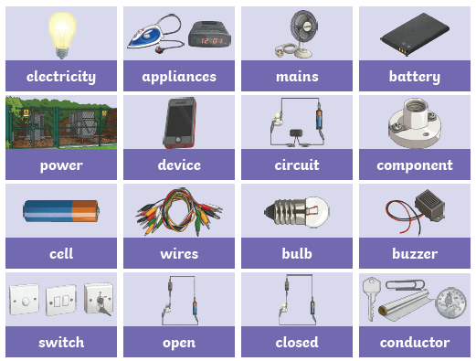

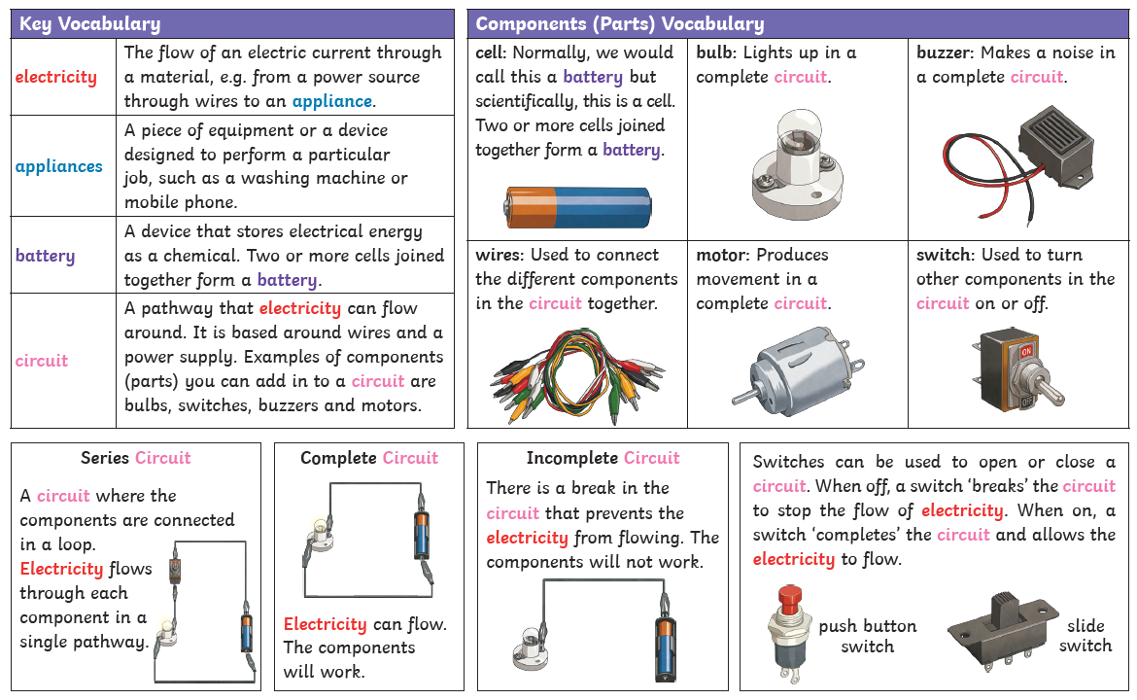
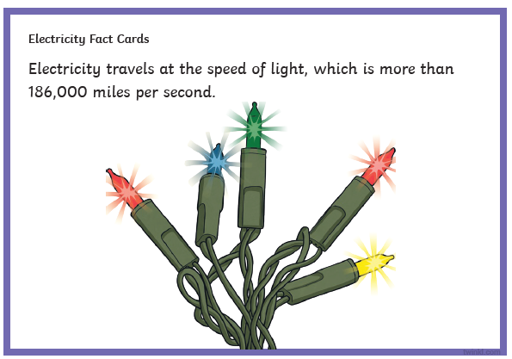
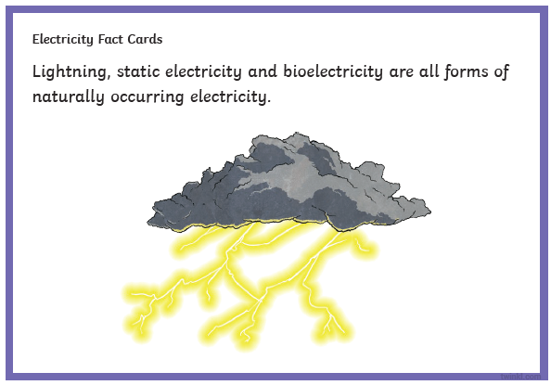
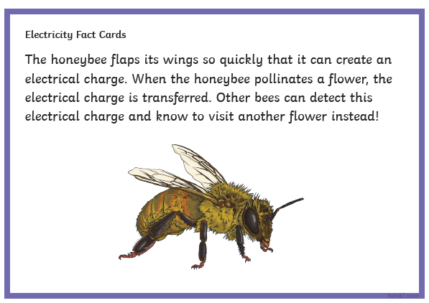
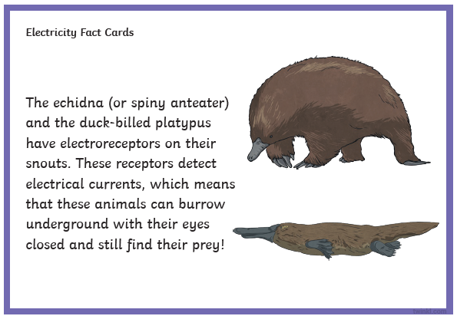
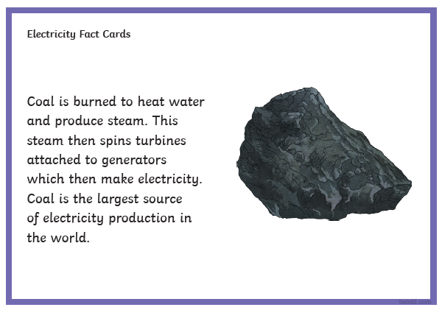
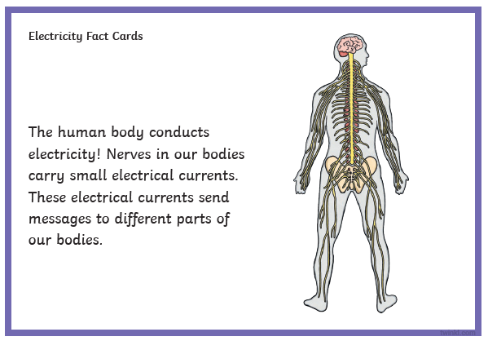
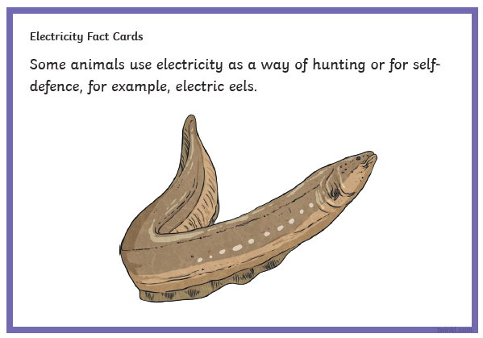
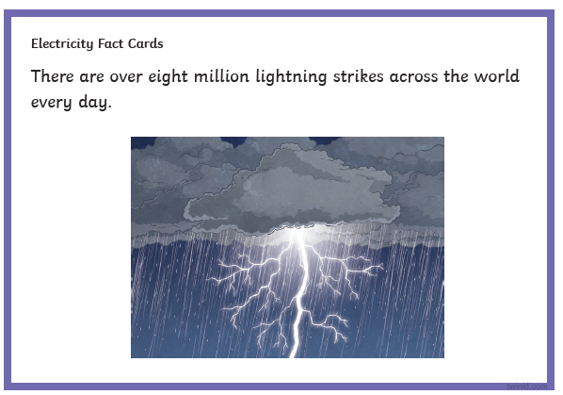
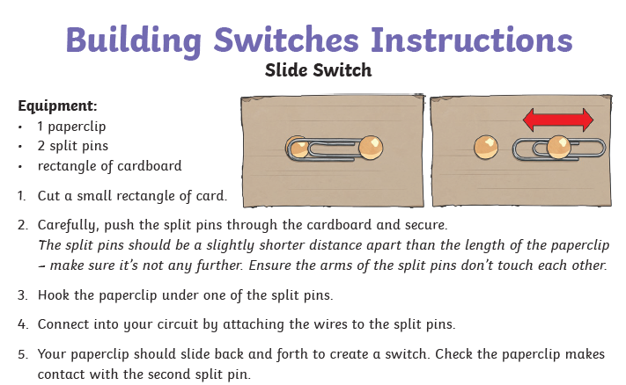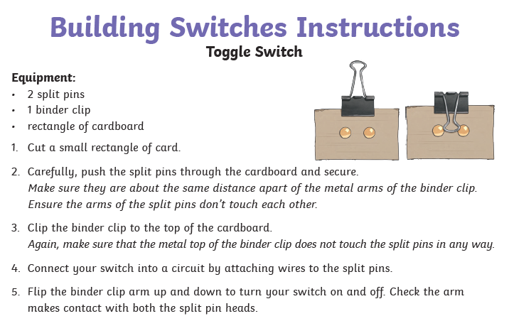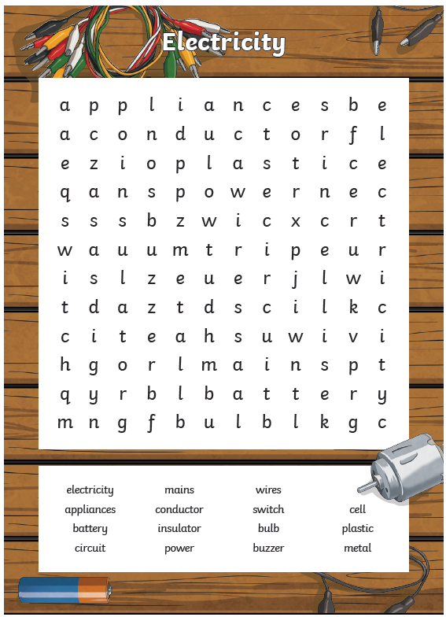
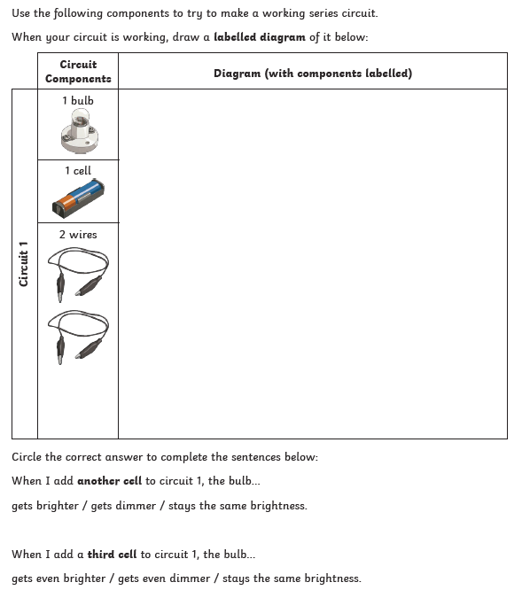
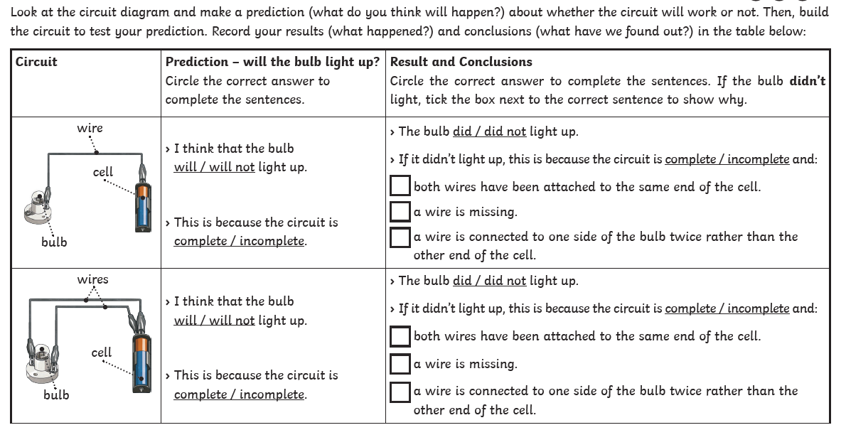

 | Videos | Activities to complete | Home activities
States of matter | Circuit Symbols  https://www.bbc.co.uk/bitesize/topics/zj44jxs/articles/zqryn9q  Electrical Components  https://www.bbc.co.uk/bitesize/topics/zj44jxs/articles/zrd2qfr  Electrical Circuits and Symbols  https://www.bbc.co.uk/bitesize/topics/zj44jxs/articles/zrd2qfr  Electrical Circuits  https://classroom.thenational.academy/units/electrical-circuits-06f7 |  | Visit the Science Museum  Look around your home for different devices that run on electricity.  Using a Venn diagram, sort them into those that use mains electricity (they are plugged in) and those that use batteries  Create a fact file on Thomas Edison (1847-1931). Inventor of the fuse.  Make home-made switched using the instructions in this pack

