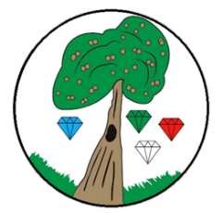
Year: 3 Term: Spring 1

Science: Animals Including Humans
Pre-Learning Pack

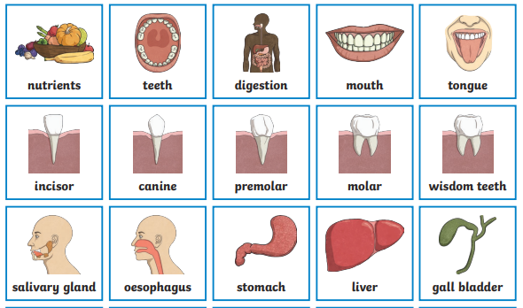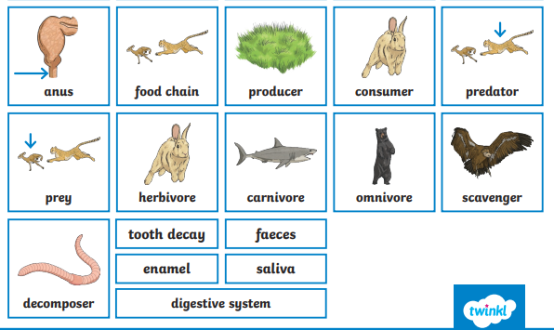

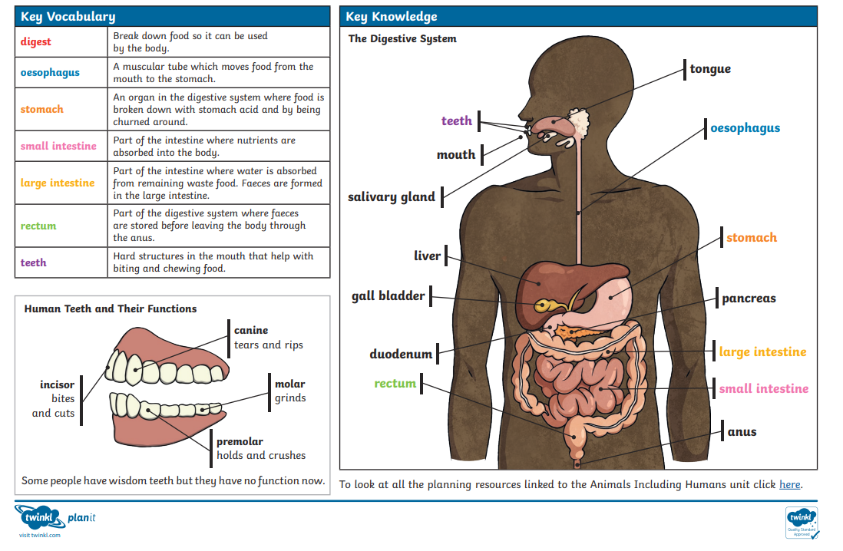
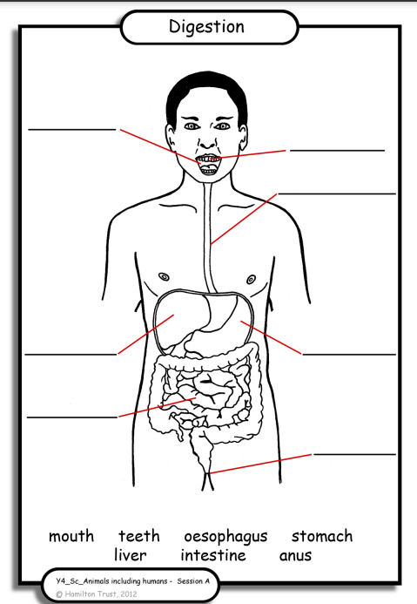

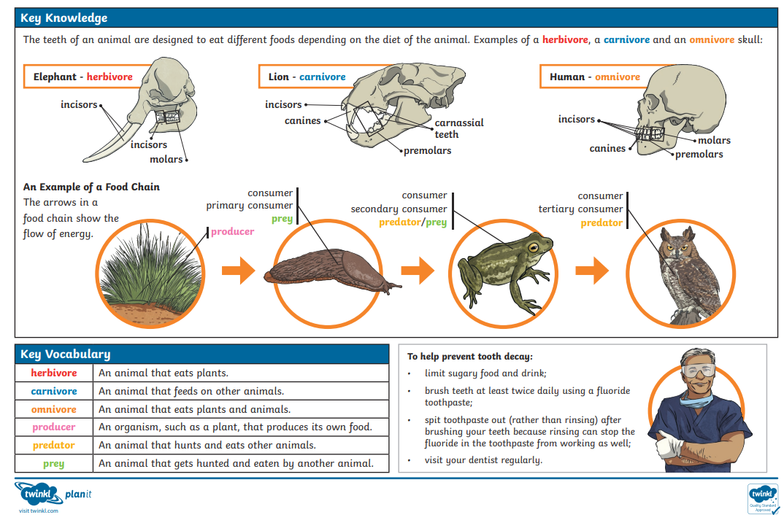

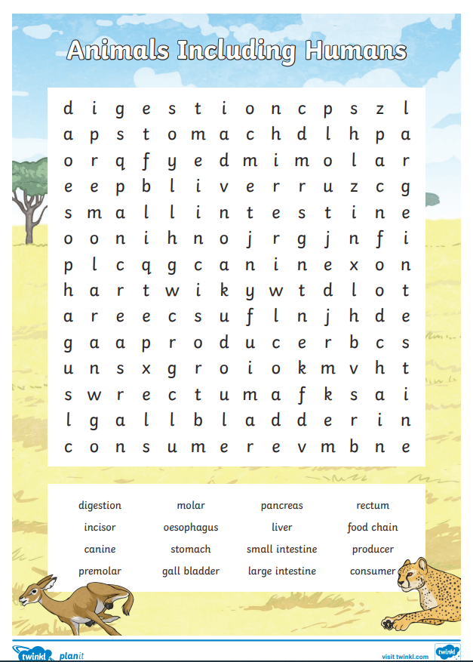

 | Videos | Activities to complete | Home activities
States of matter | The digestive system  https://www.bbc.co.uk/bitesize/topics/zcyycdm/articles/z8bntrd  Digestive system song  https://www.youtube.com/watch?v=c-LKFTcdGl0  Food chains  https://www.bbc.co.uk/bitesize/topics/zcyycdm/articles/zww9r2p  Teeth  https://www.bbc.co.uk/bitesize/topics/zcyycdm/articles/z8784xs  Teeth- online lesson  Crickweb | KS2 Science |  | - Make your own food chain picture  - Clay/ Play doh 3D mouth https://www.youtube.com/watch?v=ZlT84HS0vwU  - Digestive system model https://www.youtube.com/watch?v=oGA9_yVDjr8

