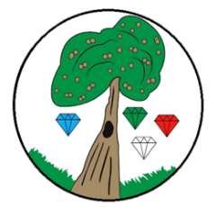
Year: 3 Term: Autumn 2

Science:
Pre-Learning Pack
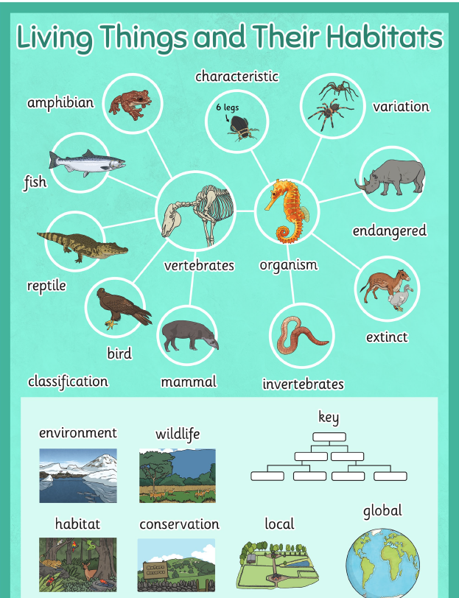
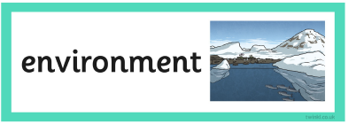
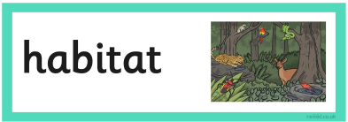
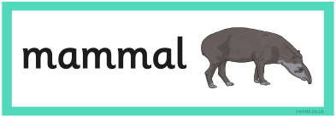
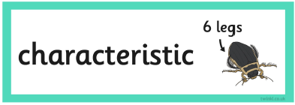
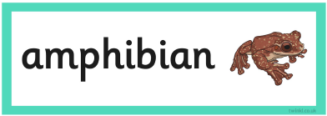
Living Things and Their Habitats
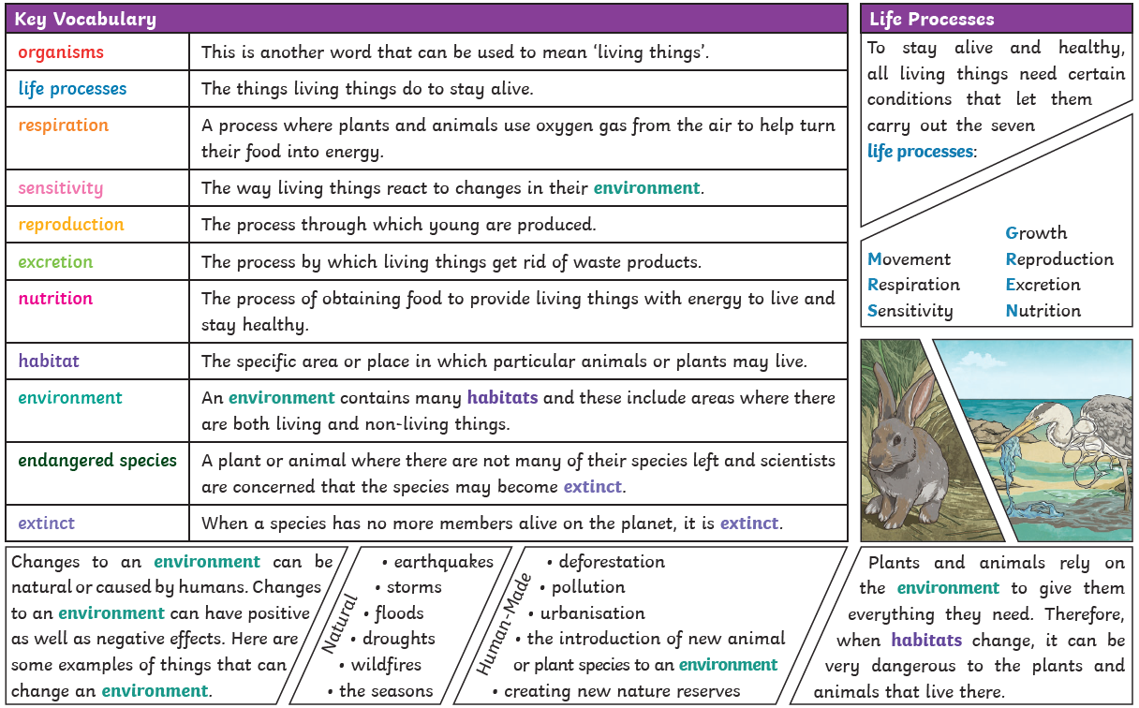
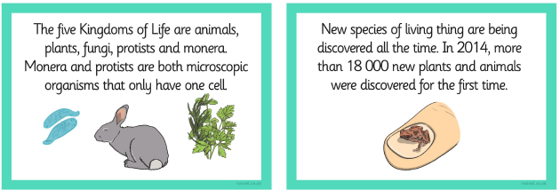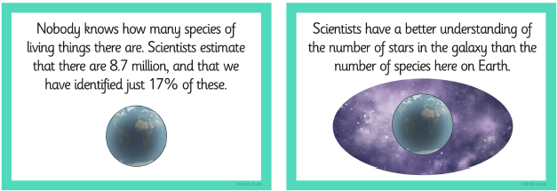

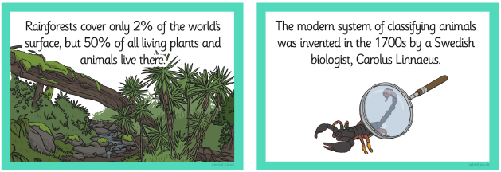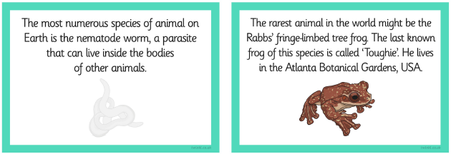

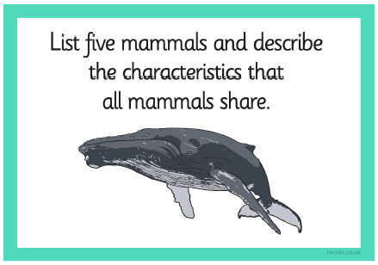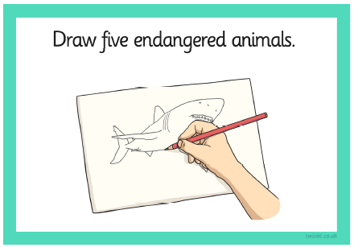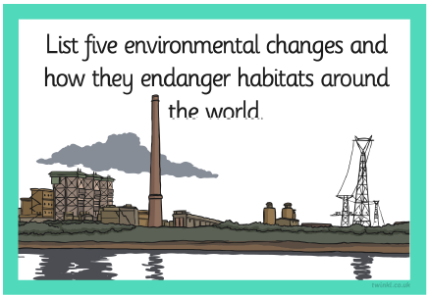
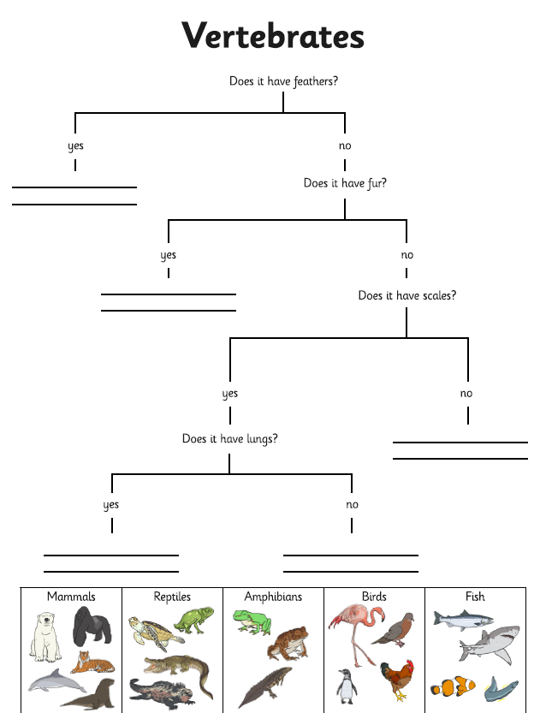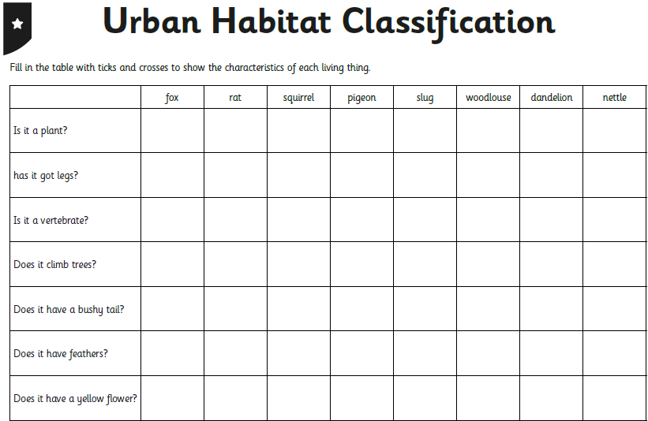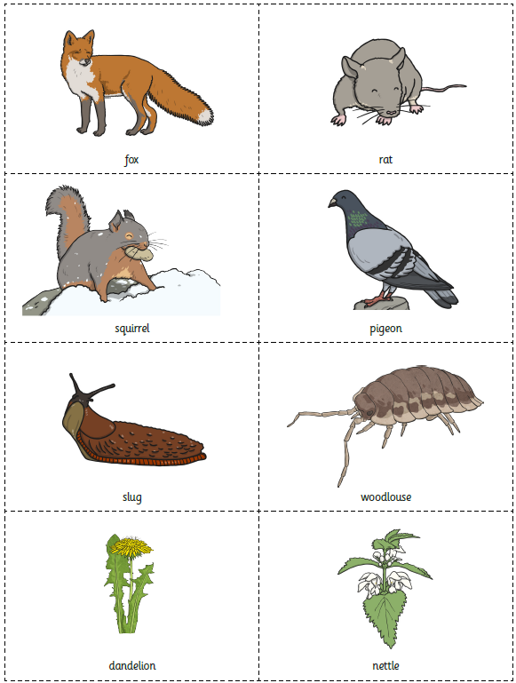
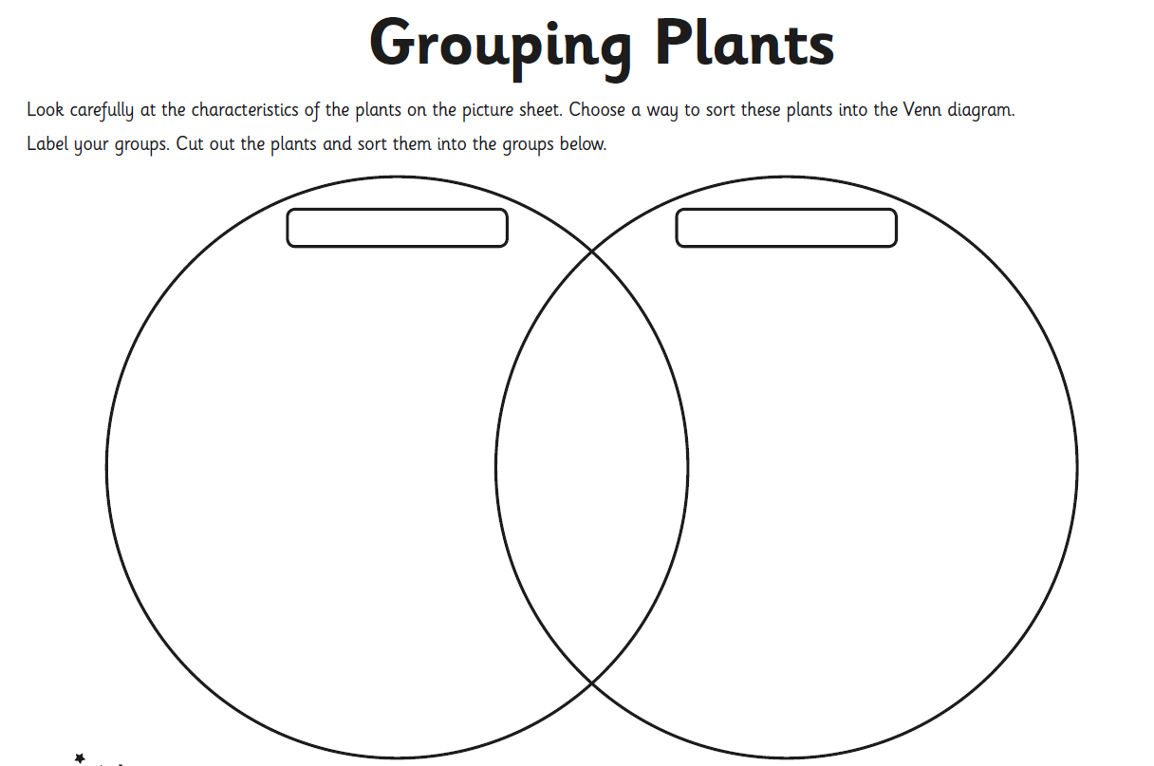
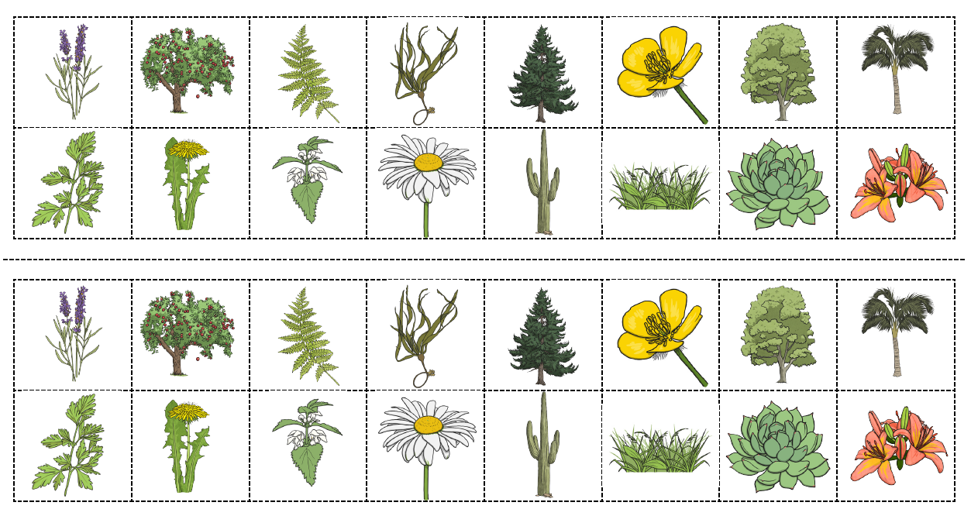
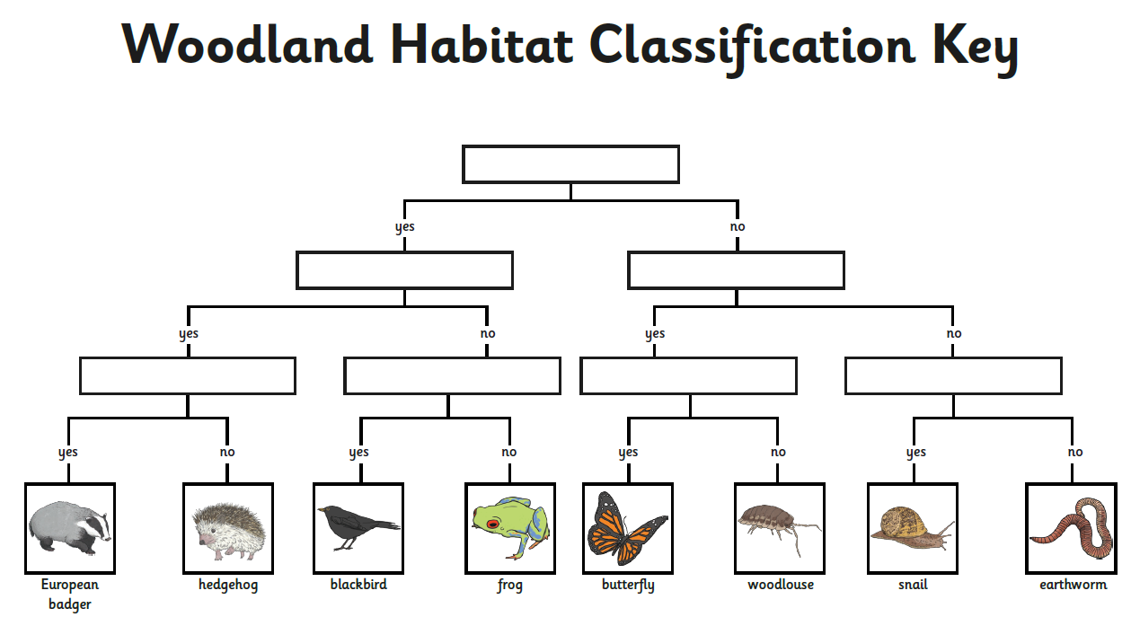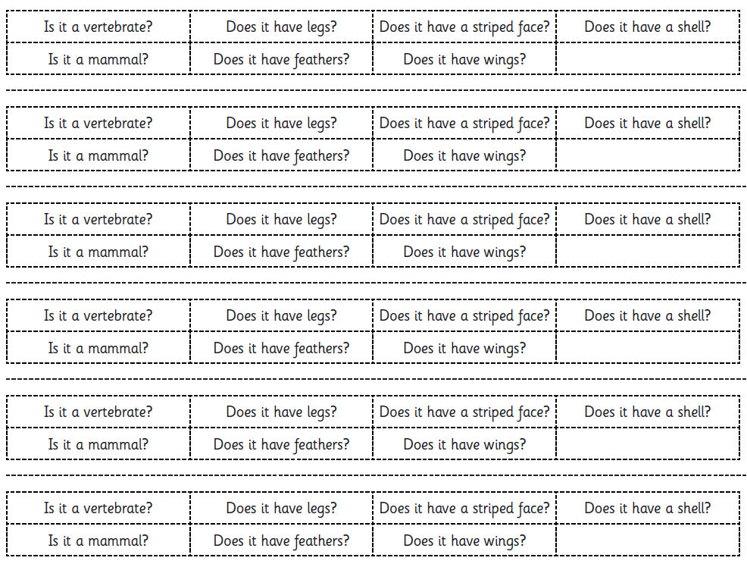
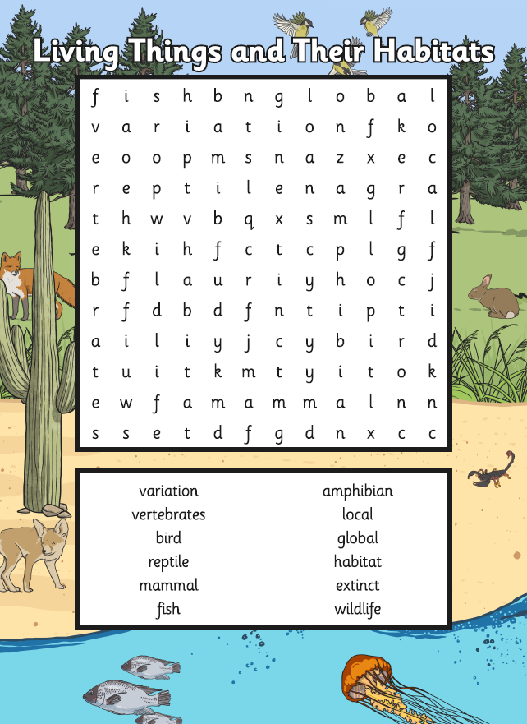

 | Videos | Activities to complete | Home activities
Living Things and Their Habitats | What is classification?  https://www.bbc.co.uk/bitesize/topics/z6wwxnb/articles/zyq9r2p  Woodland Food Chain Challenge  https://www.bbc.co.uk/bitesize/topics/z6wwxnb/articles/zsphrwx  Changing Environments  https://www.bbc.co.uk/bitesize/topics/z6wwxnb/articles/zp4w8hv  Identifying living things and their habitats  https://www.youtube.com/watch?v=2fmtIToiGjI  Habitats  https://www.bbc.co.uk/programmes/p0119dpr |  | Grow some fruit or vegetables and observe over time: https://www.bbcgoodfood.com/howto/guide/easy-crops-kids-grow  Visit a city farm:  https://www.timeout.com/london/things-to-do/city-farms-in-london  Natural History Museum  https://www.nhm.ac.uk/discover/british-wildlife.html

