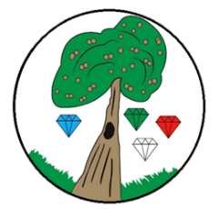
Year: 2 Term: Spring 2

Science: Plants Pre-Learning Pack

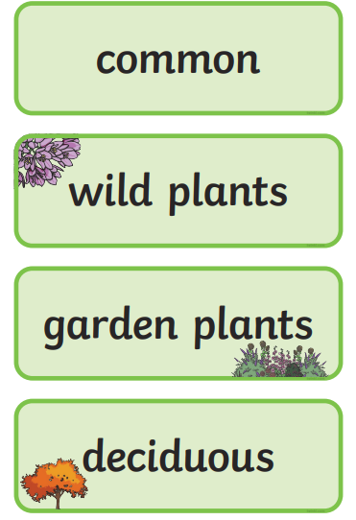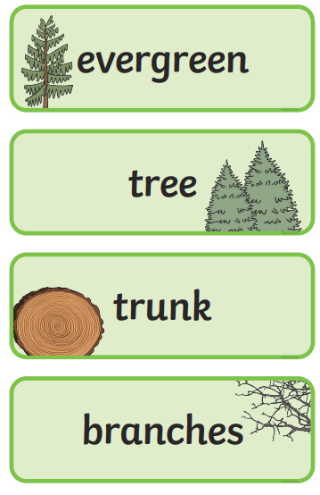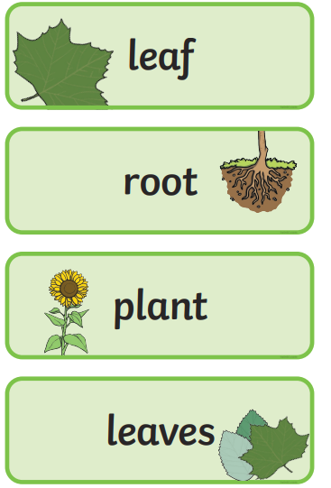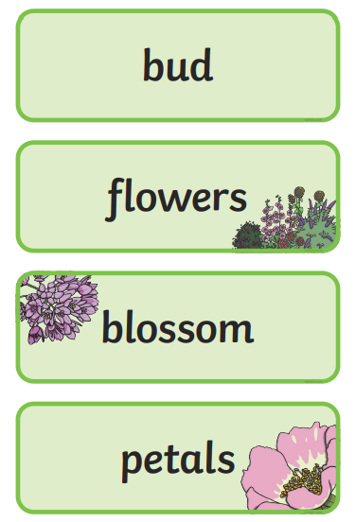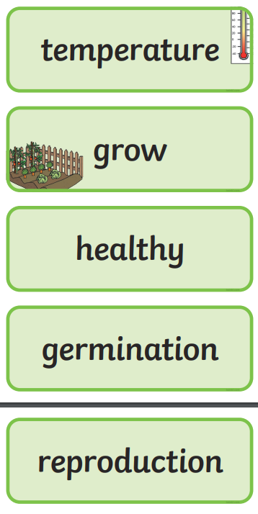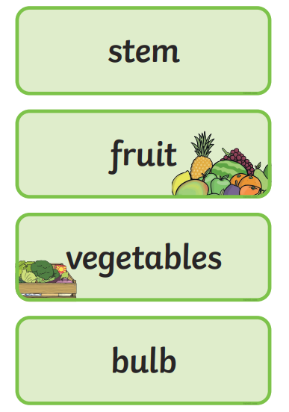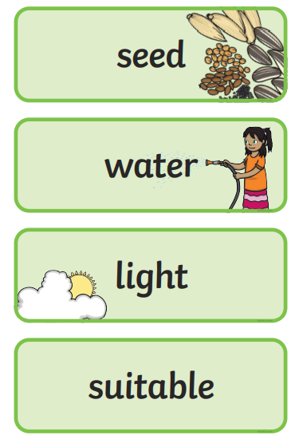
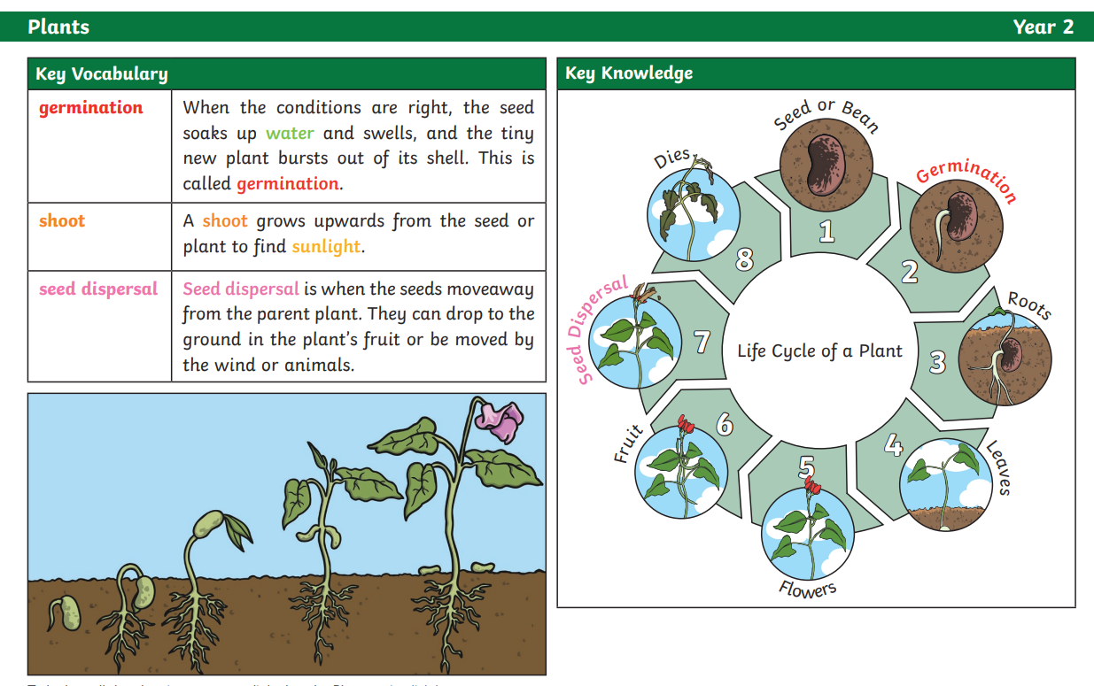
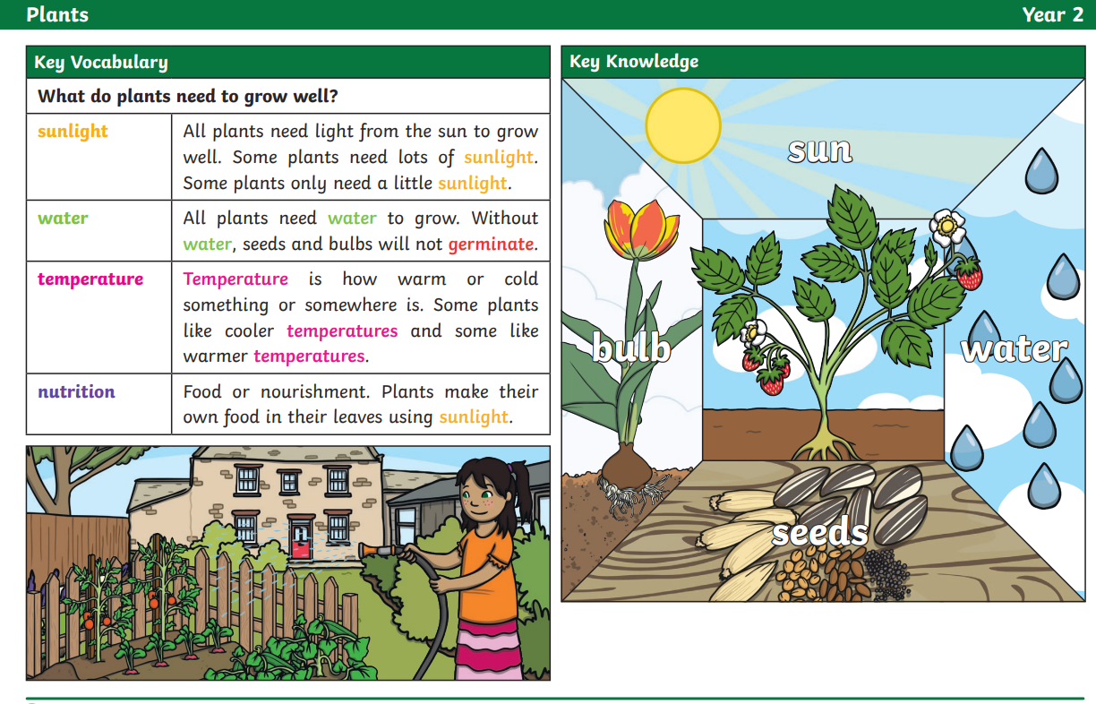
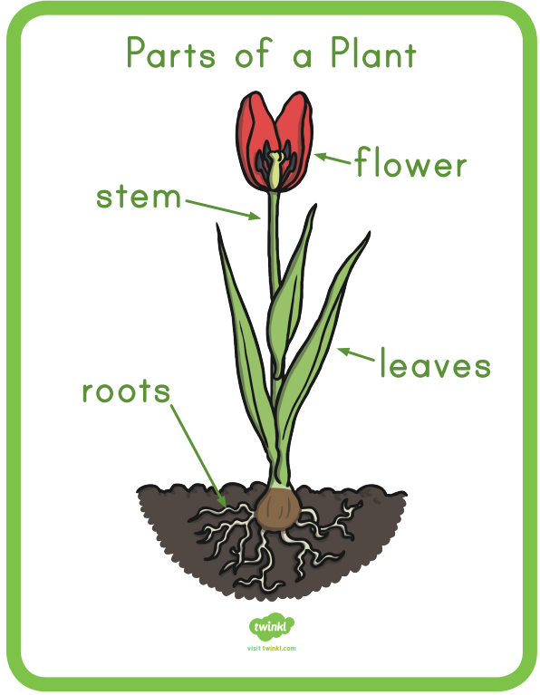
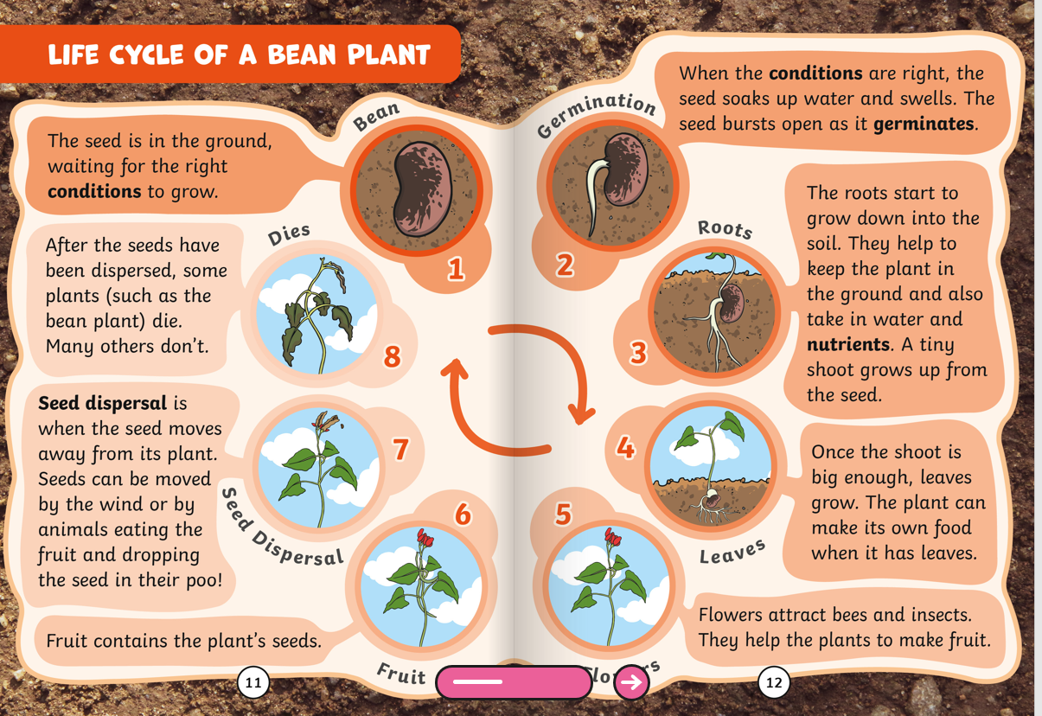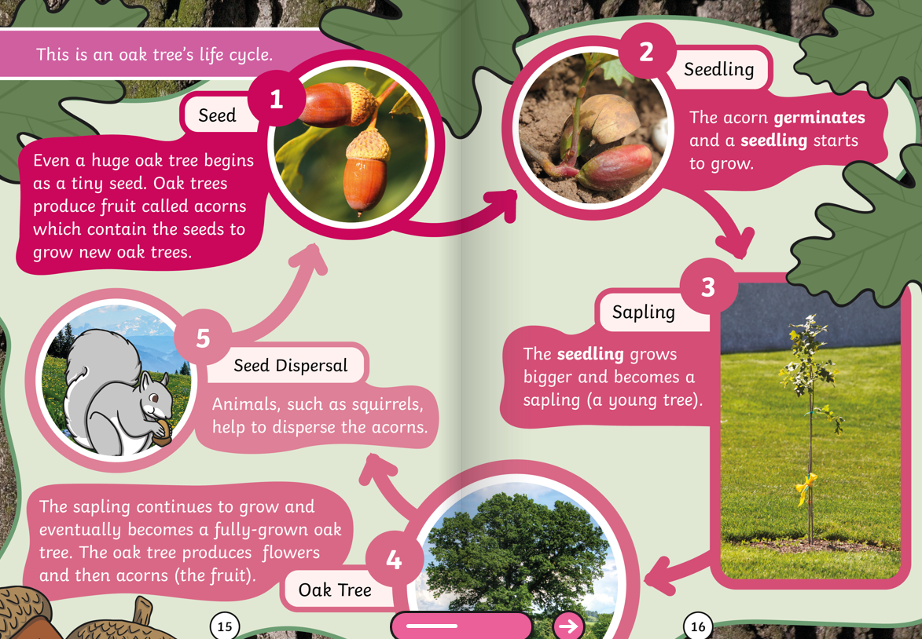
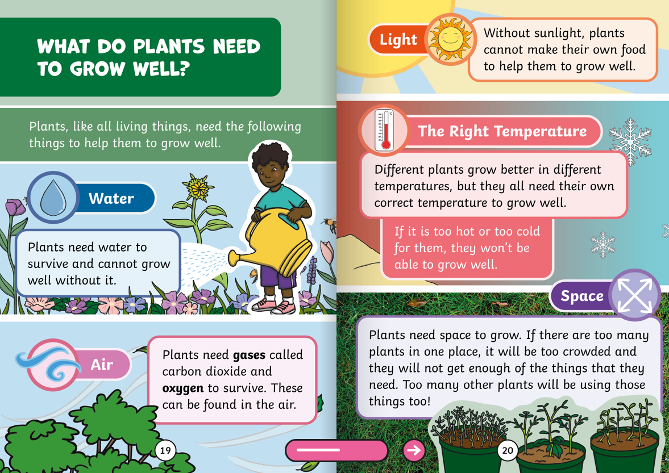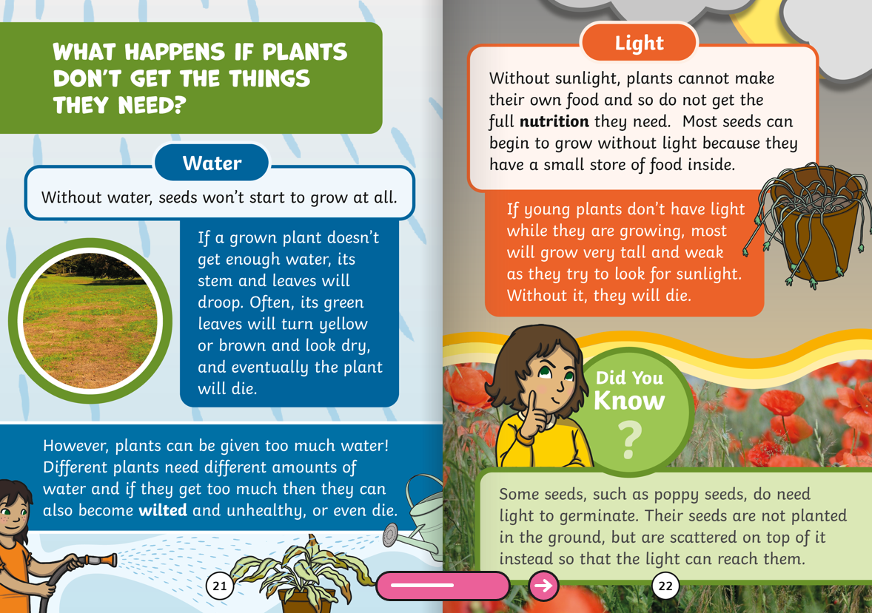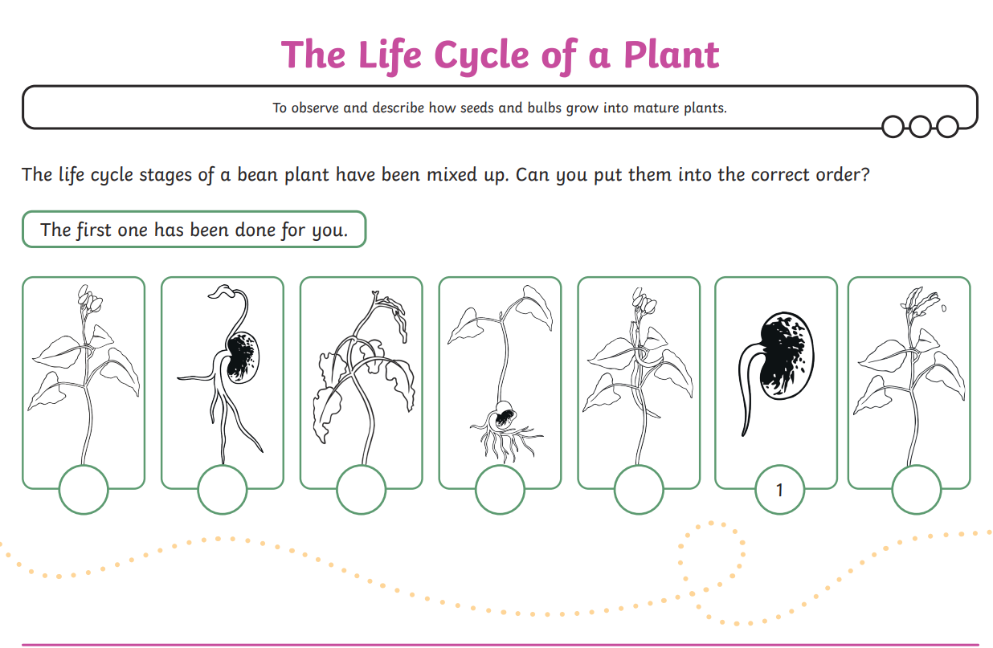
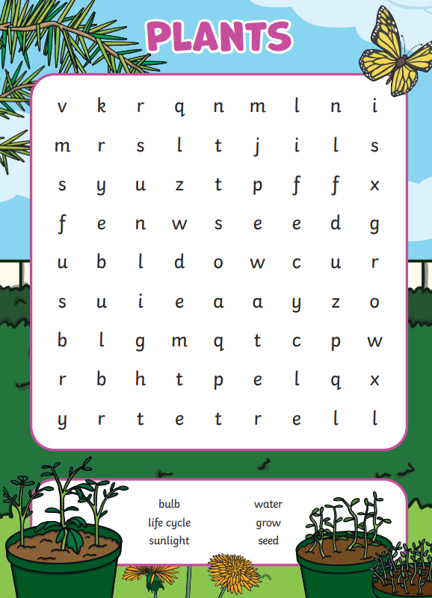

 | Videos | Activities to complete | Arts and Crafts
Plants | Wild and garden plants  https://www.bbc.co.uk/bitesize/topics/zpxnyrd/articles/zjnmqfr  The parts of a plant  https://www.bbc.co.uk/bitesize/topics/zpxnyrd/articles/z2vhxbk  The lifecycle of a plant  https://www.bbc.co.uk/bitesize/topics/zpxnyrd/articles/z6nx7yc  What do plants need to grow  https://www.bbc.co.uk/bitesize/topics/zpxnyrd/articles/zkp2jsg  Parts of a plant song  https://www.youtube.com/watch?v=9bFU_wJgvBI |  | - Plant your own seeds in a container, you could use yoghurt pot, cup, soil or cotton wool.  - Go on a plant hunt to find and drawer any plants in your local area.  - Make a handprint flower with paint.  - Make a natural flower picture with natural objects found. Inspired by the artist Andy Goldsworthy. https://artsycraftsymom.com/andy-goldsworthy-art-projects-for-kids/

