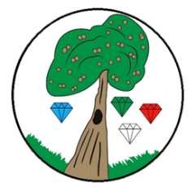
Year: 2 Term: Autumn 2

Science: Materials
Pre-Learning Pack

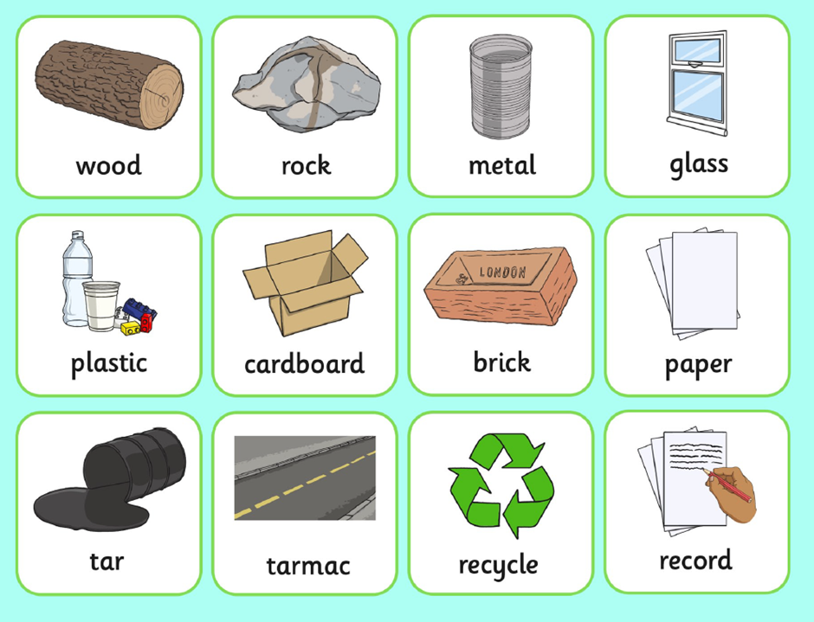

Flexible - Something that is capable of being bent. These materials can be described as flexible:

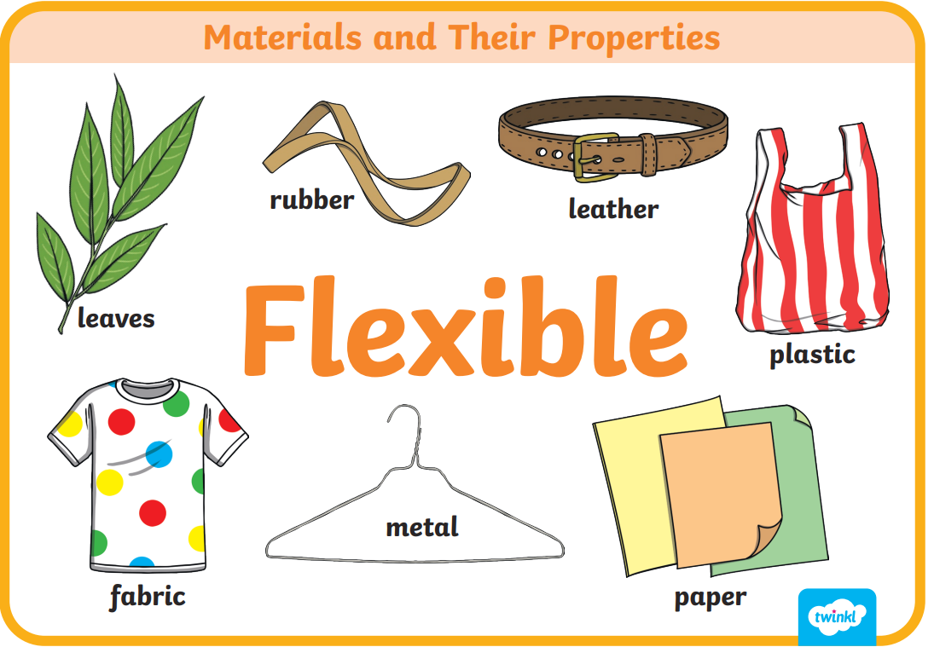

Hard - Something that is solid and firm to touch.
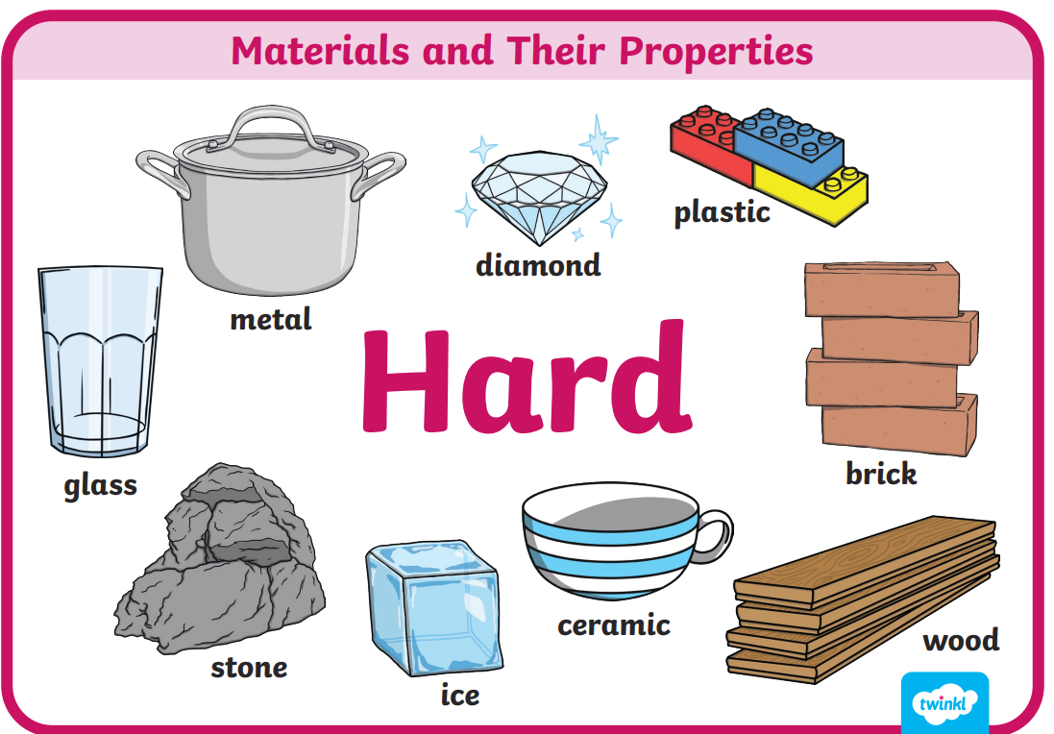

Smooth - Something free of roughness, stubble, or other imperfections that you can feel with your hands.
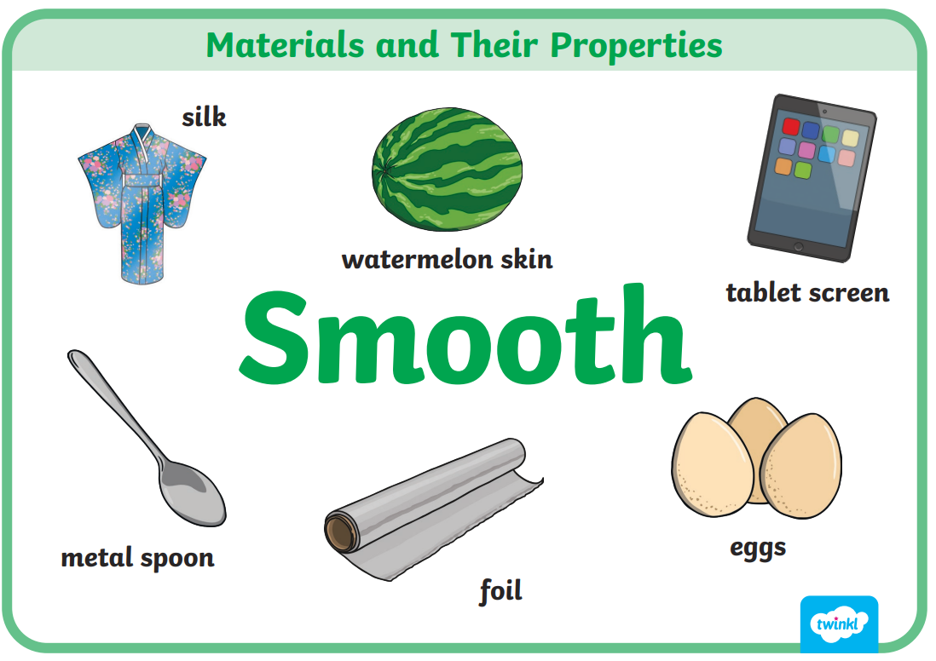

Transparent - Something you can see through.

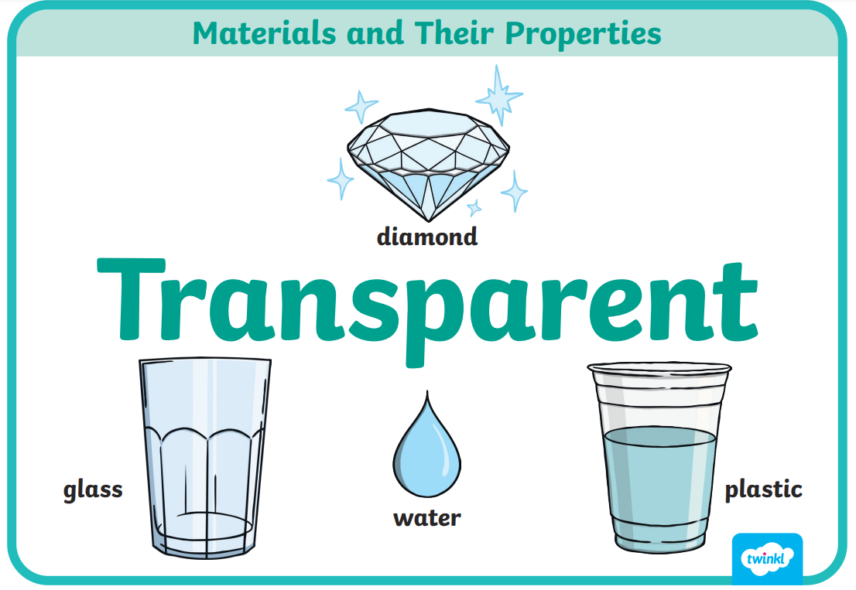

Waterproof - Something that keeps water out.
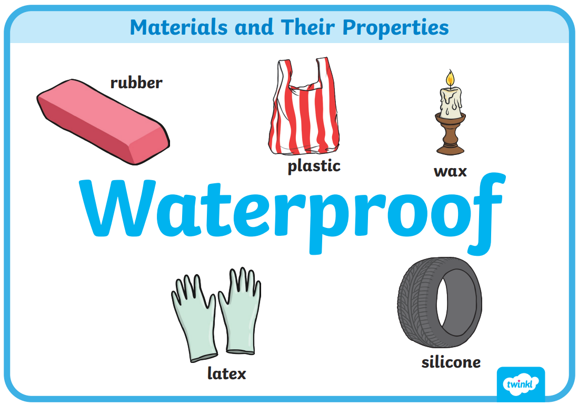

Rough-Having an uneven or irregular surface.
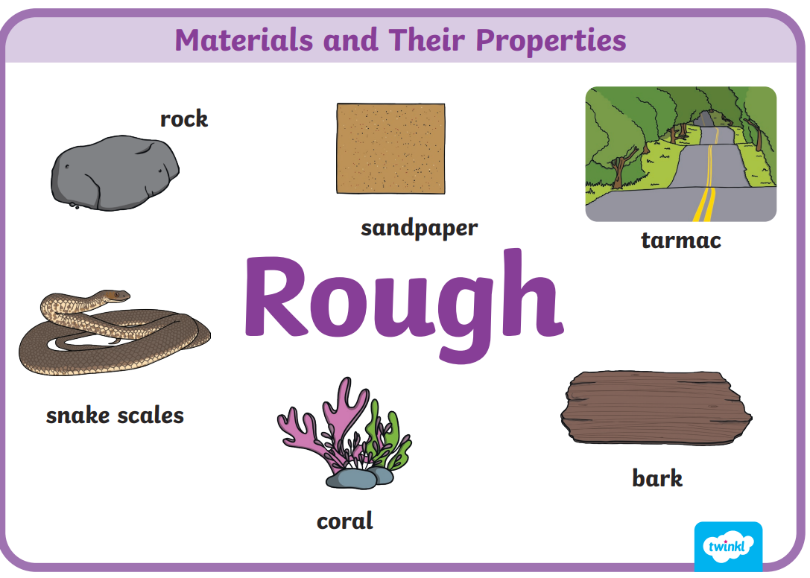

Opaque- Something you cant see through.
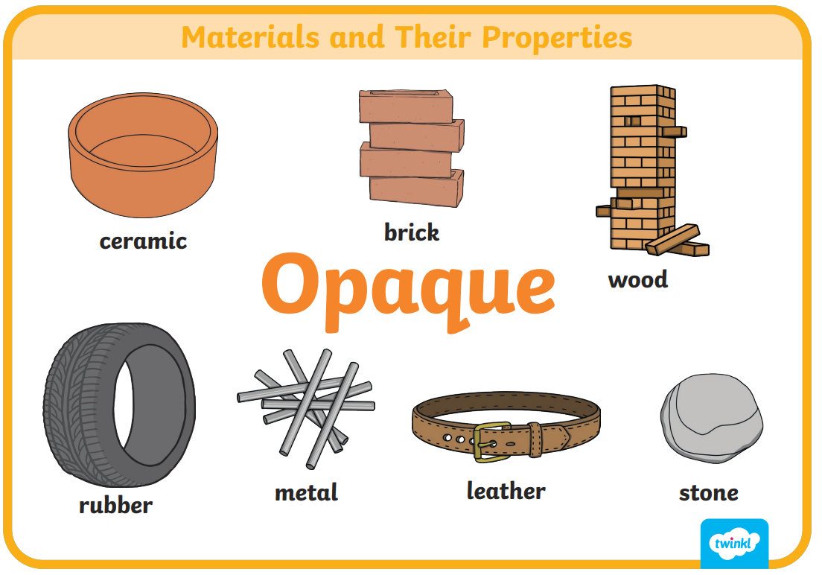

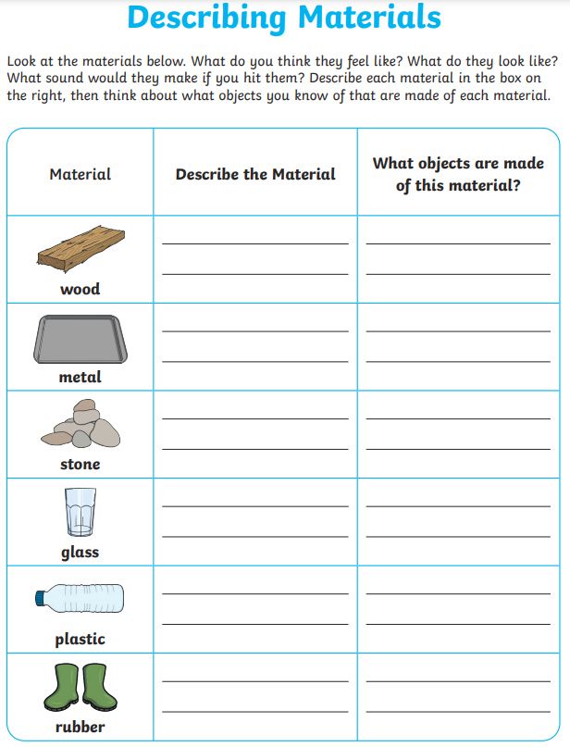

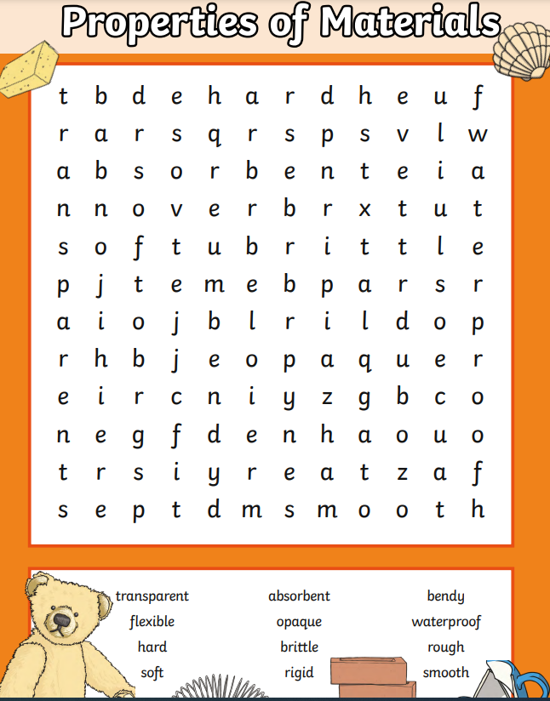

 | Videos | Activities to complete | Arts and Crafts
Materials and their properties | Why is it made front that?  https://www.bbc.co.uk/bitesize/topics/zsrfvwx/articles/zd9w8hv  Changing shapes  https://www.bbc.co.uk/bitesize/topics/zsrfvwx/articles/z62txbk  Materials song  https://www.youtube.com/watch?v=Qxdg3SExBvk  Materials  https://www.youtube.com/watch?v=340MmuY_osY  Recysling materials song  https://www.youtube.com/watch?v=DyhbovE5lrk  Visit a local recycling centre |  | Make a model using recyclable materials.

