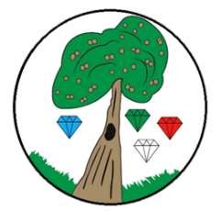
Year: 2 Term: Spring 1

Science:
Pre-Learning Pack
Living Things and Their Habitats
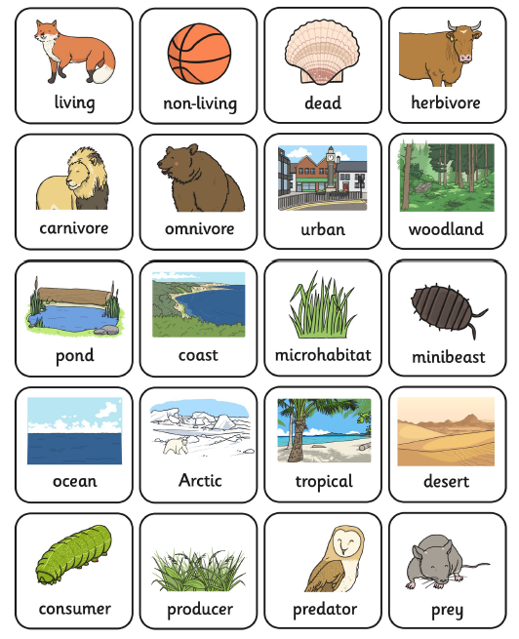
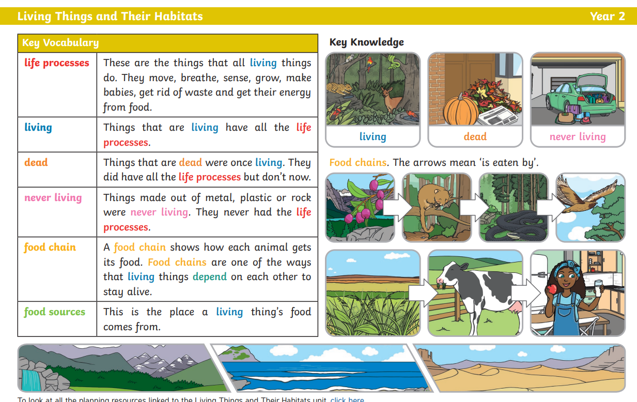

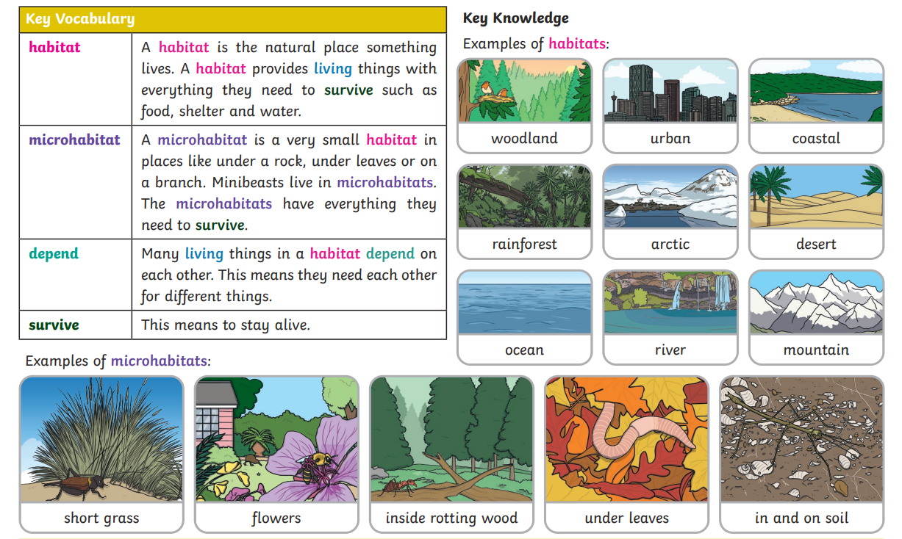

Use a tablet or phone to scan the QR codes. Can you guess which habitats they are and record your answers on the second sheet?
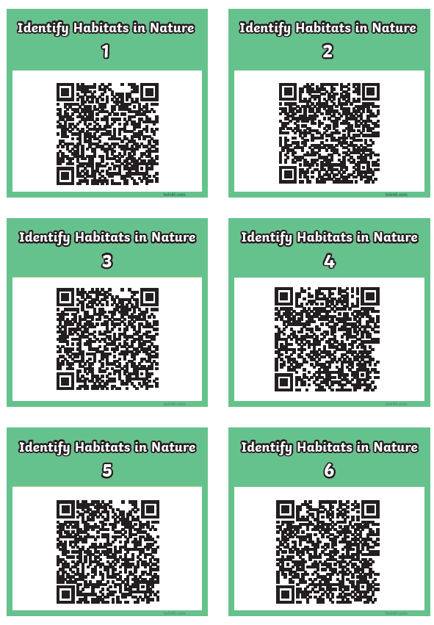
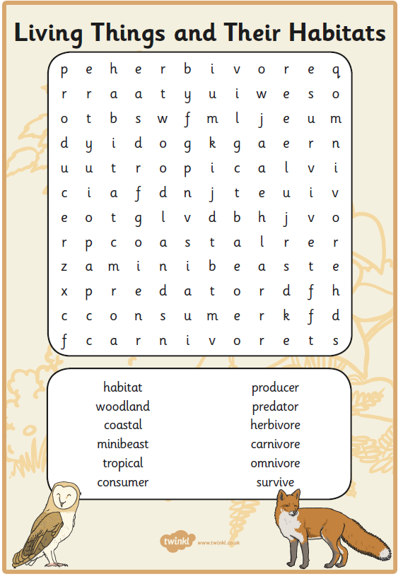

 | Videos | Activities to complete | Home activities
Living Things and Their Habitats | Dead or Alive?  https://www.bbc.co.uk/bitesize/topics/zx882hv/articles/zfhfn9q  What is a food chain?  https://www.bbc.co.uk/bitesize/topics/zx882hv/articles/zwxwkty  What is a polar habitat?  https://www.bbc.co.uk/bitesize/topics/zx882hv/articles/zcrshcw  What is an ocean habitat?  https://www.bbc.co.uk/bitesize/topics/zx882hv/articles/z6xd96f  What is a woodland habitat?  https://www.bbc.co.uk/bitesize/topics/zx882hv/articles/zxxd96f  What is an urban habitat?  https://www.bbc.co.uk/bitesize/topics/zx882hv/articles/zjq4g7h  What is a desert habitat?  https://www.bbc.co.uk/bitesize/topics/zx882hv/articles/zm6j8hv  What is a coastal habitat?  https://www.bbc.co.uk/bitesize/topics/zx882hv/articles/zsfx7yc  What is a pond habitat?  https://www.bbc.co.uk/bitesize/topics/zx882hv/articles/zxh7wnb |  | Watch the videos to the left and go on a ‘habitat hunt’ in your local area. Draw anything you find.  Visit a city farm:  https://www.timeout.com/london/things-to-do/city-farms-in-london  Natural History Museum  https://www.nhm.ac.uk/discover/british-wildlife.html  Horniman museum  https://www.horniman.ac.uk/  Visit the Horniman museum and see if you can find anything that is living, dead or never alive?  Junk Modelling – Can you use recyclable materials at home to make your own habitat?

