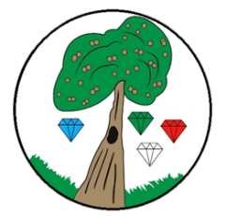
Year: 2 Term: Autumn 1

Science: Animals including Humans
Pre-Learning Pack

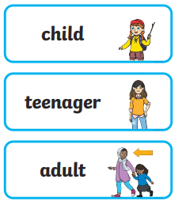
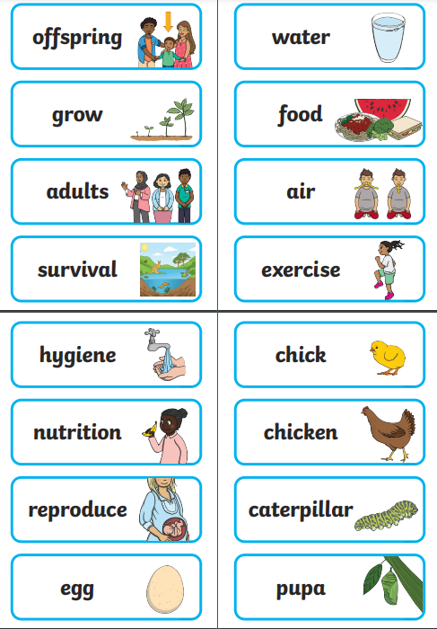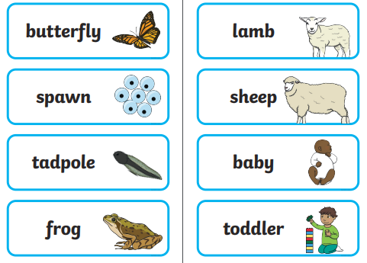

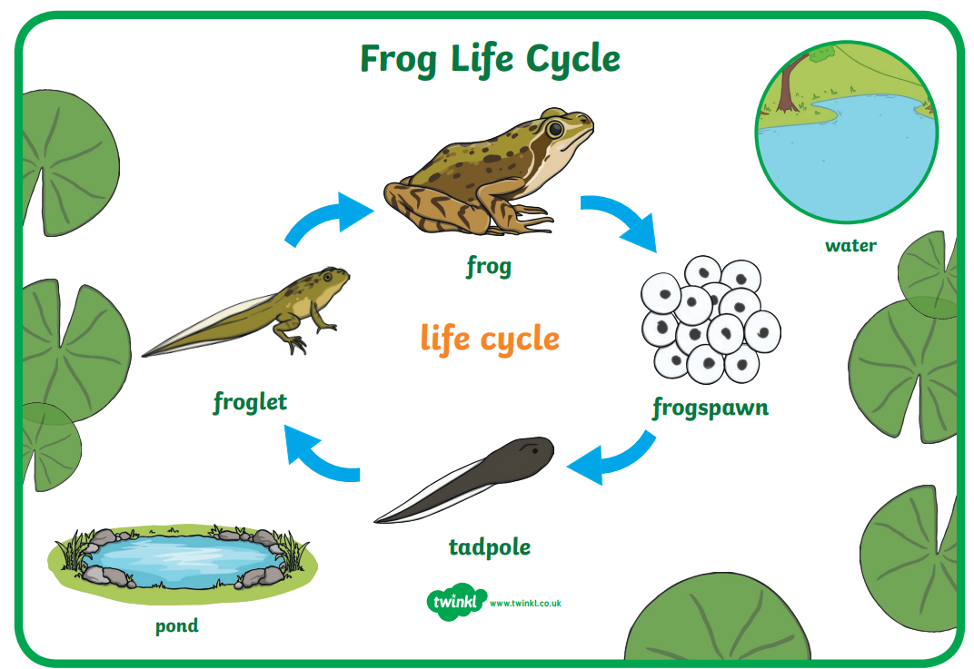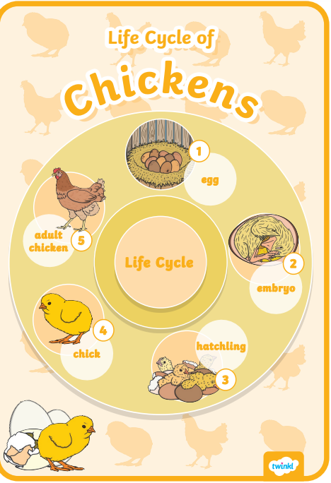
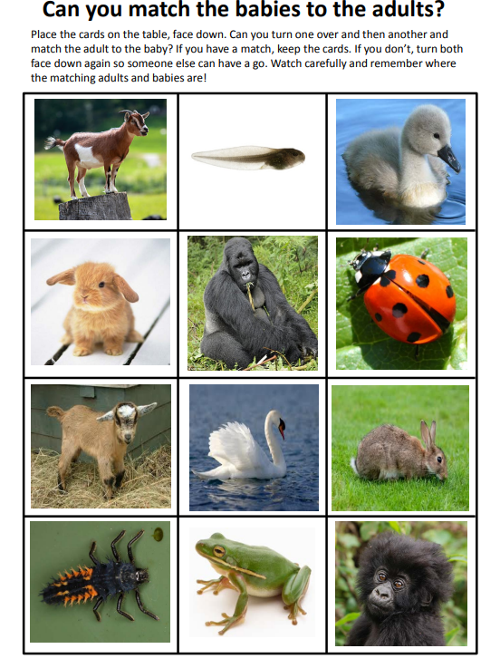
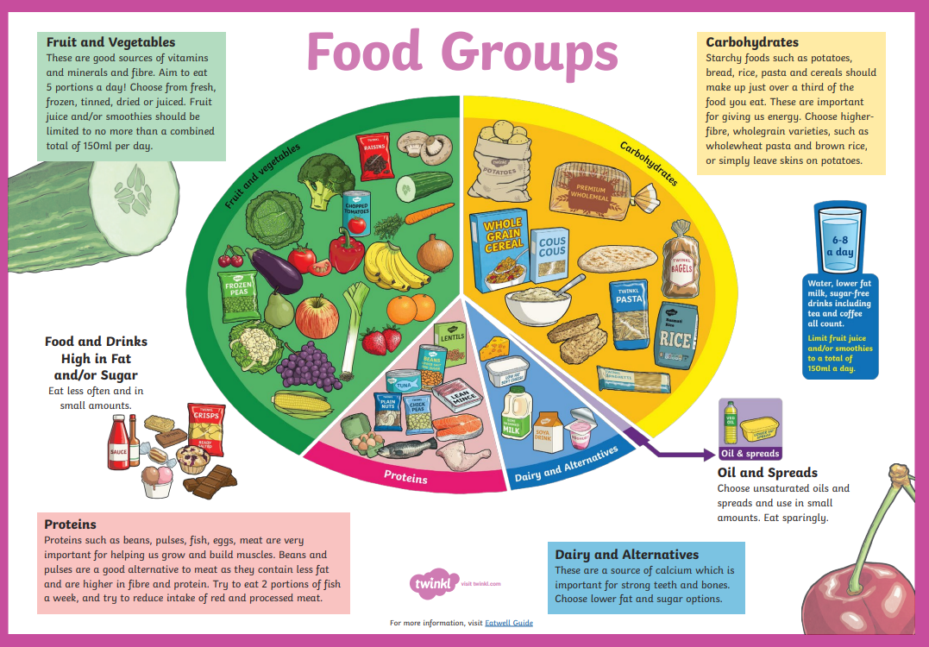
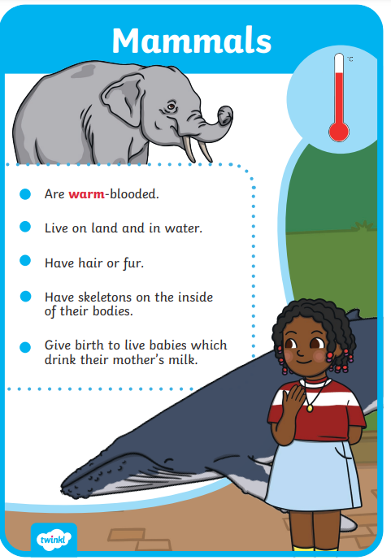
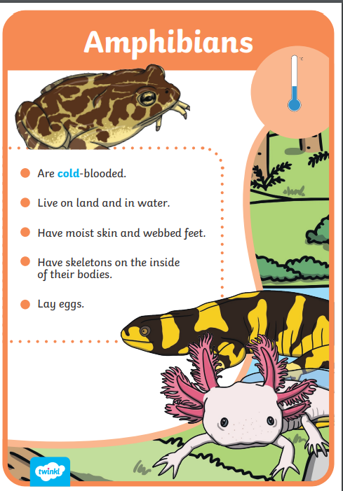
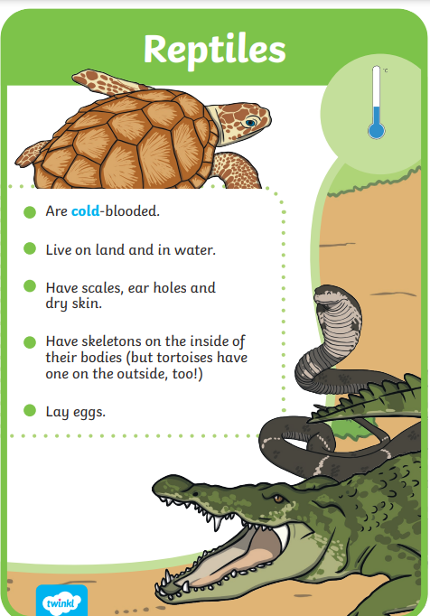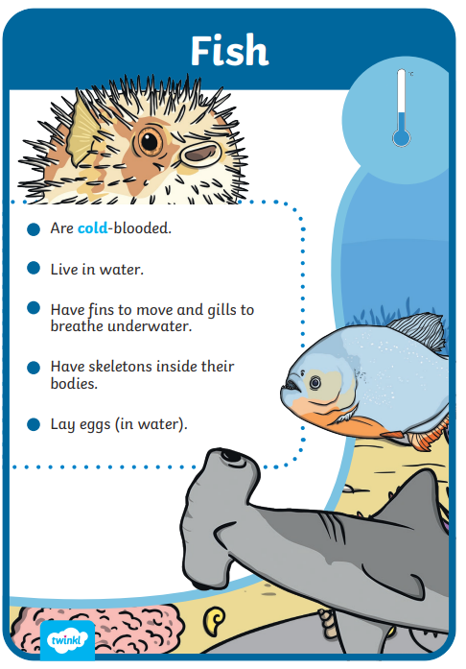
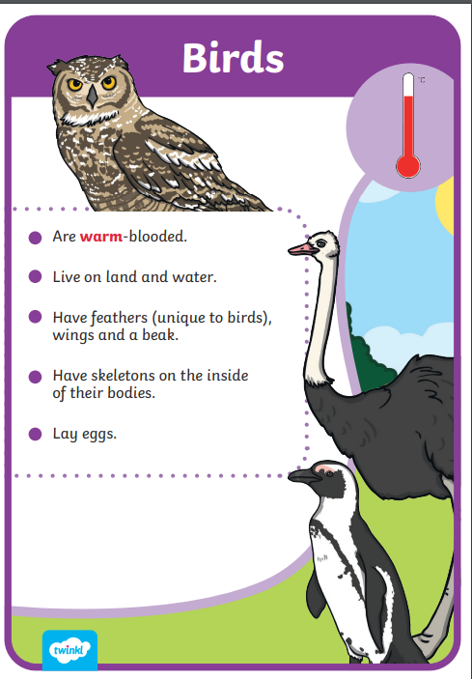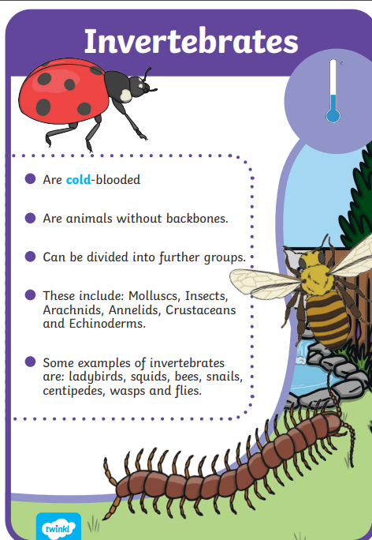
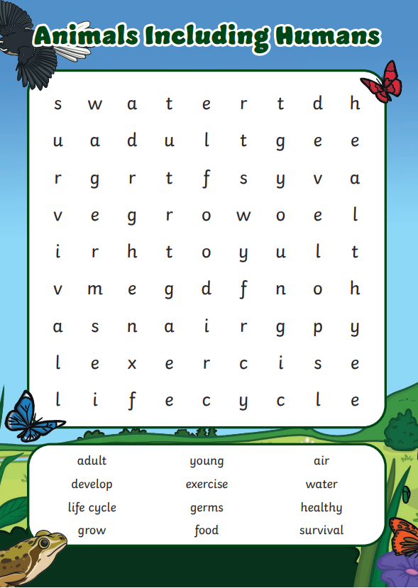

 | Videos | Activities
Animals including Humans | How do animal grow?  https://www.bbc.co.uk/bitesize/topics/z6882hv/articles/zd4dkty  What do animals need to survive?  https://www.bbc.co.uk/bitesize/topics/z6882hv/articles/z343f82  Why do humans need to be healthy?  https://www.bbc.co.uk/bitesize/topics/z6882hv/articles/z9j4g7h  Offspring song  https://www.youtube.com/watch?v=-sIQcQKSvqs | - Visit a local farm or zoo  - Visit a museum e.g. Horniman museum to observe animals  - Make an animal life cycle poster  - Design and make a healthy meal

