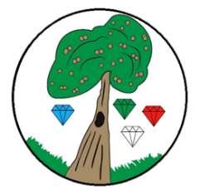
Year: 1 Term: Summer

Science: Plants Pre-Learning Pack

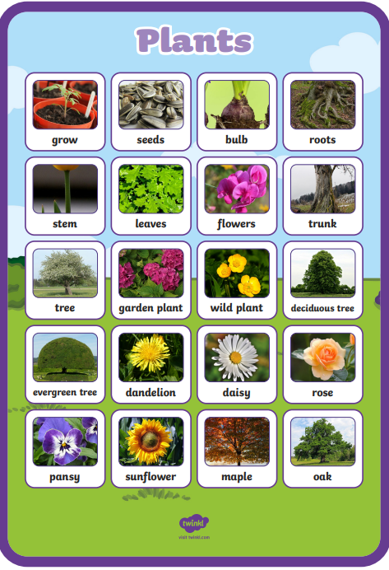
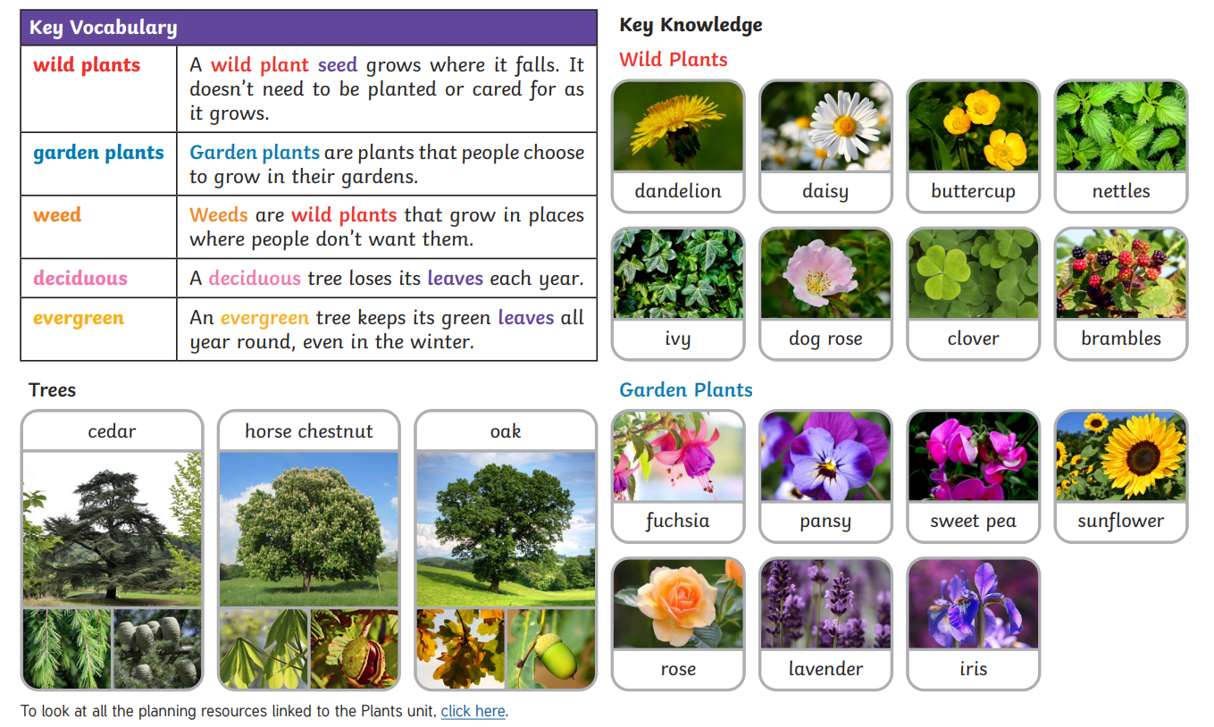
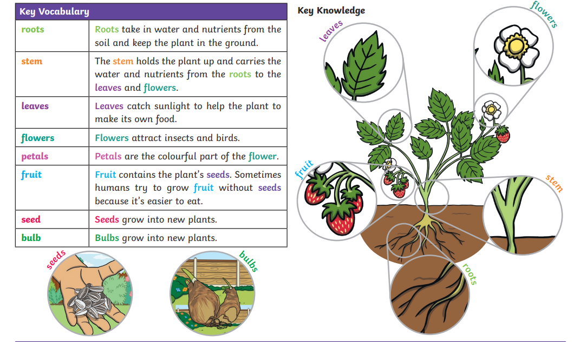
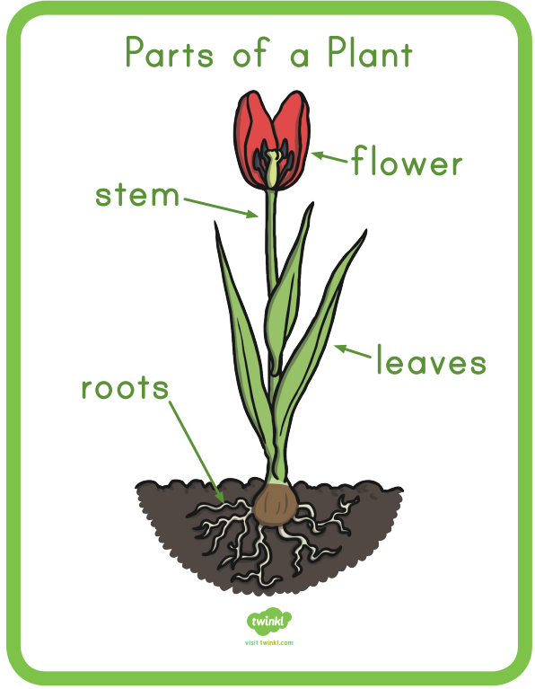
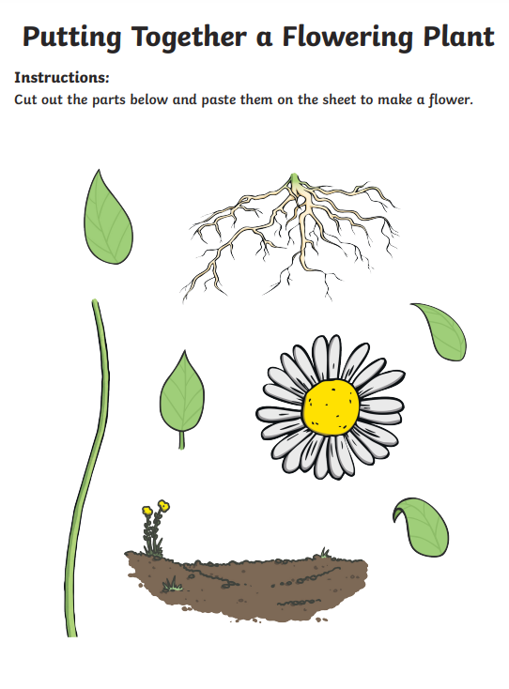
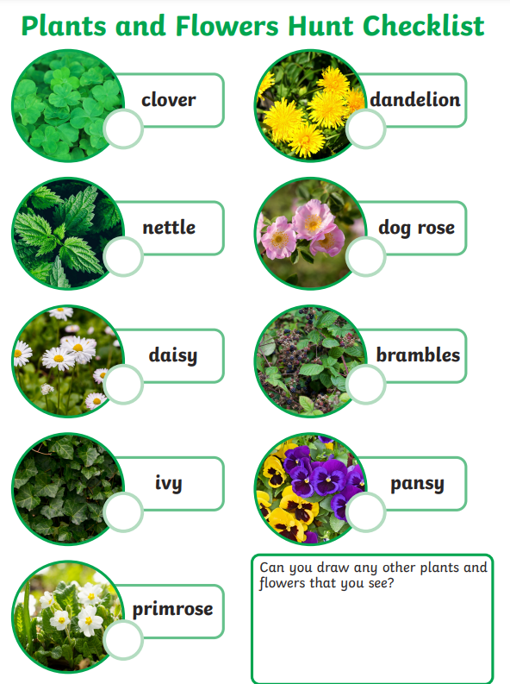
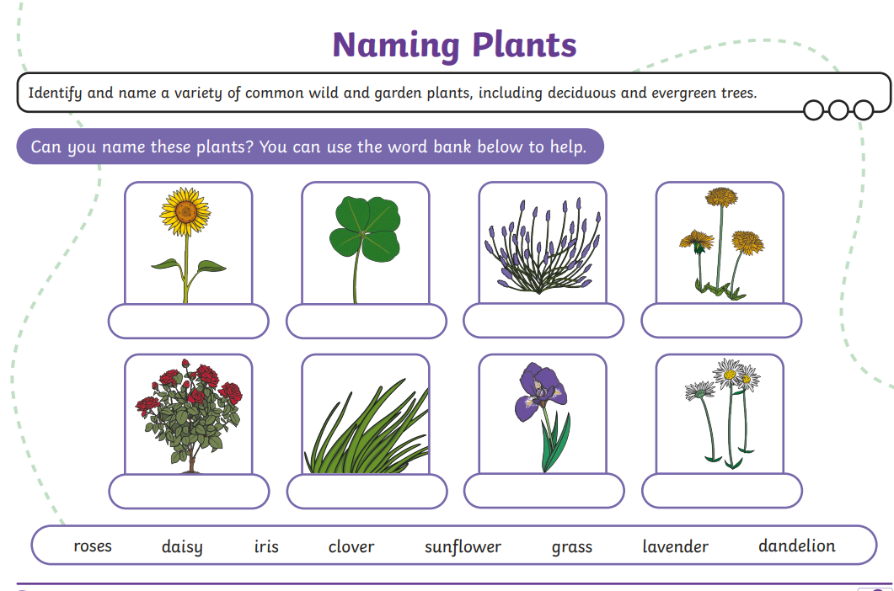

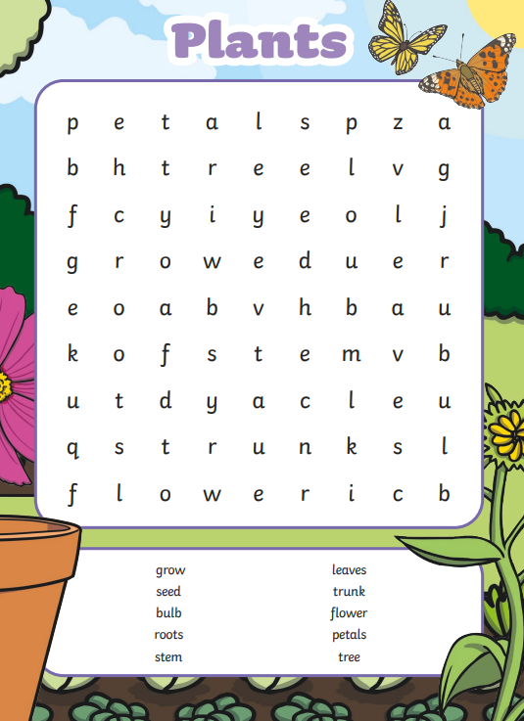

 | Videos | Activities to complete | Arts and Crafts
Plants | Wild and garden plants  https://www.bbc.co.uk/bitesize/topics/zpxnyrd/articles/zjnmqfr  The parts of a plant  https://www.bbc.co.uk/bitesize/topics/zpxnyrd/articles/z2vhxbk  The lifecycle of a plant  https://www.bbc.co.uk/bitesize/topics/zpxnyrd/articles/z6nx7yc  What do plants need to grow  https://www.bbc.co.uk/bitesize/topics/zpxnyrd/articles/zkp2jsg  Find a little seed song  https://www.youtube.com/watch?v=da_LbBewte8  Books:  Jack and the Beanstalk  Jaspers Beanstalk  The tiny Seed |  | - Plant your own seeds in a container, you could use yoghurt pot, cup, soil or cotton wool.  - Go on a plant hunt to find and draw any plants in your local area.  - Flower pressing with a book  https://www.redtedart.com/how-to-press-flowers/  - Use a plant identifying app e.g. ‘PlantSnap’  - Flower crafts  https://www.messylittlemonster.com/2020/06/flower-crafts.html

