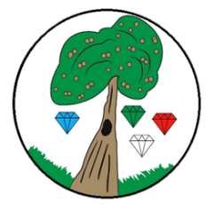
Year: 1 Term: Ongoing

Science: Seasonal Change
Pre-Learning Pack
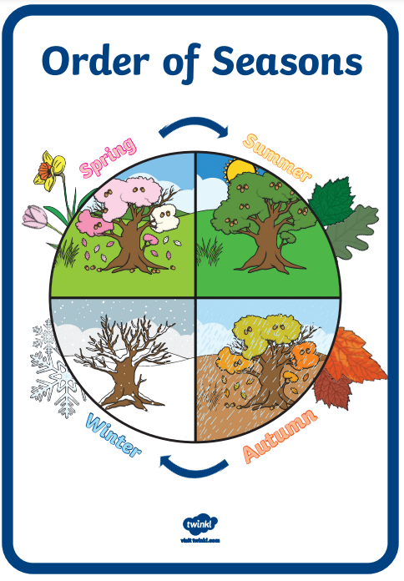
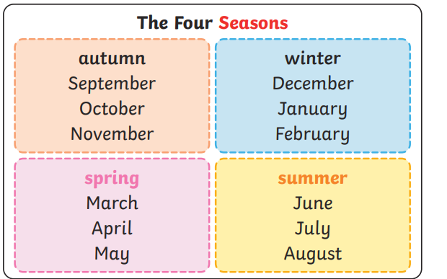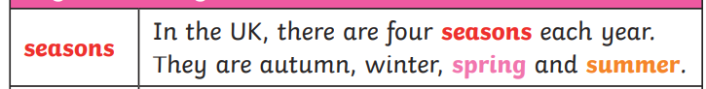
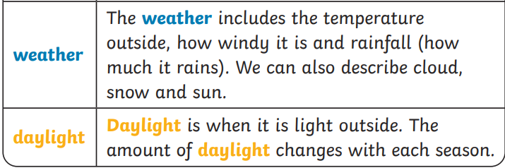

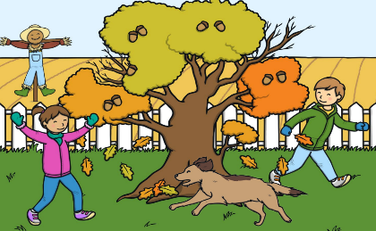
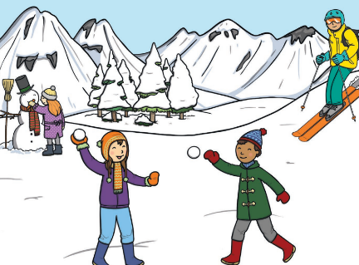
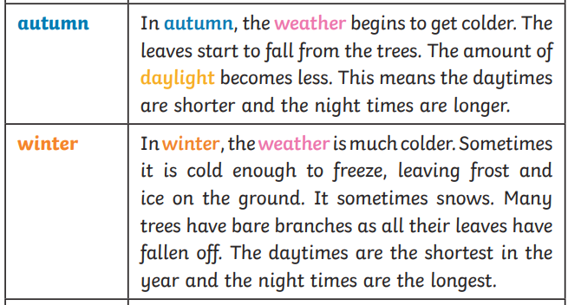
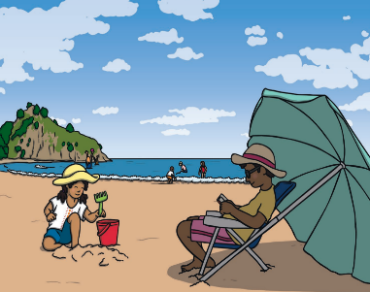
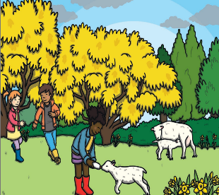
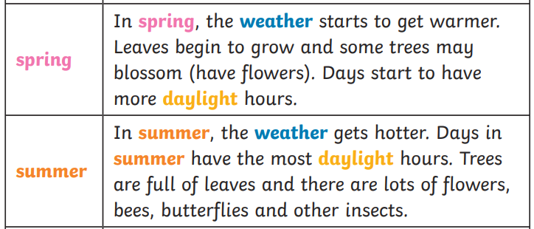
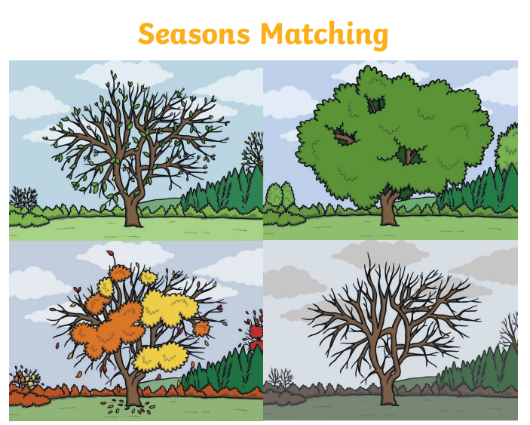
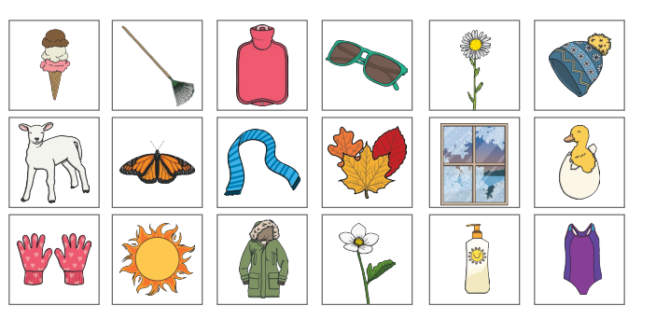

 | Videos |  | Activities to complete
Seasonal Change | What are the seasons  https://www.bbc.co.uk/bitesize/topics/zkvv4wx/articles/z3kbydm  Night and day  https://www.bbc.co.uk/bitesize/topics/zkvv4wx/articles/zyfhxbk  Seasons song  https://www.youtube.com/watch?v=NavWWM2iTEw  Months of the year song  https://www.youtube.com/watch?v=5enDRrWyXaw |  | - Seasonal scavenger hunt- look out for signs of Autum e.g. conkers and brown leaves. Repeat over year.  - Draw or photograph a deciduous tree over the 4 seasons.  - Use a thermometer, computer or phone to note the temperature in different seasons.

