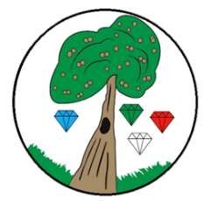
Year: 1 Term: Autumn/ Spring

Science: Everyday Materials
Pre-Learning Pack
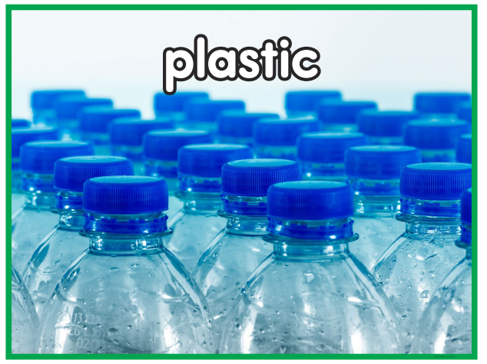
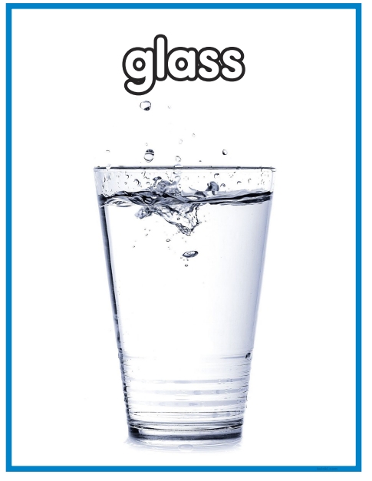
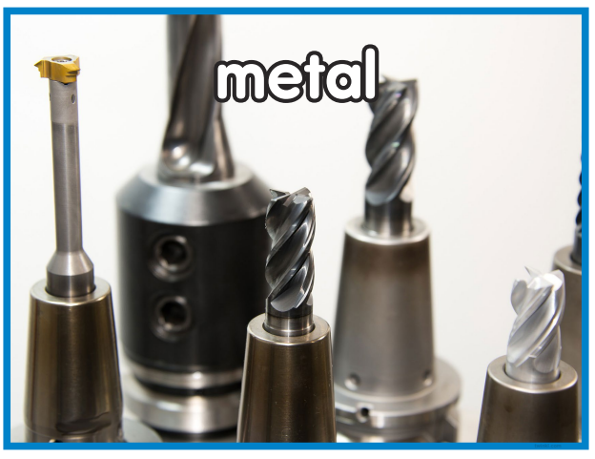

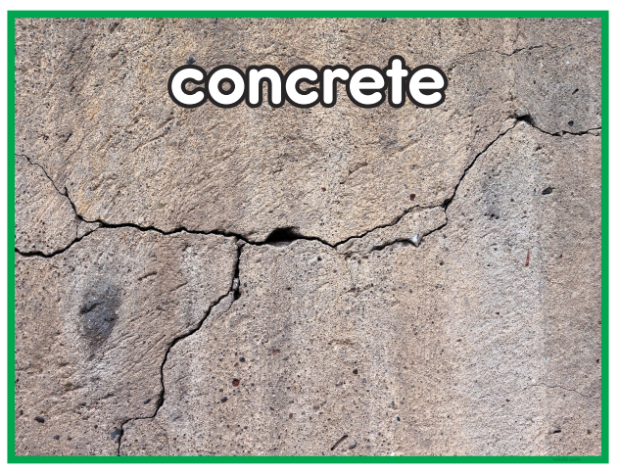
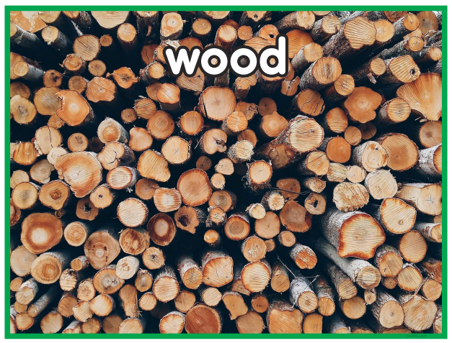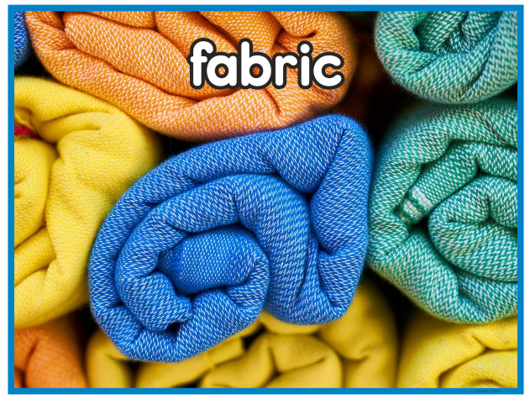
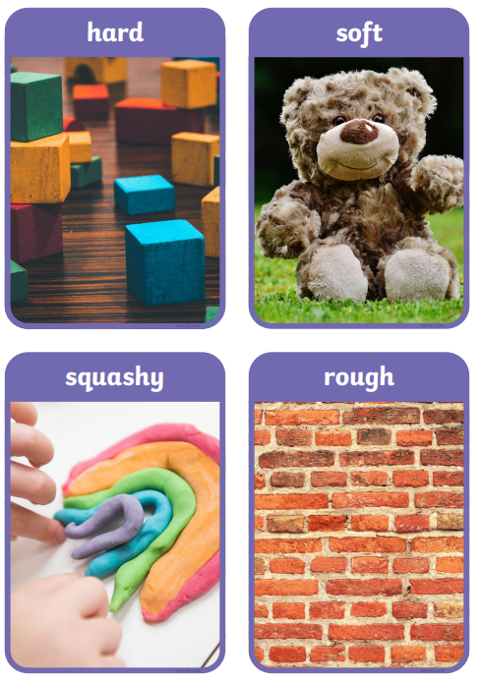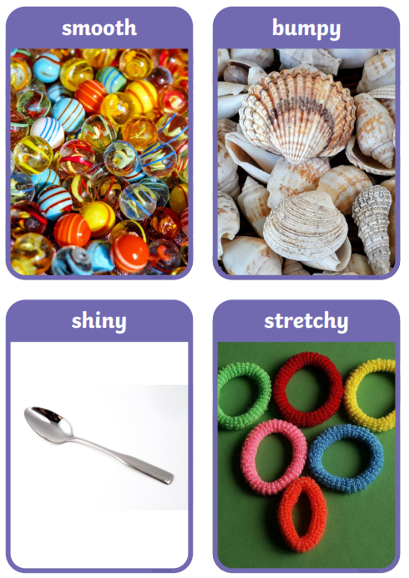
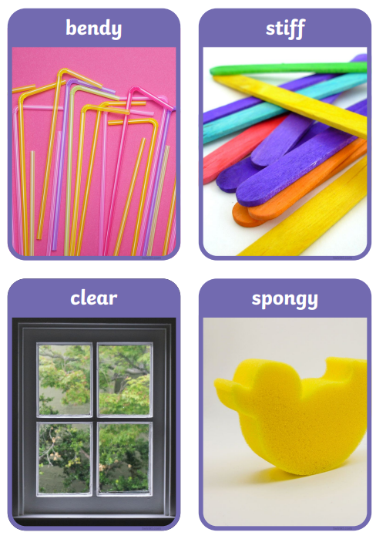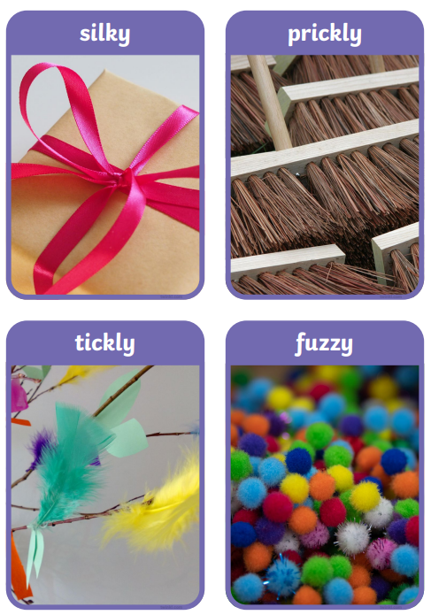
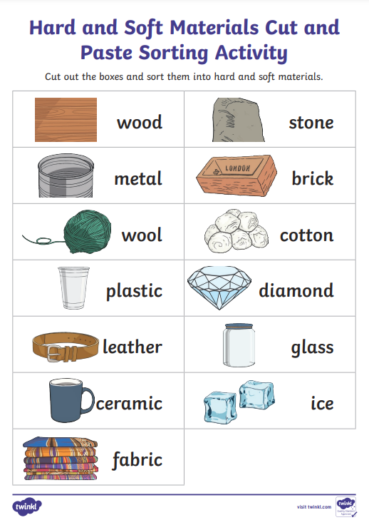

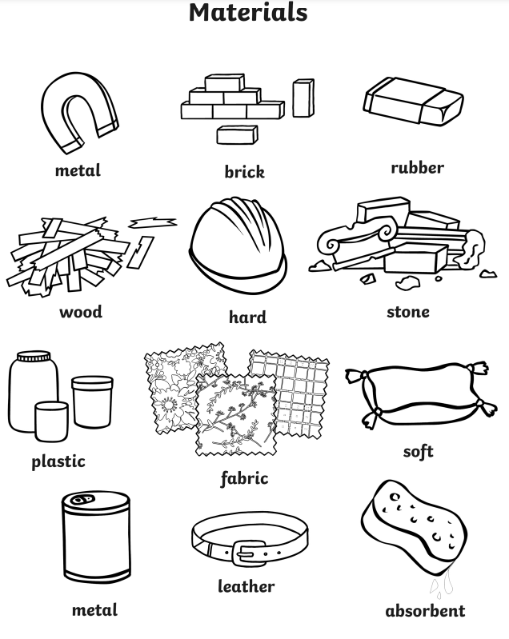

 | Videos | Activities to complete | Home activities
Everyday Materials | Describing Materials  https://www.bbc.co.uk/bitesize/topics/zrssgk7/articles/zvpysk7  Objects and Materials  https://www.bbc.co.uk/bitesize/topics/zrssgk7/articles/z6jm7yc  Everyday materials – STEM  https://www.youtube.com/watch?v=eCNade4GFpY  Examples of Materials  https://www.youtube.com/watch?v=2td5mfgf1OI  Materials song  https://www.youtube.com/watch?v=Qxdg3SExBvk |  | - Junk modelling using different materials  - Materials hunt at home with a tally chart to mark when each material is found  - Complete the ‘hard and soft’ sorting activity (above)  - Complete the materials colouring activity (above)

