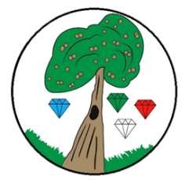
Year: 1 Term: Autumn

Science: Animals including Humans
Pre-Learning Pack
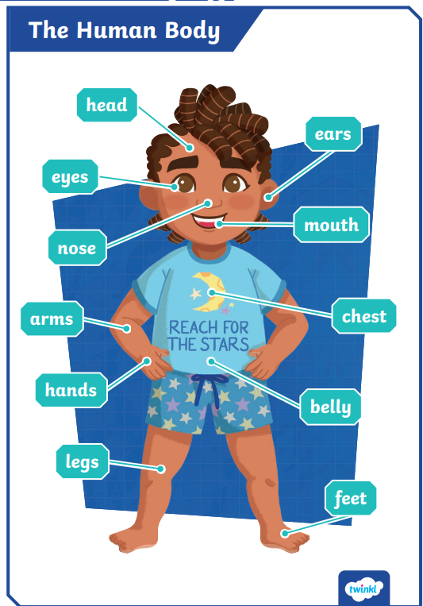
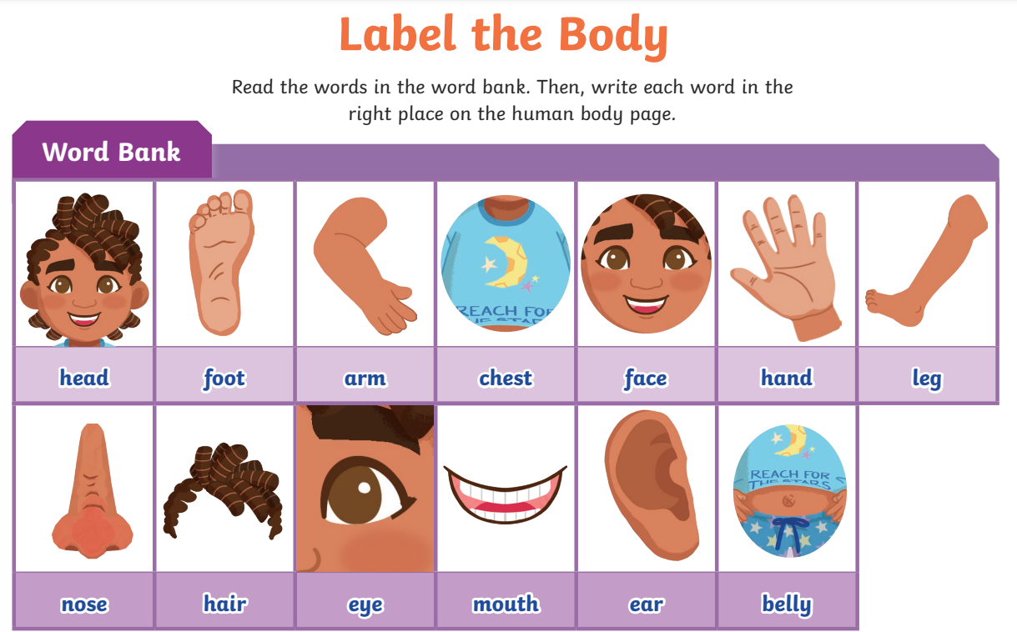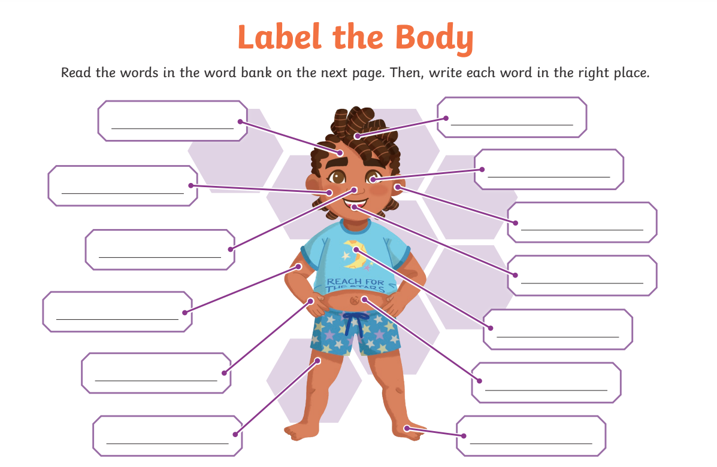

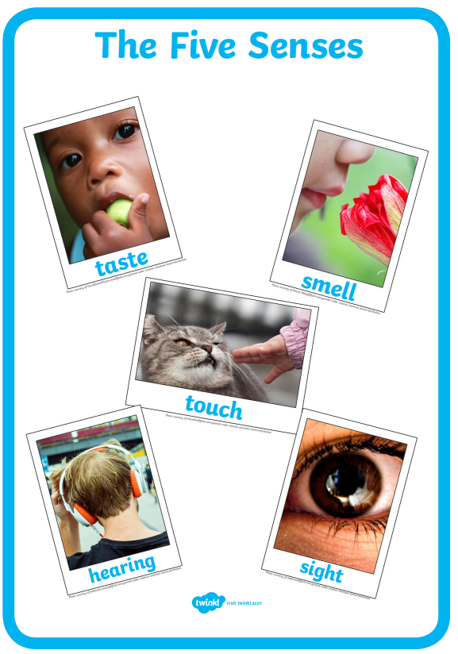

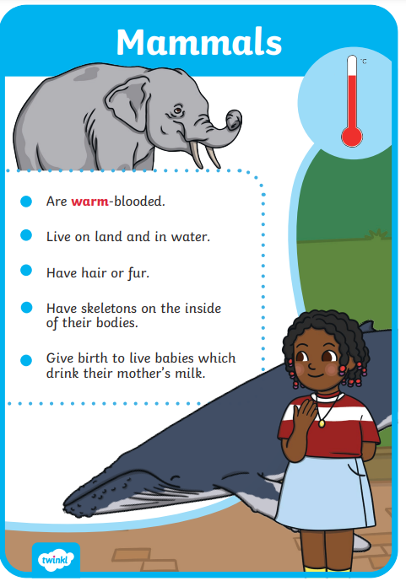
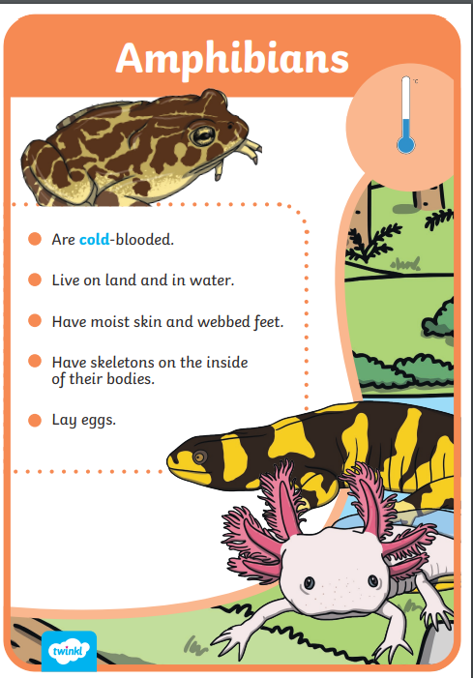
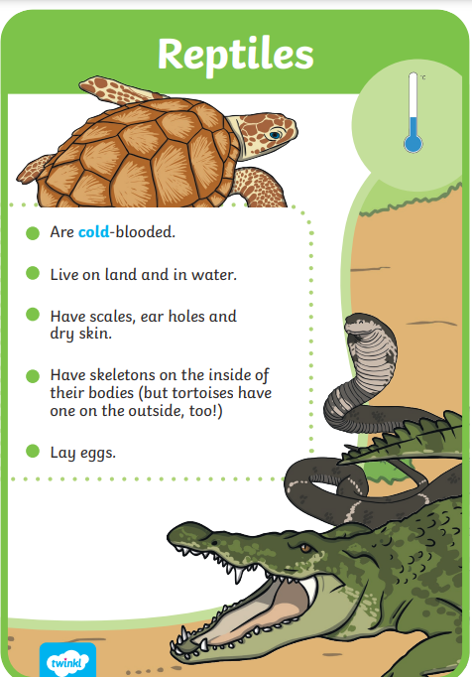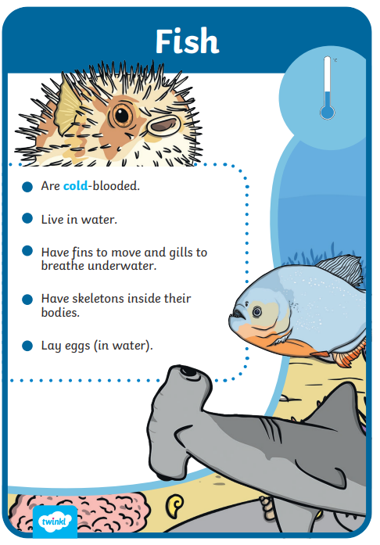
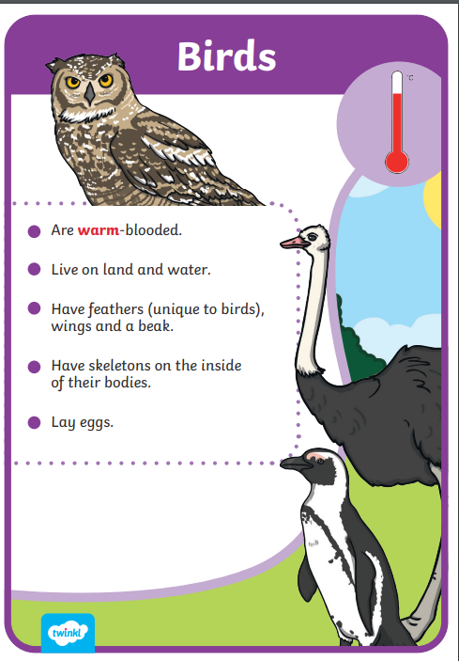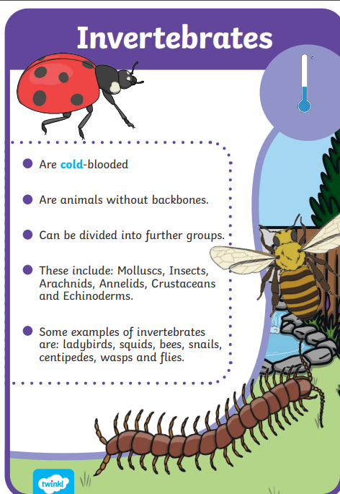

 | Videos | Activities to complete | Home activities
Animals including Humans | Body parts  https://www.bbc.co.uk/bitesize/topics/z6882hv/articles/z3cyn9q  Senses  https://www.bbc.co.uk/bitesize/topics/z6882hv/articles/zsbntrd  What do animals eat  https://www.bbc.co.uk/bitesize/topics/z6882hv/articles/zfbntrd  Mammals  https://www.bbc.co.uk/bitesize/topics/z6882hv/articles/zfm84xs  Amphibians  https://www.bbc.co.uk/bitesize/topics/z6882hv/articles/zvn2jsg  birds  https://www.bbc.co.uk/bitesize/topics/z6882hv/articles/zkn2jsg  fish  https://www.bbc.co.uk/bitesize/topics/z6882hv/articles/zt2kcmn  reptiles  https://www.bbc.co.uk/bitesize/topics/z6882hv/articles/zvfx7yc |  | - Visit a local farm or zoo  - Visit a museum e.g. Horniman museum to observe animals  - Sing heads shoulders knees and toes  - Play Simon says with body parts  - Draw around yourself on big paper or the pavement and label your body  - Junk model and label the body parts of your favourite animal

