|  |  |  |  |
| --- | --- | --- | --- |
| **BLACK HISTORY MONTH**  **LQ: Can you research an important Black figure?** | | | **Date:**  October 2025 |
| I can learn about a key Black figure and their contributions to society | | | |
| I understand what it means to ‘stand firm in power and pride’ - BHM 2025 theme | | | |
| I can place key dates in chronological order on a timeline | | | |
| * **Independent** | * **With Assistance T/TA** | * **Pairs/Groups** | |
| Bell Ribeiro-Addy - Wikipedia**Task Box**  The children read biographical information about Bell Ribeiro-Addy and how she has been powerful and proud in her lifetime. They arranged key dates in chronological order along a timeline of her life. Finally, they analysed key quotes from her speeches and considered how language can demonstrate power and pride. | | | |

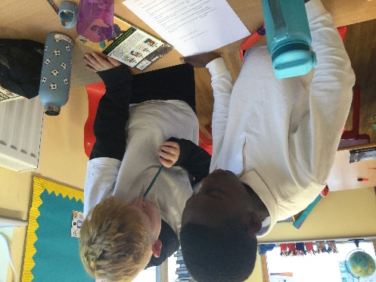 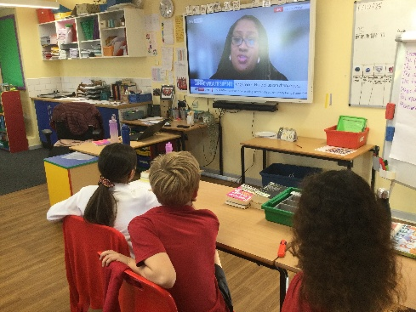 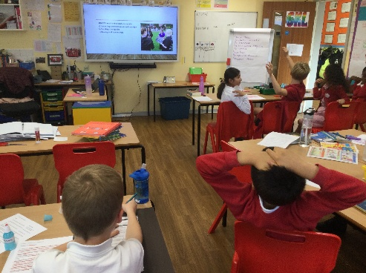

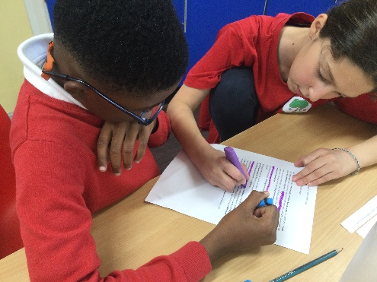 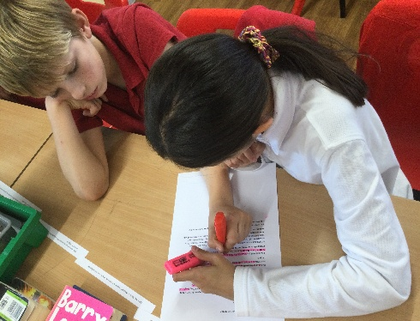 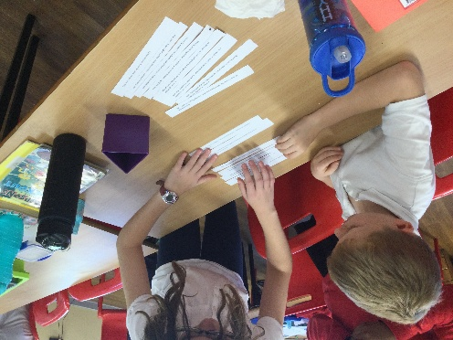

1

Answer the questions to show your understanding

Who is Bell Ribeiro-Addy? ______________________________________________

Why is she an important figure in British politics?

________________________________________________________________________

What issues does she care about or speak out on?

________________________________________________________________________

CHALLENGE – Why do you think it's important to have people from different backgrounds in politics? ________________________________________________________________________