Little Stars Nursery
Nursery Provision for 2 year olds

Welcome back to the Little Stars 2022
Our topic this term is “colours”. We will be looking at colour names and practicing naming what we see using colours, for example “blue paint” or “red apple”. We will be playing colour games indoors and outdoors with the children. To support the children at home, it is a good idea to name everyday items, for example, “What colour is that car?” “Look at the green leaves!” Etc.
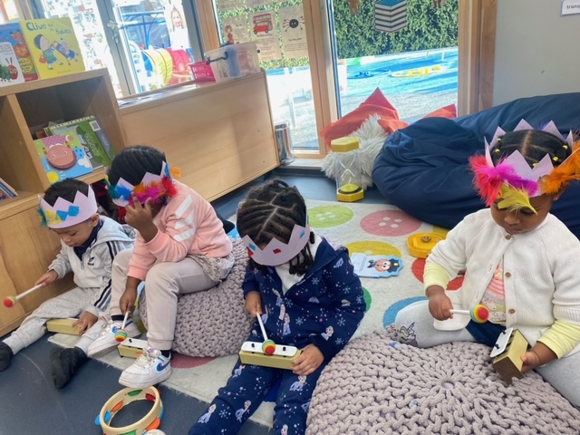
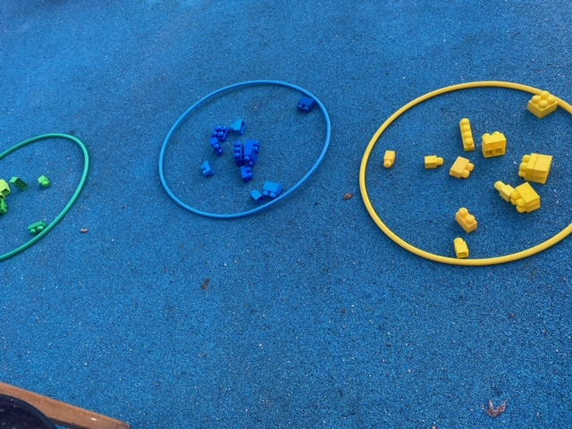

The children have enjoyed the last 7 weeks of their music sessions with Rosanna, our music teacher. The children this term will continue to enjoy learning new songs and rhymes, singing along with others, as well as playing instruments which will support them in developing recognition of rhythm and rhyme. During our music sessions, the children also express themselves using movement and dance, supporting coordination and self-confidence.
Our focus book this term will be “Brown Bear, Brown Bear” by Eric Carle” please read this book at home with your children this term, to support their learning.
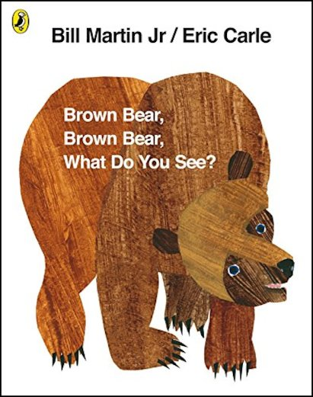

Repetitively reading the same book has been proven to significantly develop children’s language.
Rosie’s trip to Jamaica
Over Christmas, Rosie Bear went on a trip to Jamaica. Rosie went on an aeroplane, visited the beach, picked Ackee from the trees, went swimming, and looked at palm trees.
The children have been looking at the pictures of Rosie and we have been talking about Rosie Bear’s travels and if the children have any similar experiences.
This term, one child per week will get to take Rosie home for the weekend along with her diary. Children and parents will be able to look at what Rosie has being doing and add any new adventures such as, going to the park, going shopping etc.
If you do take pictures, you can email them to the school office and we will add them to the book for you
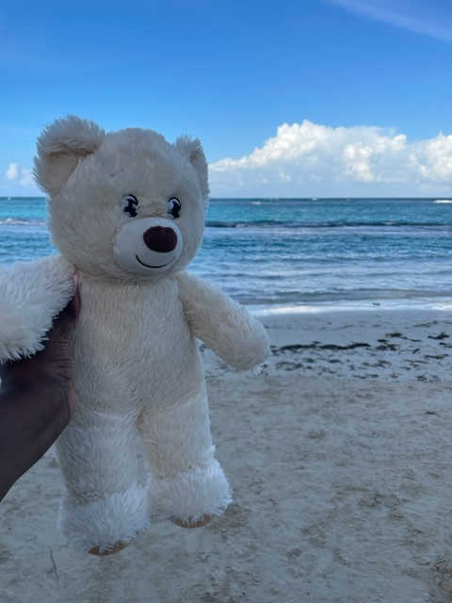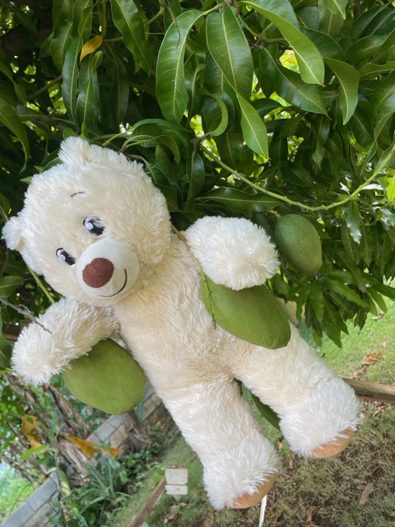

Class Reminders
*Children will get messy this is part of their development and learning. Please dress children in clothes which can get messy.
*Please drop children at the door and collect them from outside the class, we are encouraging the children to come in independently and meet you outside the class after the final carpet session of the day.
*If you need to talk to the Little Stars staff at any time, then please ask when they are free to meet with you.

Many thanks
The Little Stars Team

