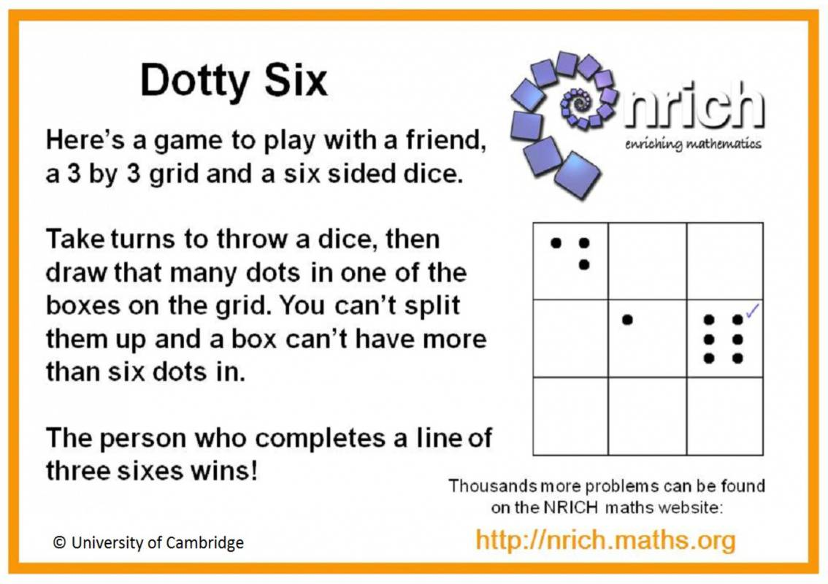
Dotty Six

You will need:
2 players
3 by 3 grid
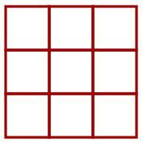
Dice or tablet

