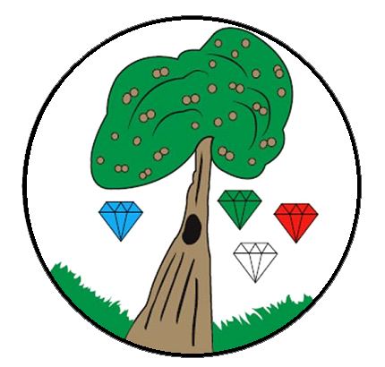

Music

Intent, Implementation and Impact

Intent

At the Gem Federation, we believe that every child should have the opportunity to inspired, to develop an appreciation and love of music that continues throughout their time at Bessemer and beyond. We endeavour for our children to become curious and creative in their learning of music, to be critical and open-minded.

Music is a thread that runs throughout our school, whether learning, observing or performing and we strive to create a culture of appreciation that resonates. Our children are provided with a diverse and ambitious curriculum that ensures learning is progressive and inclusive, so every child has the opportunity to excel.

Implementation

At the Gem Federation, music is taught progressively by specialist music tutors who provide consistently high-quality music lessons for Early Years Foundation Stage, Key Stage 1 and Key Stage 2 pupils. They deliver a comprehensive music curriculum scheme of work through weekly lessons and regular perfomances. The methodology that underpins this curriculum is based upon the work of Hungarian composer and educator, Kodaly, who believed that music learning starts with the voice.

With this in mind, our children’s music journey begins in early years through both the voice and inner voice. This is in preparation for instrumental lessons later on. The children have great fun in lessons that follow a particular formula: warm-up, songs, pitch and rhythm exercises, main activity and listening and responding to recorded music. Lessons are taught through a combination of word, song, play, movement and hand signals, to ensure learning is engaging, it resonates and can be accessed by all.

In KS1 and lower KS2, the children build upon their learning in previous years, focusing on pitch, pulse and instrument differentiation. They learn to differentiate between long and short sounds, follow plans to play a piece of music on percussion instruments and with their voices. They also learn to compose patterns of long and short sounds. The children learn to identify the difference between high and low sounds, follow symbols to play different sounding instruments and develop an understanding of rhythmic phrases. By the end of lower KS2, the children are able to play rhythms on percussion instruments, independently, in pairs and in groups. They are also able to share their opinions and suggestions about their own music and others’, using their developing musical vocabulary.

Upon entering upper KS2, the children will have had a fantastic foundation of knowledge, skills and musical appreciation and are ready to progress with their learning through a variety of instruments (Whole Class Ensemble Teaching Programme). In Years 5 children learn to play samba drums and in Year 6 children play string instruments. The children learn to play the recorder, ukulele, clarinet, flute and Samba drums. They learn technique, improvisation, playing by ear, composition and ensemble performance, all the while developing their knowledge and skills, in areas such as pitch, rhythm notation, harmony, articulation and texture. During each unit, the children listen to a huge variety of musical styles, traditions and genres, all of which are purposefully chosen, to not only expose our children to a broad variety of music, but to support their current learning. By the end of Year 6, our children will be well prepared to continue their musical journey into KS3 with confidence.

Our children have regular opportunities to perform a piece of repertoire they have studied, within their year groups during music lessons and to a wider audience at least once a year. They are also given the opportunity to describe what they have been learning in that time. In addition to this, our children take part in cross-school performances, with even larger audiences, such as the Young Voices concert. These are not only wonderful experiences for the children to show what they have achieved, but also provides an additional opportunity for their teachers to assess their progress outside of the classroom.

At Bessemer, singing and performing is not only an extremely important part of our music curriculum, but plays a significant part in school life.Through our school choir, class assemblies, seasonal concerts and end of year performances, our children are provided with a variety of opportunities to share their love of music and perform to a larger audience.

Impact

The impact of this curriculum upon our children’s learning is evident week upon week, year upon year, through the children’s lessons, singing assemblies and performances. Recordings of the children are used to keep a record of their progress and support the ongoing assessment that takes places in real-time.

Lessons are monitored by subject and senior leaders and an ongoing dialogue with class teachers and the specialist music teachers ensures gaps can be identified and improvements can be made. Additionally, it is through the children themselves that we are able to assess the impact of the curriculum: apart from observing their practice, listening to peer and self-assessments, discussions about their learning and through pupil voice, we are able to monitor their progress, understanding and enjoyment.

